LCA 5.8 North Marston Undulating Claylands

Landscape Character Type: LCT 5 Shallow Valleys

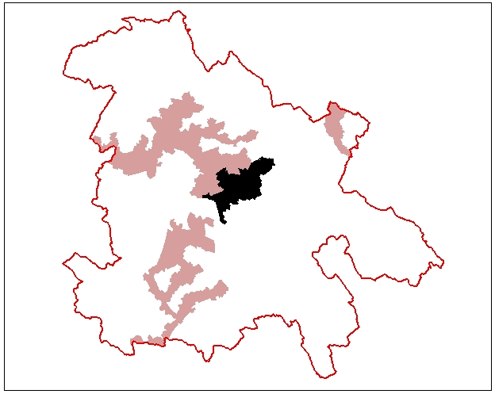

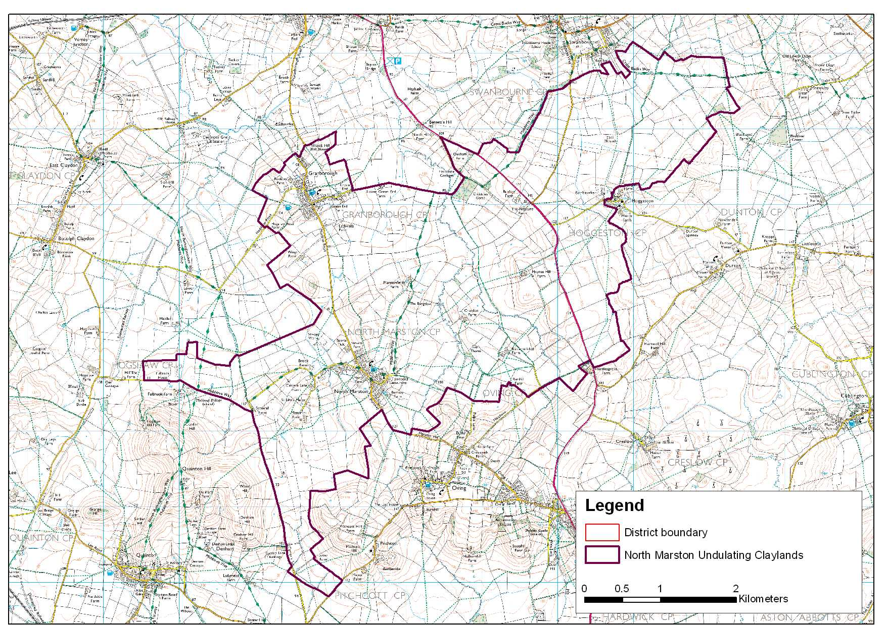

LCA 5.8 North Marston Undulating Claylands (LCT 5)
Key Characteristics  - Undulating landform  - Small hills and ridges  - Meandering streams  - Predominantly pastoral  - Settlement on high ground  - Good hedgerow pattern  - Ridge and furrow  Distinctive Features  - Minor roads and gated road  - Ponds  - Willows and poplars  - Historic earthworks  - Neutral grassland  Intrusive Elements  - Pylon lines  - Traffic on A413 has a localised impact | Location Close to the centre of the district between Winslow and Aylesbury, the A413 passes north-south though the area.  Landscape character An undulating landscape between the hills of Quainton, Oving and Dunton to the south and the Claydon Valley LCA 5.6 to the north. The area drains from the south to the north with several meandering streams with adjacent flat ground. Small hills and ridges are a feature of the area. The settlement tends to focus on areas of higher ground with the villages of North Marston and Granborough being notable for their strong historic character. It generally has a good hedgerow network over this lively landform. Pasture is the dominant land use. Although well settled in comparison to other areas within LCT 5 Shallow Valleys it remains quiet with minor lanes and gated roads enhancing a sense of remoteness in some areas. The only visual intrusion comes from pylon lines and localised impact of the A413 on high ground. Views are often enclosed by the undulating landform or focus on the higher ground of the ridge to the south.  Geology An extensive area of calcareous mudstone (West Walton Formation). Small pocket of Kimmeridge clay and glacial till along the line of the A413 corridor.  Topography An undulating character created by streamlines cutting into higher ground. There are a number of small distinct hills and ridges.  It extends to the south to the area of lower ground between Quainton Hill LCA 9.2 and Pitchcott-Whitchurch Ridge LCA 9.3. The highest ground in this LCA is about 135m AOD and the lowest in the north about 100m AOD.  Hydrology There are no major watercourses but small meandering streams are a feature particularly through the centre. Ponds are rekatively common both within villages and fields.  Land use and settlement This is a predominantly pastoral landscape with about one fifth of the area arable including some areas of prairie fields and new enclosure. The settlement is concentrated on higher ground.  Tree cover The area has a low level of tree cover with a few small woodlands. The hedgerows have a moderate amount of trees, which tend to be oak in the higher ground to the south and more ash in the north. Willow and poplar are notable in wetter areas and adjacent to streams and ponds.  Biodiversity Grassland habitats dominate – much is improved, but some is unimproved or neutral. One block of neutral grassland a broad habitat type, is associated with the watercourse that bisects the LCA, and a second is found on the northern boundary, two smaller blocks are also present in the north. An area of the priority habitat type lowland meadow is located in the centre of the LCA and forms Wet Stock Meadows CWS. This is a hay meadow rich in wild flowers and with a pond.  The other habitats are arable which is more prevalent in the northeast; broadleaved woodland - small fragments of which are present throughout; and the aquatic habitats of the numerous ponds and the stream network.  A CWS has been designated at Stonehill Lane where the hedgerows are species rich and include field maple and dogwood.  Historic environment The historic landscape of this area is largely composed of the characteristic rectilinear parliamentary enclosure fields, laid out for the parishes of Granborough and North Marston in 1796 and 1780 respectively. There are also some fossilised strips fields close to the village of North Marston.  The settlement pattern of the area is mostly nucleated forms, typified by the settlements of Granborough and North Marston. Both villages contain important listed buildings. North Marston’s conservation area contains the very fine perpendicular church of St Mary’s which is a Grade 1 listed building.  The predominance of grassland in this area has resulted in the preservation of archaeological earthworks; the most evident feature is the abundance of ridge and furrow, relicts of a communally farmed pre-enclosure landscape. Particularly fine examples of ridge and furrow can be found at Granborough and North Marston. The latter is on the English Heritage list as one of the best examples to be found in England. There are also well preserved deserted medieval settlement earthworks at Hogshaw, which is classified as a scheduled ancient monument and also good examples at Granborough and Hoggeston. The landscape also has the earlier feature of Carter’s Lane Roman road which runs along the western boundary of the area as well as a few Roman findspots.  The area has a high amenity value the Swan Way promoted as a recreational footpath. North Marston in particular contains a plethora of Rights of Way radiating from the village. This unusual density of footpaths may be attributable to the village’s past as a place of medieval pilgrimage to the healing well of John Schorne.  Designations  Conservation Area at North Marston  Scheduled Ancient Monument - Hogshaw  Archaeological Notification Areas – 32 No.  CWS – 2 No.  BNS – 6 No.

LCA 5.8 North Marston Undulating Claylands (LCT 5)

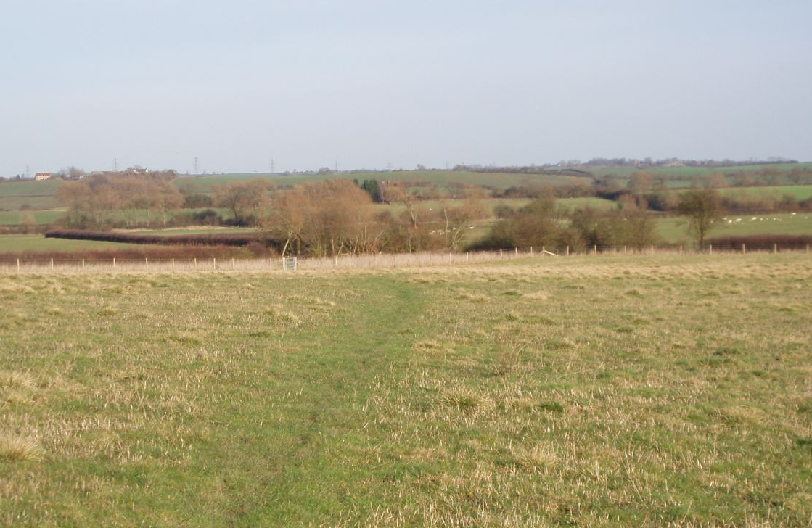

This is a predominantly pastoral landscape with a good hedgerow pattern; willow and

poplar trees tend to be focused on the lower ground adjacent to watercourses.

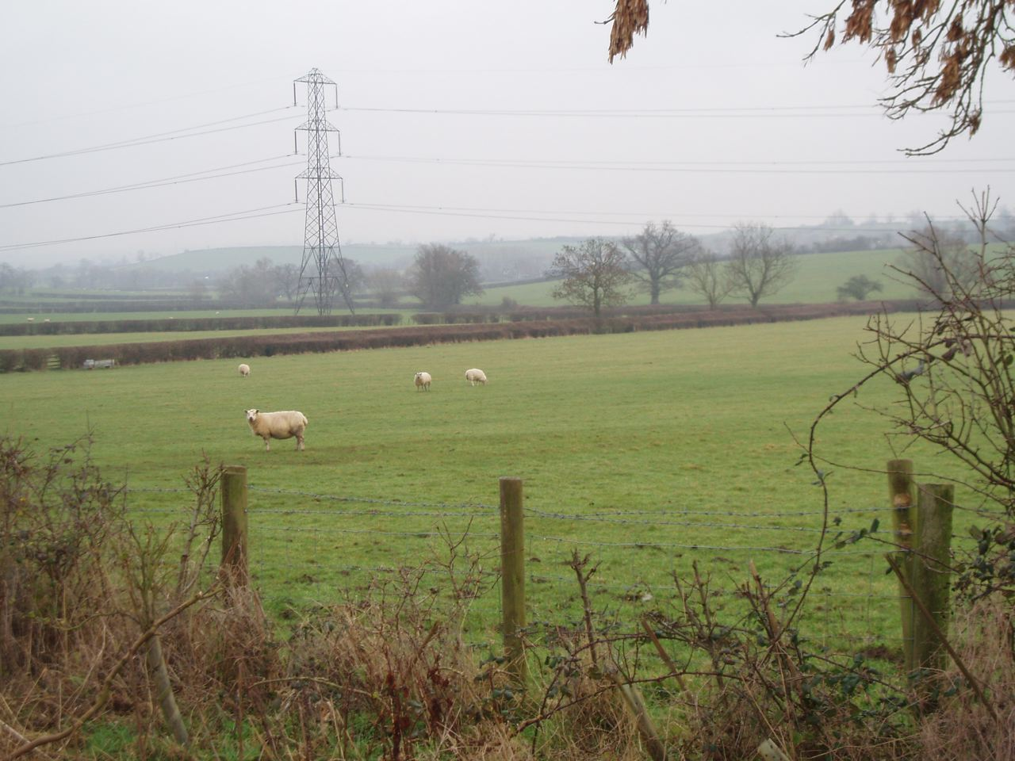2

Oak trees are a feature of hedgerows in the south of the area. Pylon lines are the main

visual detractor in a generally harmonious pastoral landscape.

LCA 5.8 North Marston Undulating Claylands (LCT 5)

Summary of Condition/Sensitivity Analysis

Condition |  | Good
Pattern of elements:  Visual detractors:  Visual unity:  Cultural integrity:  Ecological integrity:  Functional integrity: |  | Unified  Few  Strongly unified  Good  Weak  Coherent
Sensitivity |  | Moderate
Distinctiveness:  Continuity:  Sense of place:  Landform:  Tree cover:  Visibility:  Guidelines |  | Distinct  Historic  Moderate  Apparent  Intermittent  Moderate  Conserve and Reinforce
Condition

This landscape is generally in a good condition it has a strong hedgerow pattern over an undulating landscape there is little in the way of interruption or fragmentation. There are few visual detractors and there impact tends to be fairly localised. The landscape is strongly unified. The cultural integrity is considered to be good it has attractive historic settlement with a well preserved landscape of parliamentary enclosures and nationally important ridge and furrow although the age structure of the trees is generally mature or over mature. Ecological integrity is weak due to suboptimal connectivity and the low area of designated sites and habitats of District significance present compared to other parts of the District. The area has a coherent functional integrity.

Sensitivity

The landscape has a distinct character with a good sense of historic continuity, particularly around the historic settlements. This gives the area a moderate sense of place. The landform is apparent with small hills and ridges within a gently sloping valley landscape. The tree cover is intermittent with low clipped hedgerows and fairly widely spaced hedgerow trees. This gives the area a moderate visibility. Overall the sensitivity of this landscape is considered to be moderate.

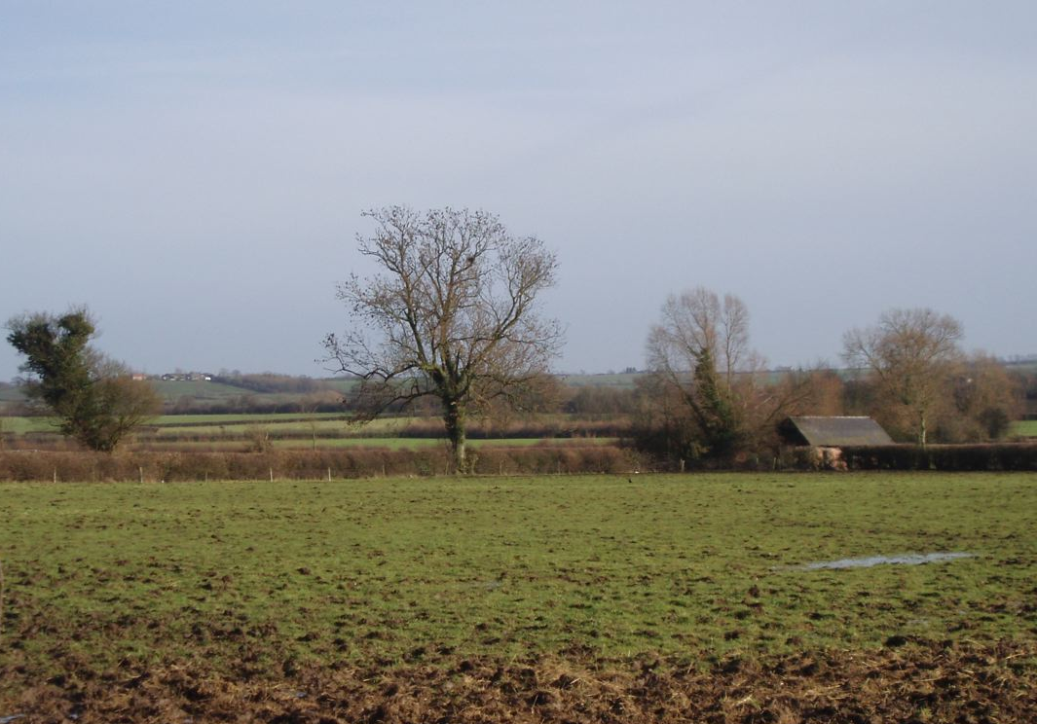

Hedgerow trees are an important feature of the landscape character of this area many trees appear to be in decline being mature or over mature.

LCA 5.8 North Marston Undulating Claylands (LCT 5)

Landscape Guidelines Conserve and Reinforce

The landscape guidelines for the North Marston Undulating Claylands are as follows:

- Encourage the retention and strengthening of the historic hedgerow pattern by infilling gaps and establishing new hedgerow trees. Oak and ash trees are a feature of hedgerows in this area.
- Encourage the management of hedgerows through traditional cutting regimes.
- Promote the management and conservation of vegetation adjacent to the meandering watercourses including the pollarding of willow.
- Maintain the condition and extent of woodland.
- Maintain the condition and extent of neutral, unimproved and semi-improved grassland wherever possible. Encourage good management practices.
- Close to watercourses promote the use of permanent pasture, with low stocking density and flooding regimes to promote biodiversity and landscape enhancement.
- Encourage the restoration and management of ponds and the area around them to provide a succession of habitats from open water through to mature trees.
- Promote the conservation and interpretation of rich historic environment.
- Where possible link ponds to adjacent hedgerows with grassland.
- Enhance connectivity of habitats.
- Identify key views to surrounding higher ground from publicly accessible land and promote the preservation and enhancement of these views.
- Encourage the preservation of historic earthworks and ridge and furrow by maintaining a continuous grass sward.
- Maintain the historically open landscape by discouraging the planting of new woodlands and sub-division of fields.
- Conserve the distinctive historic character and form of the village and its settings, especially the green and fossilised strips associated with North Marston.

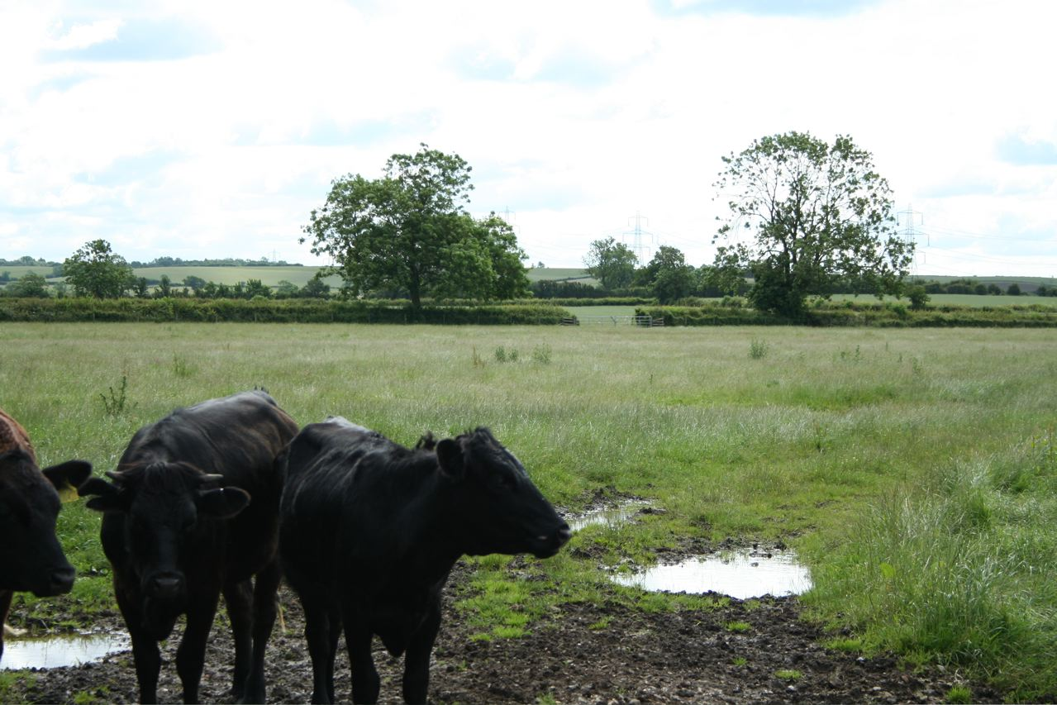
In the northeast views focus up to the surrounding higher ground of LCT 4 Undulating Clay Plateau.
Ash becomes more frequent than oak as a hedgerow tree.

