LCA 4.4 Thornborough-Beachampton Great Ouse Tributaries

Landscape Character Type: LCT4 Undulating Clay Plateau

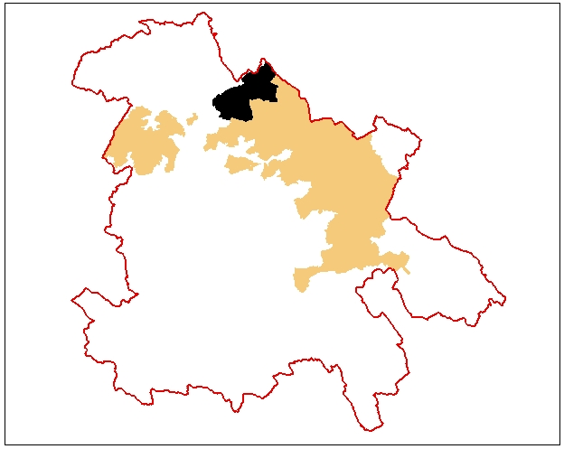

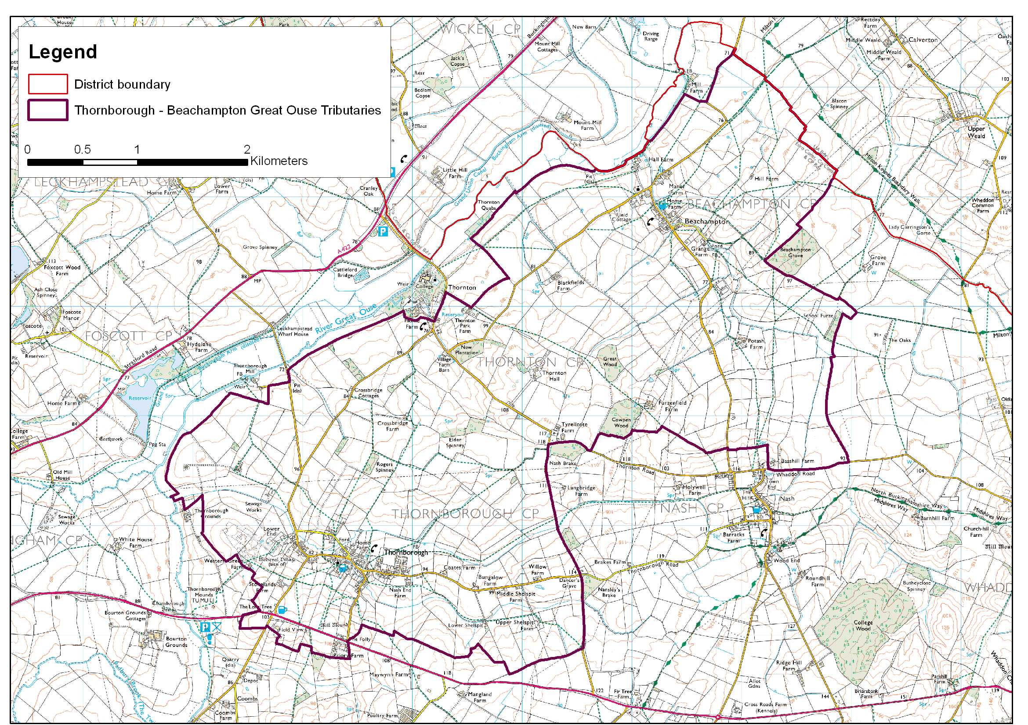

LCA 4.4 Thornborough-Beachampton Great Ouse Tributaries (LCT 4)
Key Characteristics  - Valley side sloping down from high ground south towards Great Ouse valley  - Incised by a number of streamlines  - Undulating landform  - Mixed farming predominantly arable  - Strong hedgerow pattern  - Linear settlements widely spaced  - Low level of woodland cover but concentrated in one area  - Field pattern reflects pre 18th century and parliamentary enclosure  - Earthwork remains of medieval settlement and open fields at Beachampton and Thornborough  - Fox coverts  Distinctive Features  - Pollarded willows adjacent to watercourses  - Small areas of broadleaved woodland  - Ponds  - Neutral grassland  Intrusive Elements  - Pylon lines  - Electricity substation at Beachampton | Location In the north of the district between Buckingham and Milton Keynes on the southern side of the Great Ouse Valley. The A421 runs through part of the southern edge of the area.  Landscape character A well settled landscape with several small valleys draining into the Great Ouse. The undulating valley slopes are in mixed agricultural use. Smaller pastoral fields tend to be found adjacent to settlements. Narrow winding lanes running parallel with the Ouse valley. It is predominantly an open landscape often with good views north across the Great Ouse valley however close to the villages in the incised valleys there tends to be an intimate enclosed character often with visual interest associated with historic buildings of limestone thatch and brick and the streams themselves.  Pylon lines have a negative impact on the visual character of this area particularly south of Beachampton where six lines radiate from a sub-station. The A421 has a slight impact on part of the southern edge of this area.  Geology Glacial Till overlain by occasional pockets of Glacial deposits. Large area of mudstone (Peterborough Member) in the southeast. Along the edge of the Ouse valley and its tributaries exposures of Kellaway formation (Mudstone), White Limestone formation, Forest Marble formation and River Terrace deposits.  Topography Ground that slopes down between the high ground to the south of Padbury- Nash Ridge LCA 4.6 and the low ground of Lower Great Ouse Valley LCA 3.1. The difference in elevation between the two areas is not that great being from about 70m to115m to 70m AOD. However, a number of streams cut into the surface creating a very undulating landform.  Hydrology The area is drained by a number of meandering streams that cut into the clay. Two of the small valleys they create are partly occupied by the settlements of Thornborough and Beachampton. There are several springs in the south. Ponds are a feature of the whole area with a particular concentration in the north.  Land use and settlement This is a mixed agricultural landscape with just over half the area being arable farming. The grassland tends to be concentrated around the settlements. There are two large villages and a fairly dense concentration of farms. The villages of Thornborough and Beachampton are linear and located within narrow stream valleys with meandering streams close by. The A421 cuts through the south of the area; settlement is loosely scattered along the road. The area is well connected by a network of footpaths. There is an electricity sub-station south of Beachampton with six pylon lines radiating from it.  Tree cover About 5% of the area is estimated to be woodland cover - this is scattered over the area with a notable concentration in the centre where there is most arable farming. The woodland takes the form of small copses, spinneys and plantations. The tree cover elsewhere is variable being generally best close to settlements and the banks of streams and poorer in arable areas.  Biodiversity The principle habitats are a mix of grassland and arable, with a good degree of separation - the grassland largely associated with the urban settlements and the arable concentrated centrally within the area. The grassland is mostly improved although an area of lowland neutral pasture is present in the south and a few areas of neutral grassland are distributed randomly.  Broadleaved woodland also tends to be confined to the centre, and is generally found in moderate sized blocks. Aquatic habitats are provided by the streams and the numerous ponds scattered throughout the area.  The areas of broad habitat type, broad leaved woodland and neutral grassland, are small in area but well distributed and habitat connectivity within the area is good due to the strong hedgerow pattern and the streams.  Historic environment Several possible minor Roman roads traverse the area and a couple of prehistoric/Roman sites are recorded overlooking the Great Ouse valley. The medieval settlement pattern of nucleated villages and open fields is well represented with important and extensive shrunken village earthworks and ridge and furrow at Beachampton and Thornborough. Beachampton also has Beachampton Hall, a late 16th/early 17th century building on the site of a Tudor mansion and gardens. There are also a few fossilised strip fields around the edge of the village. At Thornborough, there is also a mill mound. Both villages have conservation areas. The area has largely retained a hedgerow pattern that reflects either pre 18th century enclosure, which is predominantly irregular, found around Beachampton and Thornton or more regular parliamentary enclosure at Thornborough. There is a small amount of new enclosure and prairie farming. Around Crossbridge farm there are a number of small woodland blocks that were coverts for fox hunting.  Designations  Conservation Areas at Thornborough, Beachampton (2)  Archaeological Notification Areas – 29 No.  CWS – 2 No.  BNS – 1 No.

LCA 4.4 Thornborough-Beachampton Great Ouse Tributaries (LCT 4)

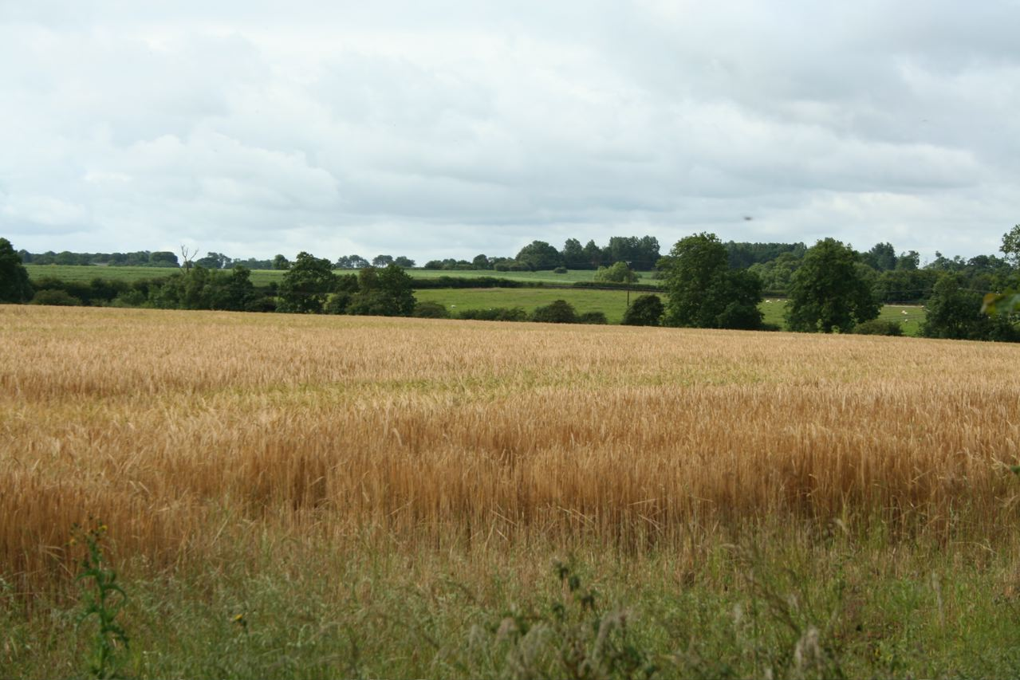
Typical view of mixed agricultural landscape with a strong hedgerow pattern and arable
use away from the villages.

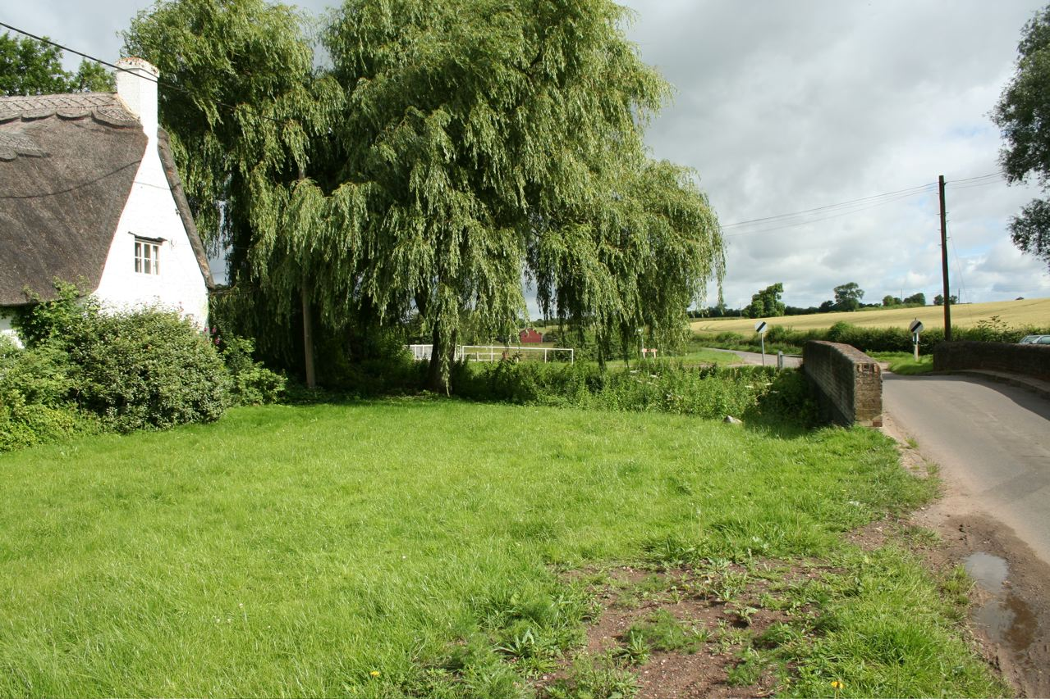

Thatched house on the north edge of Thornborough.

LCA 4.4 Thornborough-Beachampton Great Ouse Tributaries (LCT 4)

Summary of Condition/Sensitivity Analysis

Condition |  | Very good
Pattern of elements:  Visual detractors:  Visual unity:  Cultural integrity:  Ecological integrity:  Functional integrity: |  | Coherent  Few  Unified  Good  Moderate  Strong
Sensitivity |  | Moderate
Distinctiveness:  Continuity:  Sense of place:  Landform:  Tree cover:  Visibility:  Guidelines |  | Distinct  Historic  Moderate  Apparent  Intermittent  Moderate  Conserve and Reinforce
Condition

The condition of the landscape is assessed as being very good. The pattern of landscape elements is coherent being held together by a generally intact historic hedgerow pattern. There are few visual detractors. The cultural integrity is considered to be good being strongest in association with the well preserved historic villages, the small fields of pasture on their edges and the large areas of medieval earthworks. It is weaker where the hedgerow pattern in being eroded in more intensively managed arable areas. Ecological integrity is moderate despite strong connectivity because of the relatively low areas of designated sites and habitats of District significance. The combination of a good cultural integrity and a moderate ecological integrity give the area overall a strong functional integrity.

Sensitivity

The area is considered as a whole to be of moderate sensitivity. This reflects the fact that it is a distinct landscape with good historic association and sense of continuity thus giving the area a moderate strength of character. The landform is apparent but not dominant and the tree cover is intermittent, giving the area a moderate level of visibility. This combination of a moderate strength of character and a moderate visibility gives the overall assessment of a landscape of moderate sensitivity.

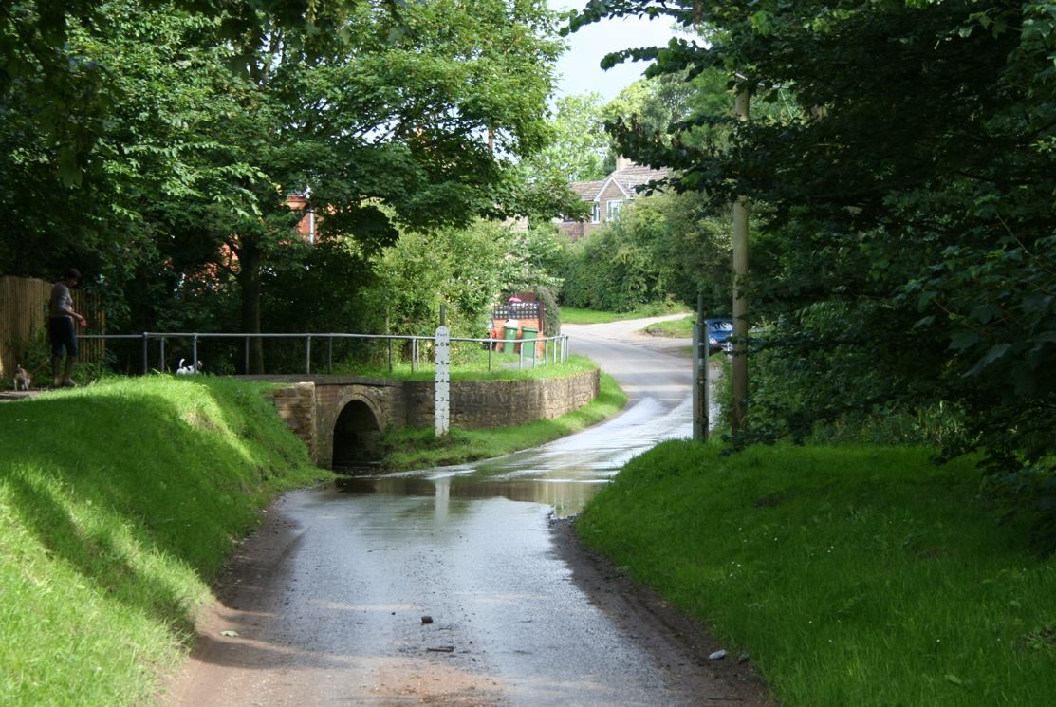

Thornborough has great visual interest associated with the watercourses. Here the ford
and raised pedestrian walkway create distinctive local character.

LCA 4.4 Thornborough-Beachampton Great Ouse Tributaries (LCT 4)

Landscape Guidelines Conserve and Reinforce

The landscape guidelines for Thornborough-Beachampton Great Ouse Tributaries are as follows:

- Encourage the restoration of the historic hedgerow pattern where it has been lost to enhance the landscape character and strengthen habitat connectivity. Where necessary use historic maps to identify where hedgerows have been lost.
- Maintain and improve the condition of existing hedgerows through traditional cutting regimes.
- Promote the use of new woodland planting to mitigate the visual impact of pylon lines.
- Maintain the condition and extent of woodlands using traditional techniques to create and manage a wide diversity of habitats.
- Maintain the condition and extent of neutral grassland wherever possible. Encourage good management practices.
- Maintain connectivity of habitats.
- Encourage landowners to improve ecological diversity by establishing and maintaining varied land maintenance regimes to benefit landscape and habitats.
- Encourage the conservation and interpretation of the areas rich historic environment.
- New housing and alterations to existing housing should be designed to reflect the traditional character of the area and use locally traditional materials.
- Promote good pond management to encourage a wide diversity of habitats.
- Promote the retention of the character of minor roads by the management of hedgerows and verges and limiting urbanising elements such as signage and kerbing.
- Ensure the preservation of archaeological earthworks by maintaining grassland.

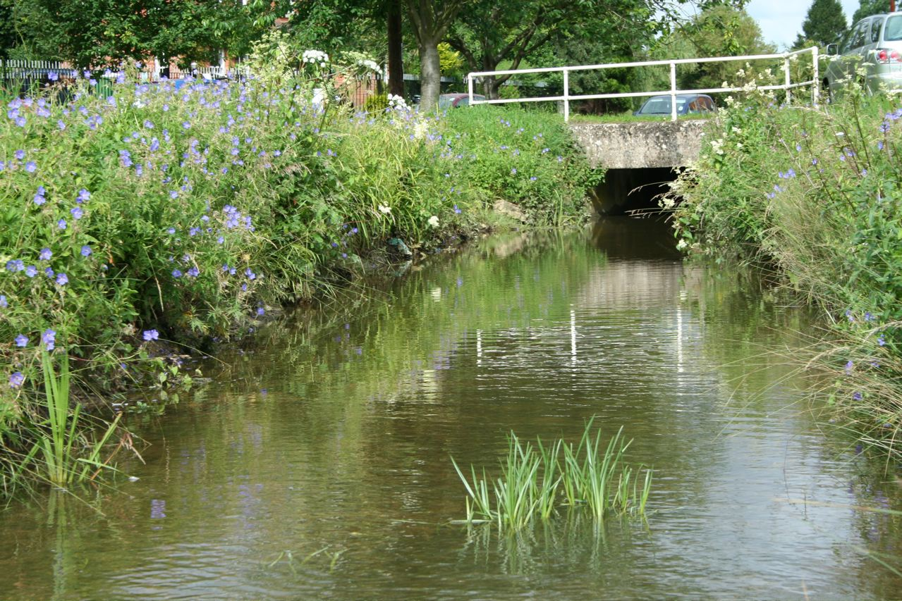

Open streams are a feature of Thornborough and Beachampton.

