LCA 4.2 Preston Bissett Plateau Edge

Landscape Character Type: LCT 4 Undulating Clay Plateau

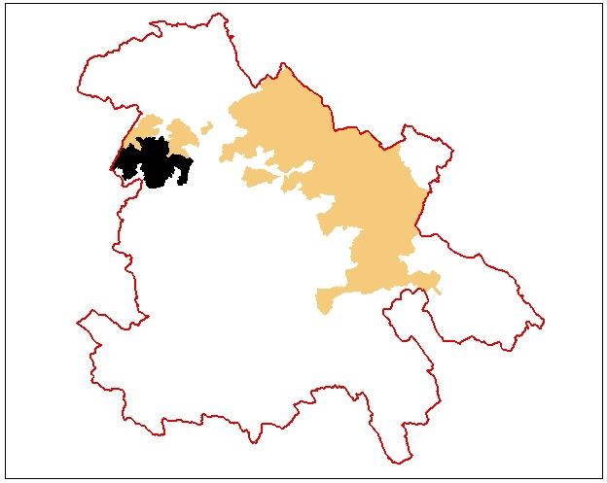

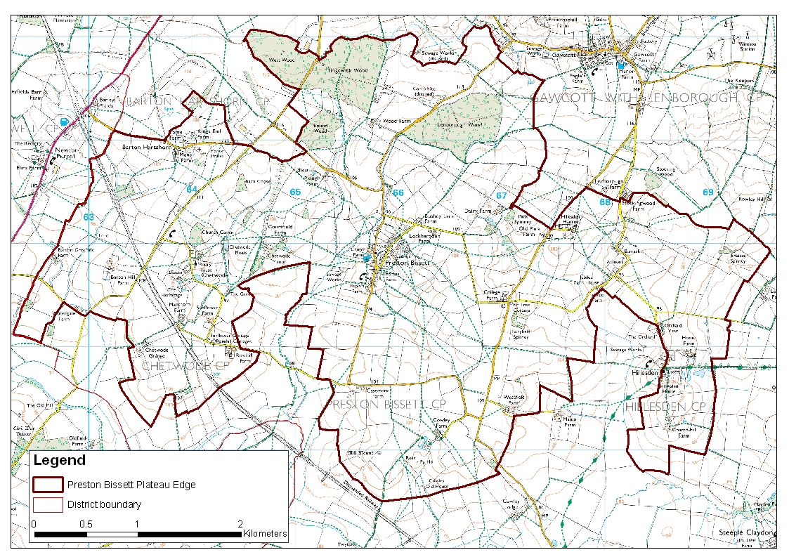

LCA 4.2 Preston Bissett Plateau Edge (LCT 4)
Key Characteristics  - Gently sloping ground  - Incised by several shallow stream valley  - Large woodlands in the north of the area  - Hedgerows generally strong and clipped  - Pre-18th century fields  Distinctive Features  - Disused railway line  - Oak as hedgerow tree particularly in the north  - Large limestone houses  - Hillesden Church and Chetwode Priory  - Medieval archaeological sites  - Small village and hamlet conservation areas  - Tingewick Meadows SSSI  - Neutral pasture  - Large blocks of woodland  - Fen  Intrusive Elements  - Pylon lines | Location Located on the western edge of the county to the southwest of Buckingham. The higher flatter more open and disturbed ground in the north runs into Tingewick Plateau LCA 4.1. To the south the land starts to fall more steeply to form part of Twyford Vale LCA 5.4  Landscape character High ground which predominantly slopes from north to south with the strongest slopes in the south. The land use is variable with several large woodlands, but predominantly mixed farming. Generally an open landscape but close to settlement nestled in streamlines the character becomes more intimate and enclosed. The historic settlements are a feature of the area as are several large limestone houses. There are significant views out from the south over the Twyford Vale LCA 5.4. A quiet agricultural area with a strong sense of history associated with interesting settlements and historic houses with small areas of parkland.  Geology Glacial till with small pockets of undifferentiated glacial deposits. Exposures of Kellaways Formation and Peterborough Member (both types of mudstone) in the west and south.  Topography High ground sloping gently from north to south and incised by a number of tributary streams of the Padbury Brook creating distinctly lower and undulating areas. The lowest ground occurs at the top of Twyford Vale at around 80m AOD with the highest ground close to Tingewick Plateau and Gawcott Ridge is around 110m AOD.  Hydrology The gently sloping plateau edge is incised by a number of streams draining the area from north to south. The most distinct streamline is to the west of Preston Bissett. The streams are often quite straight but this larger stream meanders significantly. Small ponds adjacent to farms are a feature of the area.  Land use and settlement This is a mixed agricultural landscape predominantly grassland with a moderate level of woodland cover. The settlement is concentrated in the south of the area in a dispersed pattern with many vernacular houses, a large number of which are limestone. Roads along the higher ground are straight and fast whilst within the lower streamlines the roads meander around the settlements creating a very different character.  Tree cover The large woodlands in the north and scattering of small woodlands elsewhere give a moderate level of woodland cover for the area as a whole. The concentration of woodlands in the north and around Chetwode gives a distinctly wooded character. The hedgerow trees are predominantly oak particularly in the north; elsewhere the cover is variable being weaker in areas of arable farming in the southeast.  Biodiversity The area is predominantly agricultural and contains the mix of arable and improved grassland habitats common to most parts of the District. Some of the grassland in the centre, far north and far west is however neutral or neutral lowland meadow, and a relatively high proportion of grassland in the south is unimproved.  In this area the dominance of agricultural habitats is offset by woodland habitats including large blocks of coniferous, broadleaved, mixed and yew, and lowland deciduous woodland in the north, and smaller fragments elsewhere. Much of the woodland is designated as a CWS or BNS and the major blocks of Round Wood, Lenborough Wood, Tingewick Wood and West Wood are ancient woodlands. The latter includes a superb wet community of plants.  In addition there is Tingewick Meadows SSSI one of the last remnants of old meadowland in north Buckinghamshire which is located in close proximity to the ancient woodlands. Areas of fen, marsh and swamp are also present in the eastern half.  The range and good connectivity between habitats and their significance makes this area of strong significance in biodiversity terms.  Historic environment This area was part of Bernwood Forest in the 12th century but was disafforested in the 13th century. Medieval archaeology is well represented with the site of Chetwode Priory, a hermitage, shrunken and deserted settlements and ridge and furrow. Hillesden House was besieged and destroyed during the English Civil War and its successor demolished in the 18th century. About half this area retains features of a pre 18th century landscape including ancient woodland and enclosures, four small parklands, fossilised strips and one meadow and a tiny village green. There is very little 18th and 19th century influence but recent hedgerow removal has created prairie farming and new enclosure in about a third of the area. There are conservation areas containing clusters of listed buildings at Chetwode, Preston Bissett, Hillesden Church End and Hillesden Hamlet. The churches at Chetwode and Hillesden are particularly fine, the latter being in a lavish entirely Perpendicular style set in a prominent position.  Designations  Conservation Areas at Hillesden Church End, Hillesden Hamlet, Preston Bissett and Chetwode  Archaeological Notification Areas – 29 No.  SSSI: Tingewick Meadows  CWS – 7 No.  BNS – 9 No.

LCA 4.2 Preston Bissett Plateau Edge (LCT 4)

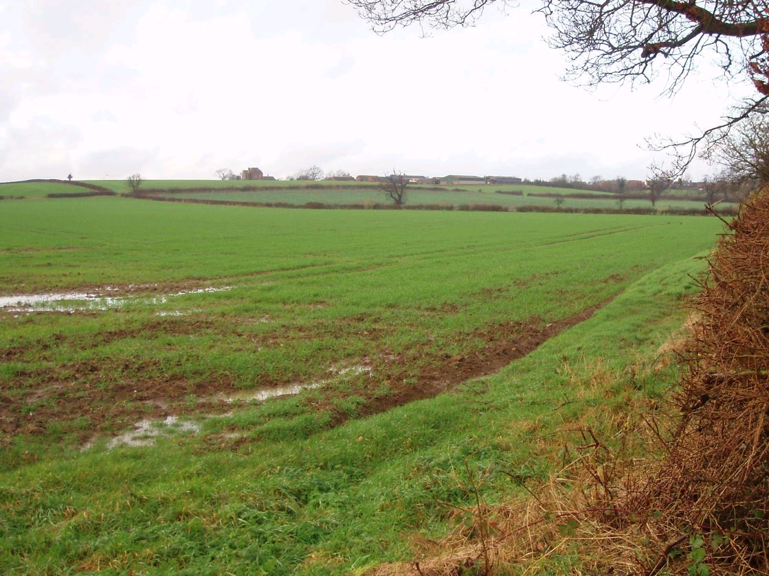

The hedgerow pattern is very important to the landscape character of the area without it

the landscape becomes very open and slightly bleak.

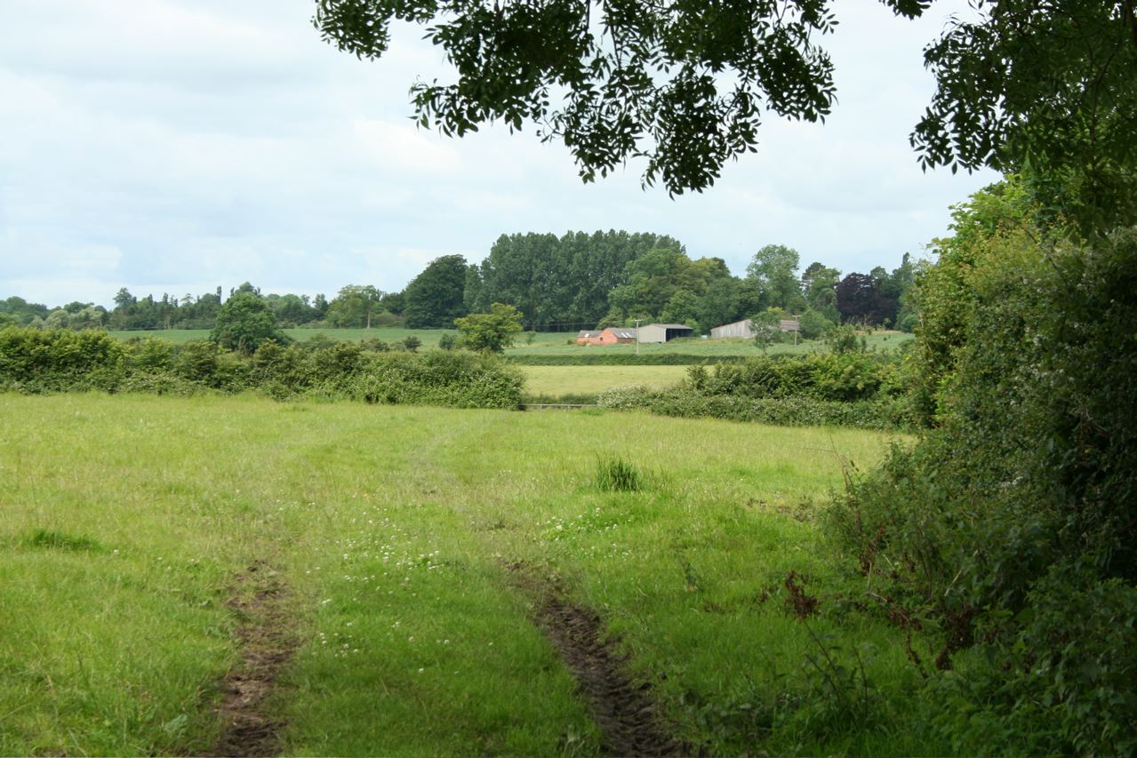

The area has a mixed agricultural landscape, predominantly grassland with a
moderate level of woodland cover.

LCA 4.2 Preston Bissett Plateau Edge (LCT 4)

Summary of Condition/Sensitivity Analysis

Condition |  | Very good
Pattern of elements:  Visual detractors:  Visual unity:  Cultural integrity:  Ecological integrity:  Functional integrity: |  | Unified  Few  Strongly unified  Variable  Strong  Strong
Sensitivity |  | Moderate
Distinctiveness:  Continuity:  Sense of place:  Landform:  Tree cover:  Visibility:  Guidelines |  | Distinct  Historic  Moderate  Apparent  Intermittent  Moderate  Conserve and Reinforce
Condition

The landscape is generally in a very good condition. It is unified by the hedgerow pattern and scattered historic settlement. There are few visual detractors making this a strongly unified landscape. The cultural integrity is considered to be variable the historic settlements are generally in good condition but the hedgerows are very variable with some loss to prairie farming and many becoming gappy with few hedgerow trees. Ecological integrity is strong due to good connectivity and large areas of designated sites and habitats of District significance. This combination of a variable cultural integrity and a strong ecological integrity give the area overall a strong functional integrity

Sensitivity

The landscape of this area is distinct with a good sense of historic continuity. This combination produces a landscape with a moderate strength of character overall. The landform is apparent but not a dominant feature. The tree cover is considered to be intermittent over the area as a whole although in some areas and particularly in the north, there is sufficient woodland cover to create an enclosed landscape in places. The apparent landform and the intermittent tree cover create a landscape with a moderate sense of visibility. Overall the moderate sense of place and the moderate visibility combine to create a landscape of moderate sensitivity.

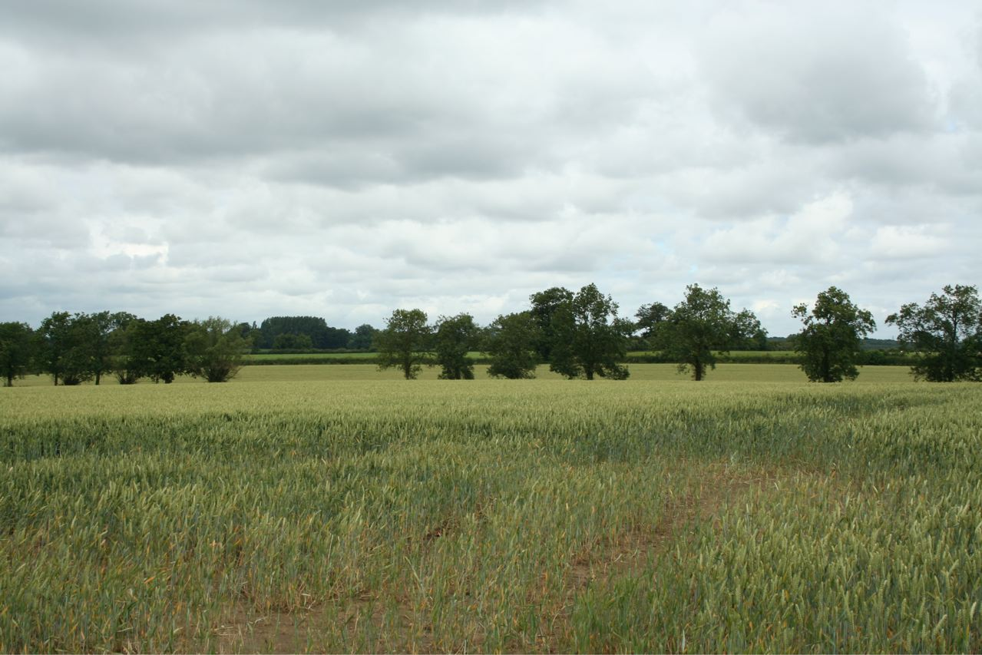

The south of the area is generally more open but large hedgerow trees remain a feature of the landscape.

LCA 4.2 Preston Bissett Plateau Edge (LCT 4)

Landscape Guidelines Conserve and Reinforce

The landscape guidelines for the Preston Bissett Plateau Edge are as follows:

- Encourage the restoration of the historic hedgerow pattern where it has been lost. To enhance the landscape character and strengthen connectivity of habitats. Where necessary use historic maps to identify where hedgerows have been lost.
- Maintain and improve the condition of existing hedgerows through traditional cutting regimes.
- Encourage the establishment of new hedgerow trees particularly in the south east of the area.
- Promote the use of new woodland planting to minimise the impact of pylon lines.
- Maintain the condition and extent of woodlands using traditional techniques to create and manage a wide diversity of habitats.
- Maintain the condition and extent of neutral grassland - encourage good management practices.
- Maintain connectivity of habitats.
- New housing and alterations to existing housing should be designed to reflect the traditional character of the area and use locally traditional materials.
- Promote the retention of the character of minor roads by the management of hedgerows and verges and limiting urbanising elements such as signage and kerbing.
- Identify key views from publicly accessible locations and ensure these views are retained and enhanced.
- Ensure the preservation of archaeological earthworks by maintaining grassland
- Promote heritage of historic settlements.

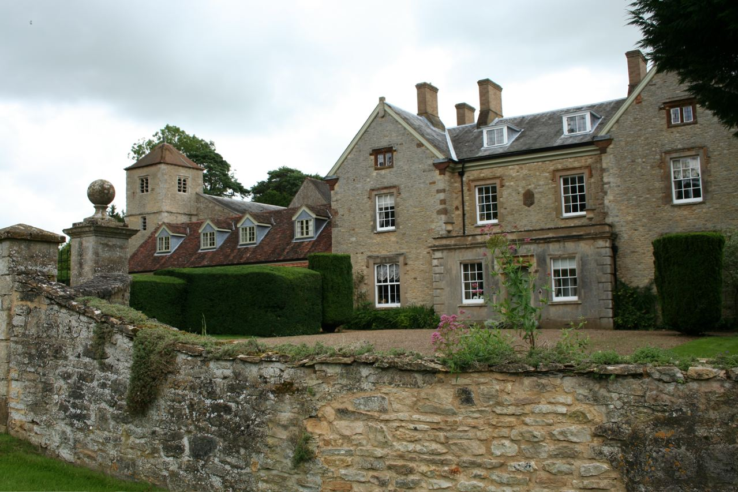

Large historic houses built of local limestone are a distinctive feature – this is at Barton Hartshorn. Parts of the church in the background are thought to date from the 13th Century.

