LCA 2.1 Westbury-Biddlesden Great Ouse Valley

Landscape Character Type: LCT 2 Incised Valleys

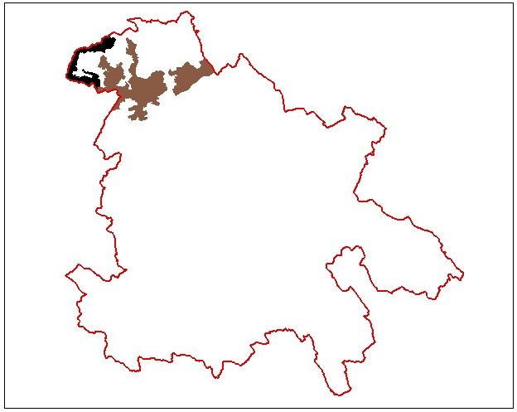

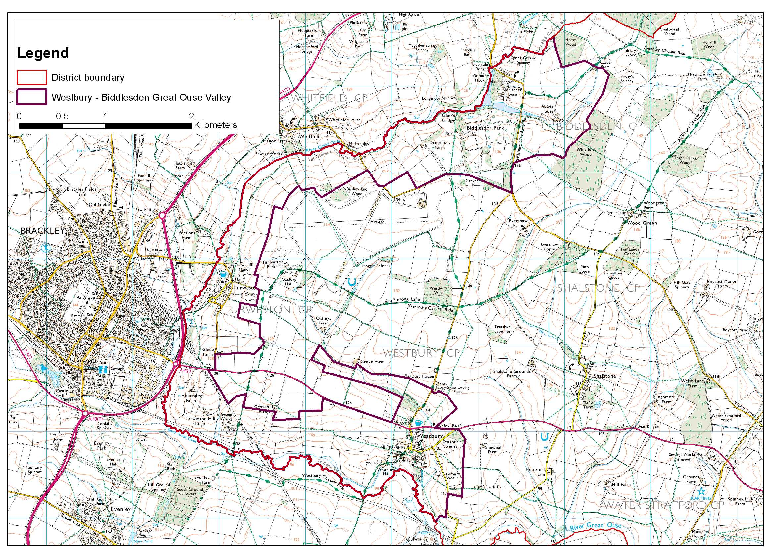

LCA 2.1 Westbury-Biddlesden Great Ouse Valley (LCT 2)

Key Characteristics  - Left side of the Great Ouse valley  - Steeply sloping undulating ground  - Narrow floodplain  - Mixed agricultural landscape with arable, pasture and woodland  - Wide range of field size  - Small woodland blocks  - Low level of woodland cover  - Pre 18th century meadows adjacent to the river  - Tranquil close to the river  Distinctive Features  - Disused railway line  - Biddlesden Park  - Park at Westbury  - Historic villages and mill buildings adjacent to river  - Areas of purple moor grass rush pasture and fen.  Intrusive Elements  - A422 Brackley Road  - Pylon line  - A43 along western boundary  - Sewage works | Location The left side of the Great Ouse valley in the extreme northwest of the District where the county boundary follows the river. The area is long and narrow located between the river and the LCT 1 Wooded Ridge. The A422 crosses the southern parts.  Landscape character There is a generally enclosed character, which close to the valley floor and the meandering river feels remote and tranquil and has much visual interest associated with bank side vegetation, historic buildings and bridges. The upper valley sides afford long distance views mainly to the south and west. Scattered small woodlands enhance the sense of enclosure, particularly around Biddlesden.  The historic parkland at Biddlesden is a notable feature although most of the parkland is screened from the wider landscape by surrounding woodland. There are several notable buildings, including Abbey House near Biddlesden, which add visual interest to the landscape. The valley has a higher level of settlement than in most of the adjacent countryside.  The A422 and its junction with the A43 on the edge of the area are discordant elements within a generally harmonious agricultural landscape with strong historic associations.  Geology Glacial till on plateau top. Eroded valley side with varying types of limestone exposures. Sand formations, mudstone and alluvium deposits in valley bottom.  Topography The valley has a narrow bottom and consistently steep undulating sides. Close to Westbury and Biddlesden streams have cut into the valley sides. At Biddlesden this has created a more open rolling landscape but at Westbury it has created a very narrow steep sided valley. Elevation ranges from 95-135m AOD.  Hydrology The hydrology is dominated by the meandering course of the Great Ouse, which is joined by two small tributaries at Westbury and at Biddlesden. The river flows south westwards above Brackley (in Northamptonshire) but then to the east of the town takes a dramatic turn to flow eastwards towards Buckingham. The parkland at Biddlesden includes lakes created by damming the stream. There are also several small lakes in the tributary valley to the east of Westbury. Several springs emerge close to the river.  Land use and settlement The land use is mixed agriculture with a tendency to more grassland particularly close to the river and settlement where many small fields remain. Although the field pattern remains largely small or medium sized in some locations hedgerows have been removed to create large arable areas.  The villages of Turweston and Westbury lie close to the valley floor and are significantly larger than any of the other villages found close by. They both have areas of new housing around their historic core but retain a strong sense of their historic identity with vernacular buildings predominating. Around Biddlesden Park there are a few other dwellings forming a small settlement. The A422 cuts across the area in two places but elsewhere roads through the area are narrow meandering lanes, which are sometimes sunken.

LCA 2.1 Westbury-Biddlesden Great Ouse Valley (LCT 2)

Tree cover About 5% of the area is estimated to be woodland concentrated in the woodlands around Biddlesden. Elsewhere there is a light scattering of small woodland blocks.

Biodiversity Biddlesden Park a CWS, forms a large area of varied habitat in the north including woodland, a lake and parkland. Another CWS, - Turweston Manor Grassland is one of the most valuable areas of habitat within the area, providing a diversity of habitats including fen and unimproved grassland. Other interest includes a small area of purple moor grass rush pasture in the north, fragments of neutral grassland and areas of standing water in the far north and far south and the scattered broadleaved woodlands.

The Great Ouse, its tributaries and associated lakes are a broad habitat of District significance.

The remainder of the area is of lesser interest, largely grassland and arable habitats. The distribution is fairly uneven, with a tendency for fields of the same habitat type to be grouped. Grassland is largely improved however a relatively high proportion of unimproved grassland is found within the area compared with the rest of Aylesbury Vale. The hedgerows provide habitat connectivity.

Historic environment The northern part of this area was traversed by a Roman road along which there is evidence for settlement. Other prehistoric and Roman remains might be expected along the river valley, although there has been little investigation. The whole area was within the medieval royal hunting forest of Whittlewood, but disafforested before 1286. The features of most note include meadows adjacent to the river and historic settlement. About 75% of the area reflects the landscape pattern of early enclosure. In the remaining landscape the original enclosure pattern has been lost to prairie farming and small areas of new settlement, recreation and modern enclosure. Biddlesden Park was a former medieval deer park and part of Biddlesden Abbey, a Cistercian house founded in 1147. Historic buildings are concentrated in the villages of Westbury and Turweston, which are both conservation areas, and around Biddlesden House. Turweston is notable for its stone buildings.

Designations
Conservation Areas at Turweston and Westbury
Archaeological Notification Areas – 7 No.
CWS – 2 No.
BNS – 6 No.

LCA 2.1 Westbury-Biddlesden Great Ouse Valley (LCT 2)

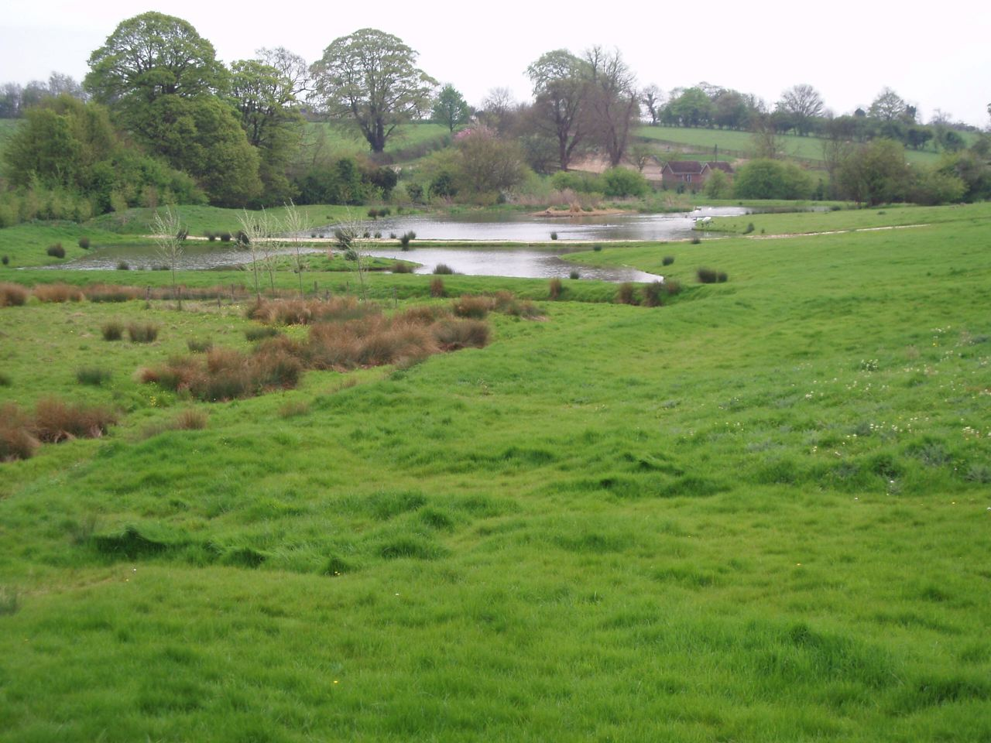

Looking south over small lakes in the tributary valley to the east of Westbury.

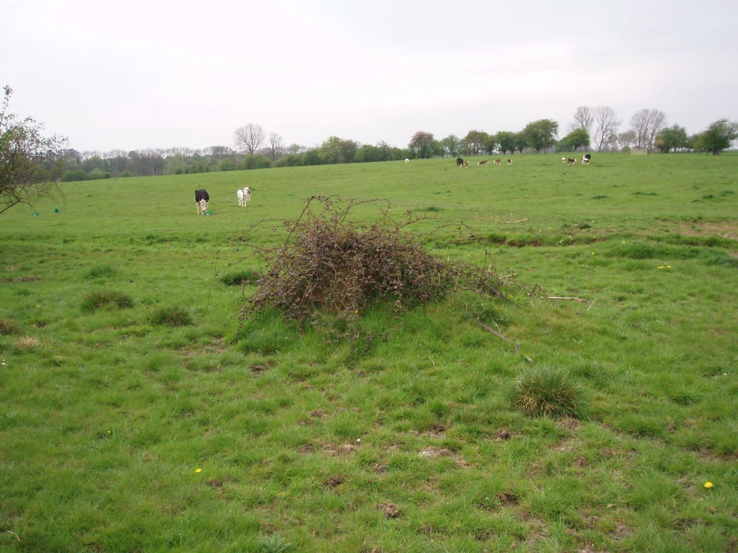

Pasture on gently sloping valley sides - both hedgerows and landform enclose the view.

LCA 2.1 Westbury-Biddlesden Great Ouse Valley (LCT 2)

Summary of Condition/Sensitivity Analysis

Condition |  | Very Good
Pattern of elements:  Visual detractors:  Visual unity:  Cultural integrity:  Ecological integrity:  Functional integrity: |  | Coherent  Few  Unified  Variable  Strong  Strong
Sensitivity |  | Moderate
Distinctiveness:  Continuity:  Sense of place:  Landform:  Tree cover:  Visibility:  Guidelines |  | Distinct  Historic  Moderate  Apparent  Intermittent  Moderate  Conserve and Reinforce
Condition

The landscape in this area is assessed to be in very good condition. There is a coherent pattern of elements with a good hedgerow network and small woodlands and streams. There are few visual detractors in the area, as a whole the greatest visual intrusion tends to be associated with roads and road junctions just of the county boundary to the west. The cultural integrity is considered to be variable. This reflects the fact that the historic field pattern has generally been retained and the settlement, riverbanks and parkland give a strong sense of historic continuity to much of the area. However recognition of archaeological interest and promotion of heritage is less well developed. Ecological integrity is strong due to good connectivity and large areas of priority habitat types. The combination of good variable cultural integrity and strong ecological integrity combine to give an area, which is assessed as having a strong functional integrity.

Sensitivity

This is a distinct landscape of part of a small valley with good historic associations giving a good sense of historic continuity. This gives the area a moderate sense of place. The landform is apparent but is not a dominant feature in the landscape character of the area. The tree cover is intermittent being generally stronger closer to the river. This produces a landscape of moderate visibility where the views are generally more open from the upper slopes and more enclosed closer to the valley floor. The combination of moderate visibility and moderate sense of place give a moderate sensitivity.

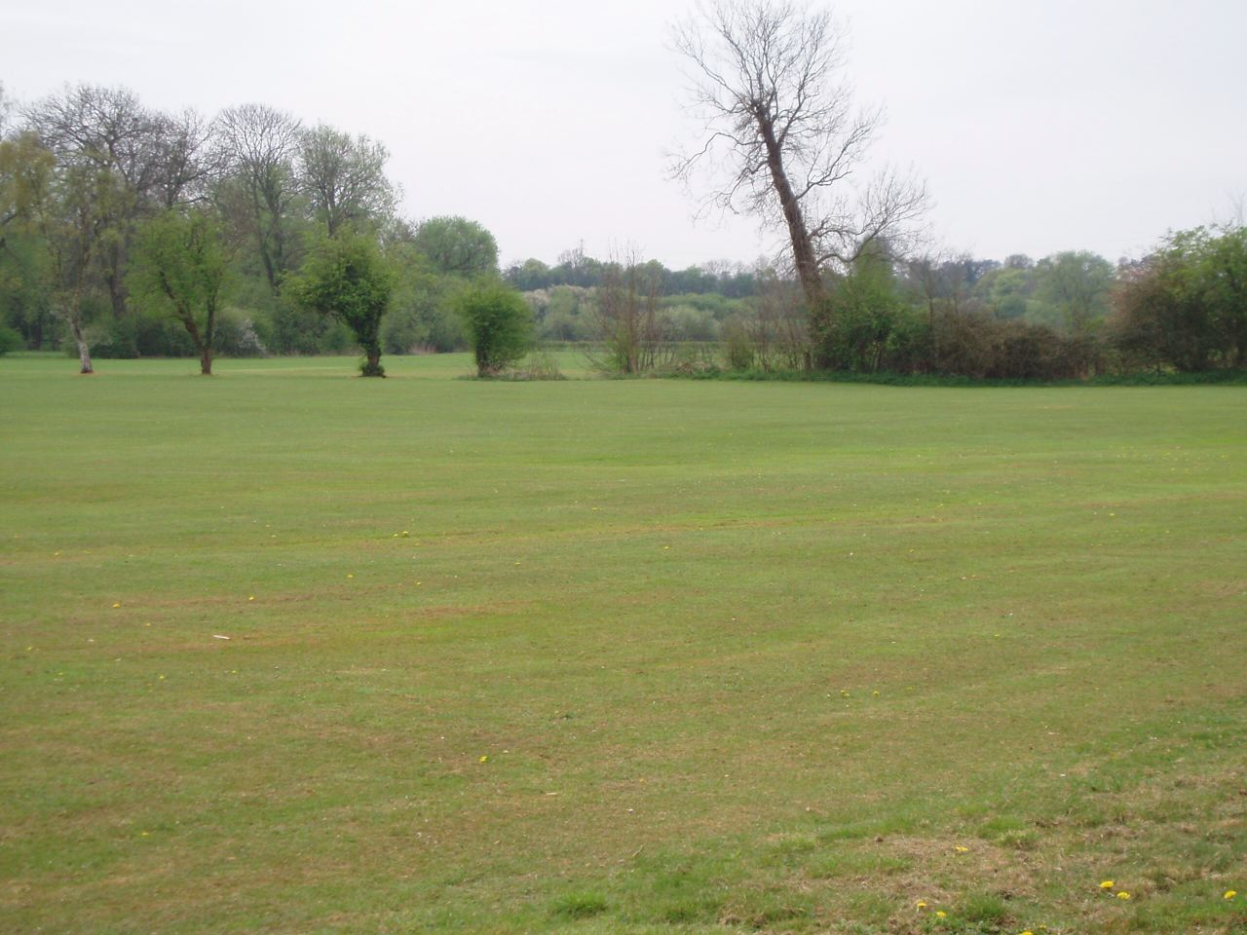

Flat public recreational area on the valley floor south of Westbury.

LCA 2.1 Westbury-Biddlesden Great Ouse Valley (LCT 2)

Landscape Guidelines Conserve and Reinforce

The landscape guidelines for the Westbury-Biddlesden Great Ouse Valley are as follows:

- Encourage the retention and strengthening of the existing historic hedgerow pattern with new hedgerow trees.
- Encourage the restoration of the historic hedgerow pattern where it has been lost. To enhance the landscape character and strengthen the ecological diversity. Where necessary use historic maps to identify where hedgerows have been lost.
- Encourage the management of hedgerows through traditional cutting regimes.
- Maintain the extent and condition of woodland using traditional techniques to create and manage a wide diversity of habitats.
- Support and promote the identity of the medieval hunting forest of Whittlewood with new planting, access and interpretation.
- Maintain the extent and condition of unimproved and semi-improved grassland. Encourage good management practices.
- Improve the management of historic meadows and pastures.
- Close to watercourses promote the use of permanent pasture, with low stocking density and flooding regimes to promote biodiversity and landscape enhancement.
- New housing and alterations to existing housing should be designed to reflect the traditional character of the area and use locally traditional materials.
- Promote the survey, retention and restoration of historic parkland around Biddlesden.
- Promote the retention of the character of minor roads by the management of hedgerows and verges and limiting urbanising elements such as signage and kerbing.
- Maintain the extent and condition of purple moor grass rush pasture.
- Maintain the extent and condition of fen.
- Maintain the extent and condition of parkland.

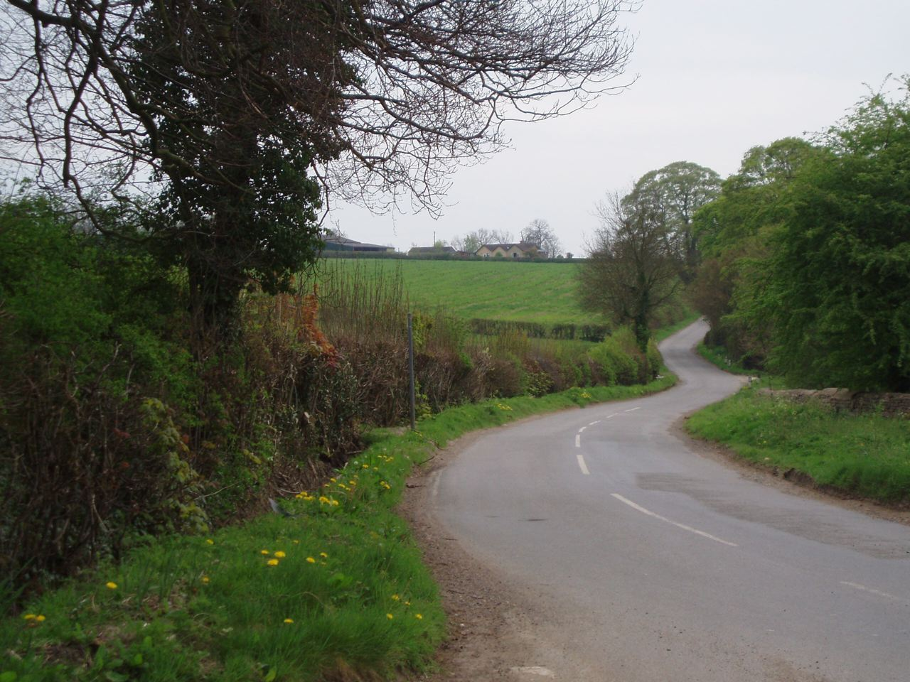

Meandering lane rising up the valley side east of Westbury.

