LCA 10.5 Drayton Manor Chalk Slopes

Landscape Character Type: LCT 10 Chalk Foothills

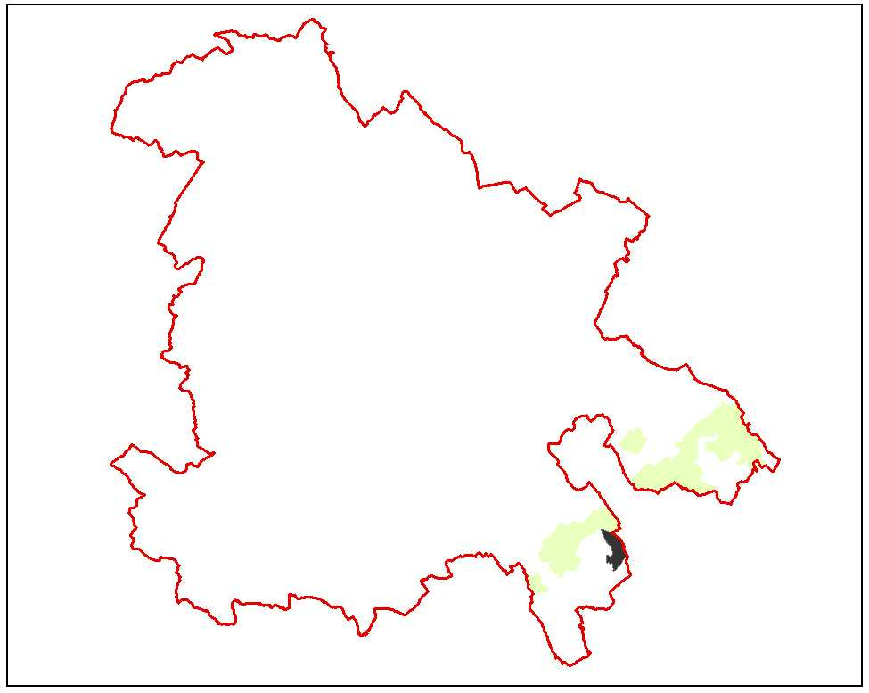

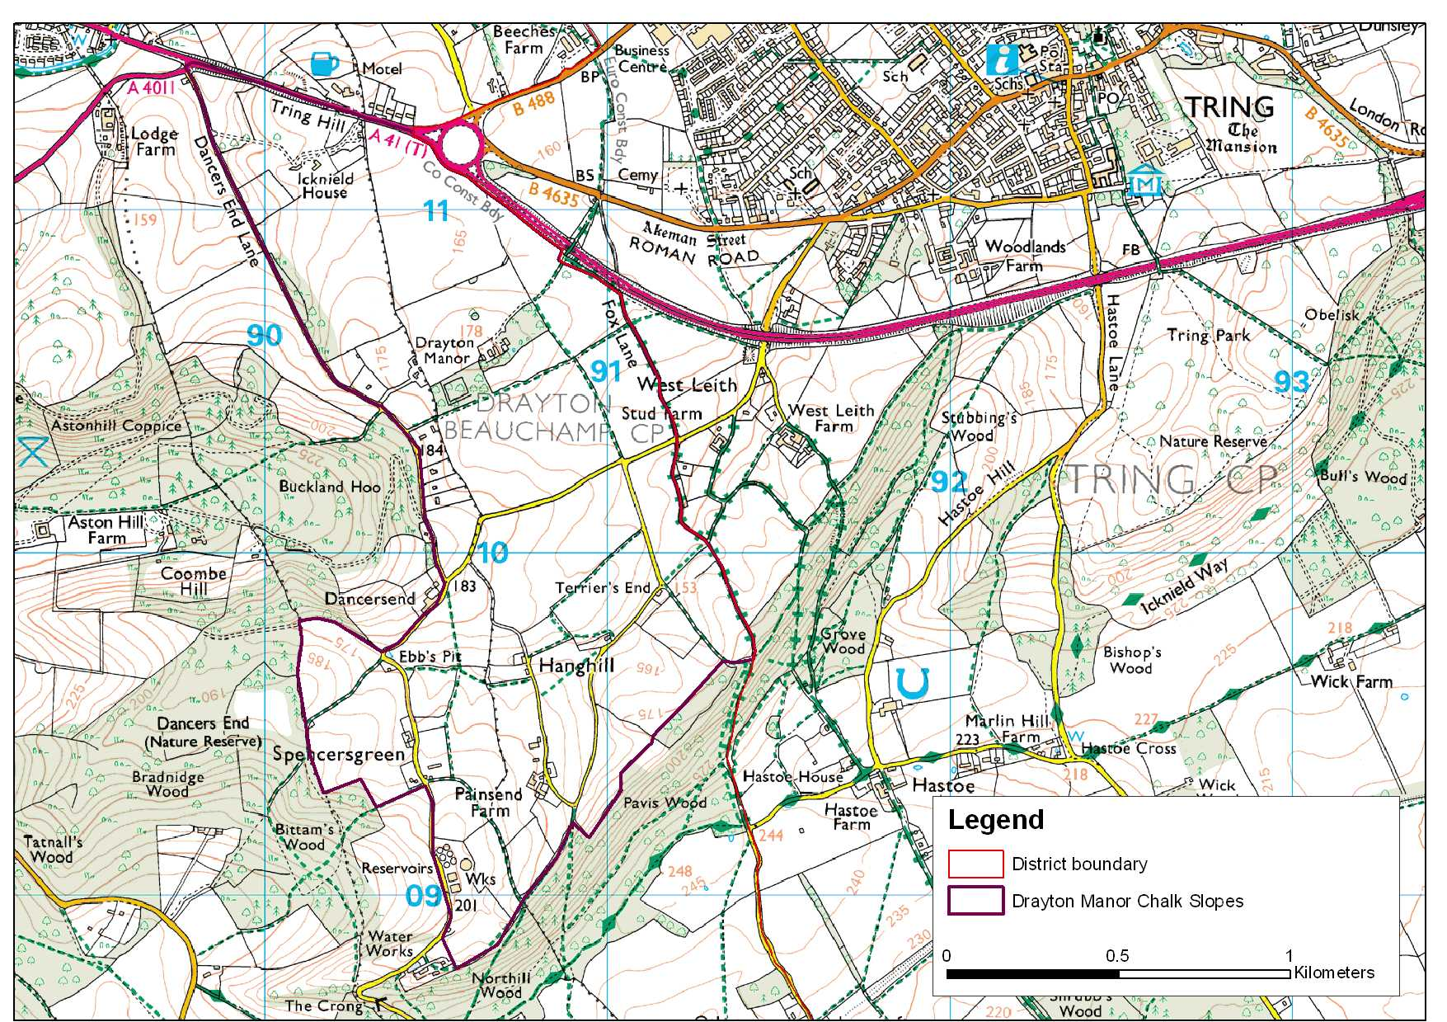

LCA 10.5 Drayton Manor Chalk Slopes (LCT 10)
Key Characteristics  - Sloping chalk downland  - Narrow winding, sunken lanes  - Dispersed farmsteads and settlements  - Open area with views over Tring  - Arable land use on the lower, shallower slopes  - Grazing land on steeper slopes  - Ancient coaxial fields and lanes  Distinctive Features  - Drayton Manor Grounds (Parkland)  - A41 Roman Road in a chalk cutting  - Large arable field parcels on the lower slopes  - Smaller irregular shaped field parcels on upper slopes  - Calcareous grassland  Intrusive Elements  - Water storage facilities  - Tring junction of the A41 Aston Clinton Bypass | Location The area lies to the east of Aston Hill on the lower slopes facing the town of Tring. The eastern boundary follows the county boundary. The northern boundary is defined by the A41 at Tring Hill whilst the southern boundary extends to the scarp face south of Painsend Farm.  Landscape character Foothills below scarp, land falls away to the ‘Tring Gap’ in the east. Views over town of Tring (outside the County). Small irregular shaped parcels of grazing land especially on the higher slopes. Narrow lanes climbing up the hill slopes and to provide access to properties/farmsteads. Area defined to west and south by woodland on scarp slopes. Northern boundary defined by A41 Roman road and new bypass junction.  Geology The area is predominantly underlain by the middle chalk. The very northern tip encroaches onto the lower deposit of West Melbury marly chalk.  Topography The land falls west to east. The chalk slope has been eroded into a network of steeper dry valleys. Drayton Manor stands on a shallow hill above the level of the surrounding slopes. The uppermost slopes on the western boundary reach a level of 190m AOD falling to 150m AOD at West Leith on the eastern boundary.  Hydrology The area has over time been eroded into a network of valleys which are now dry. There is an underground water reservoir at the southern tip.  Land use and settlement Mixture of arable and grassland land use. Distribution related to steepness of slopes. Dispersed farmsteads and larger dwellings are found along the upper slopes.  Tree cover No distinguishable woodland cover other than the parkland at Drayton Manor. Pockets of scrub tree cover (hawthorn) are found on western fringe.  Biodiversity The habitats of the area consist mostly of arable and some grassland, nearly all of which is improved, although a small area of calcareous pasture is present at the southern extremity. There are a few small stands of the broad habitat type of broadleaved, mixed and yew woodland. There are no aquatic habitats.  Pavis & Northill Wood SSSI including ancient woodland runs along the south eastern boundary just beyond the LCA boundary within LCA 11.1C, however a very small part only is included in the LCA.  Historic environment This is an ancient landscape. At the north end of the area there are coaxial enclosures, these are fields that have sinuous boundaries often defined by ancient lanes such as Fox Lane, and sub- divided into small elongated fields with species rich hedgerows. The antiquity of these coaxial field boundaries can be attested by the presence of the Roman road of Akeman Street (A41) which cuts through the boundaries at the northern end. Elsewhere the character of fields is more irregular, with pre 18th century enclosures found around the farmstead of Fiddlers and Spencers Green. The landscape has isolated areas of 20th century enclosure converting older fields into horse paddocks.  The settlement pattern of the area is very dispersed and, reflected in the ‘Green’ place names, the area consists entirely of isolated farmsteads or farmstead clusters. There are no listed buildings of note although the more interesting buildings are to be found at Drayton Manor and Dancers End Farm.
The area around the Roman road is of some archaeological sensitivity, the recent bypass on the A41 have revealed an Iron Age site and Saxon cemetery which may extend into this area.

Although there are no promoted routes the landscape has a high amenity value and part of the area is within the boundary of the Chilterns AONB.

Designations
Chilterns AONB
Archaeological Notification Areas – 1 No.
SSSI: Pavis & Northill Wood
BNS – 7 No.

LCA 10.5 Drayton Manor Chalk Slopes (LCT 10)

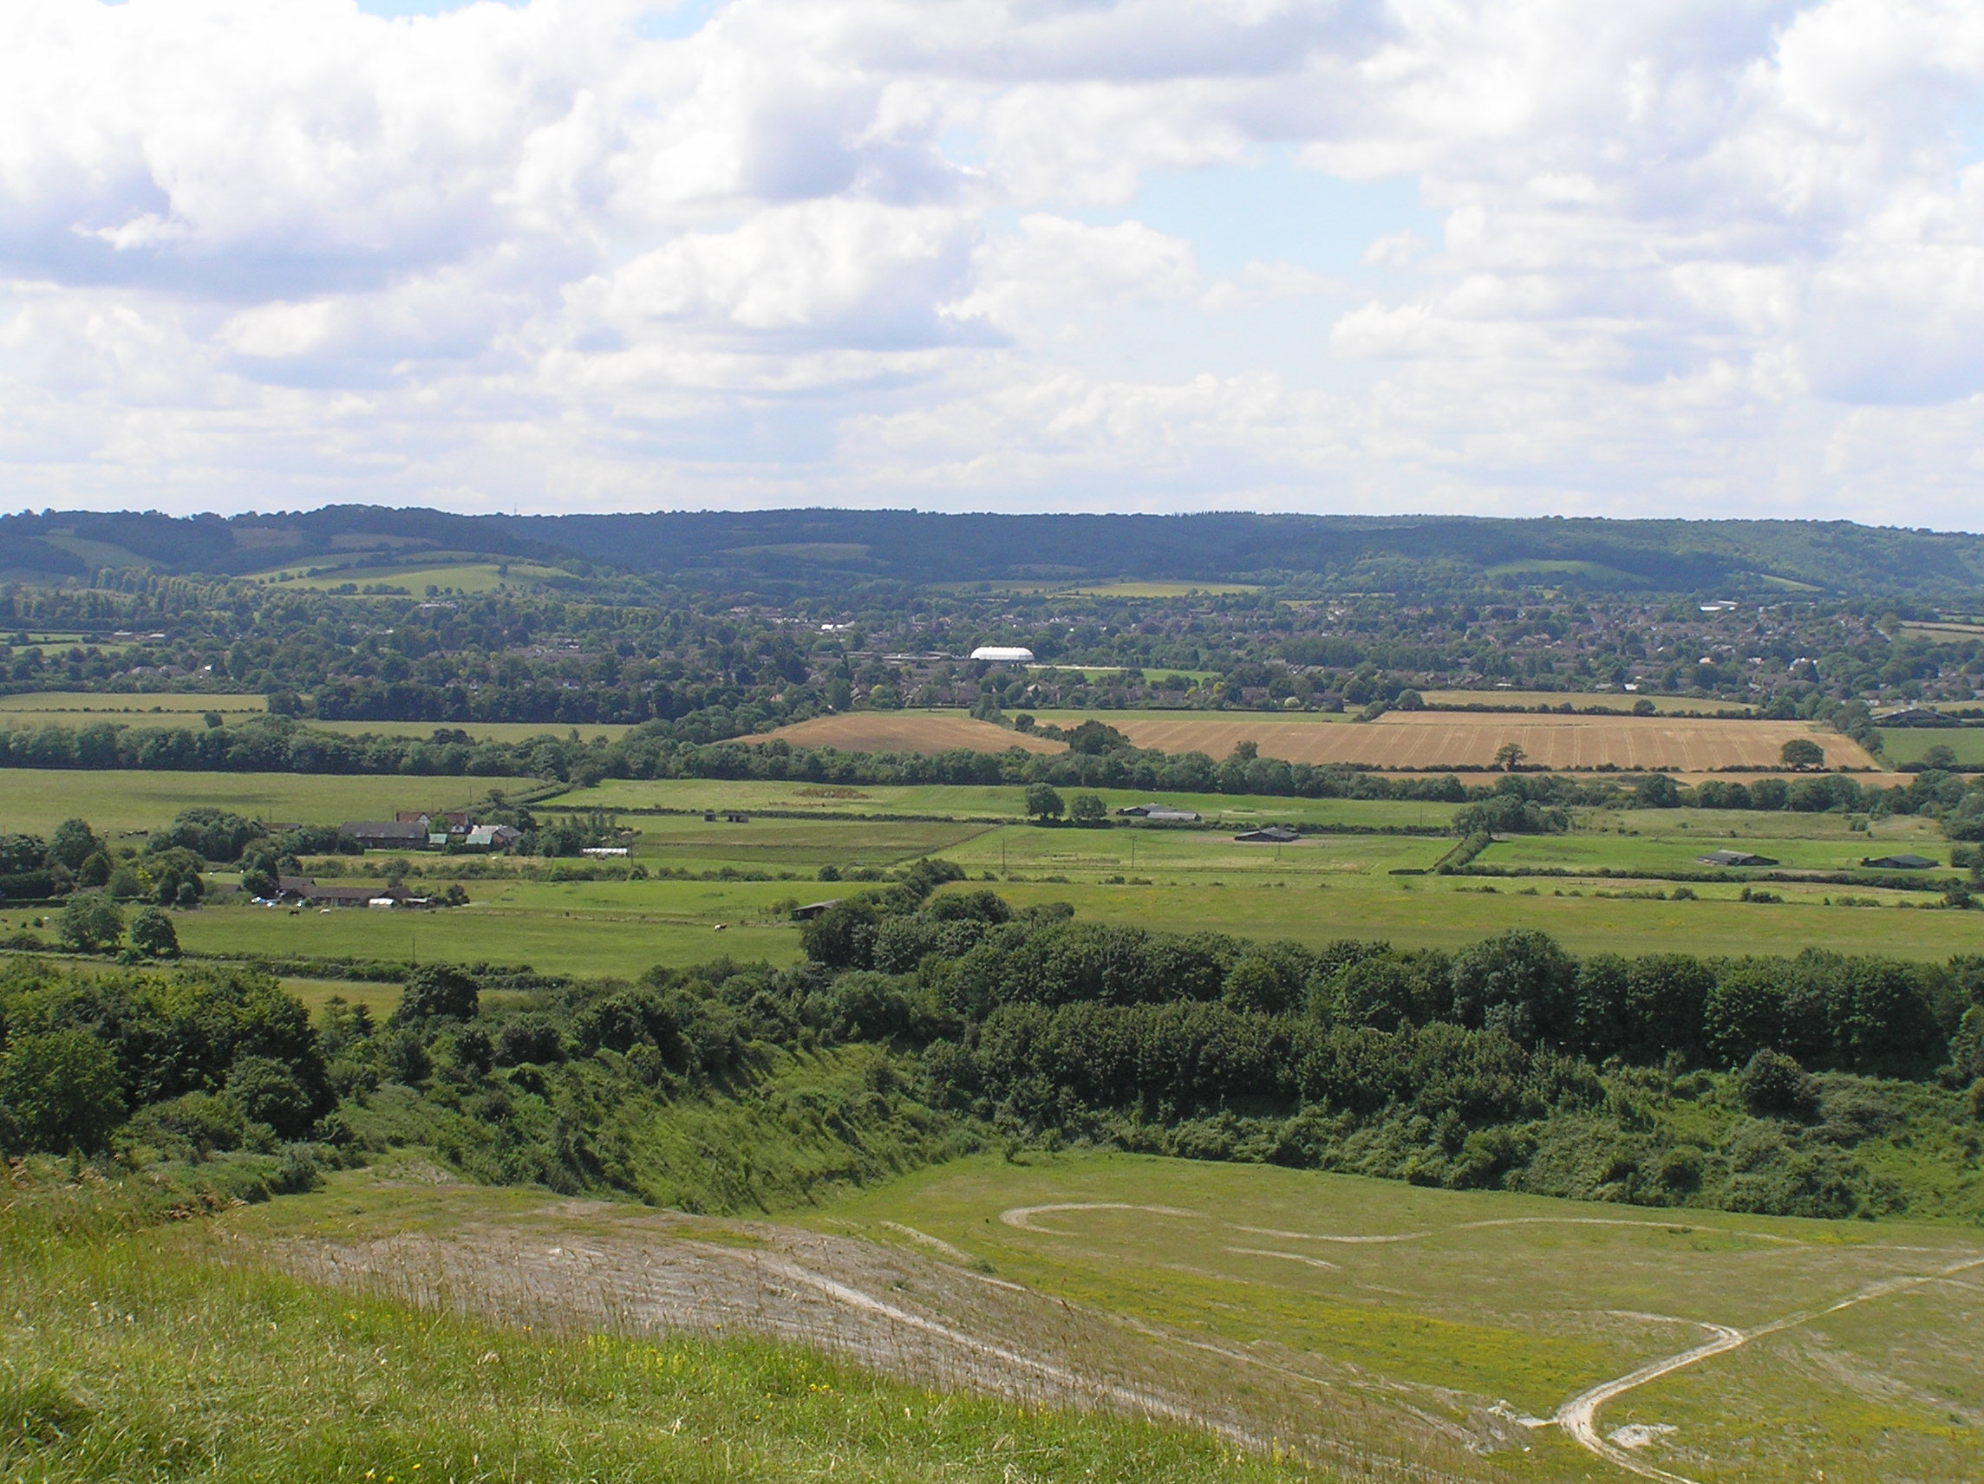

Drayton Manor slopes below scarp. View from Pitstone Hill.

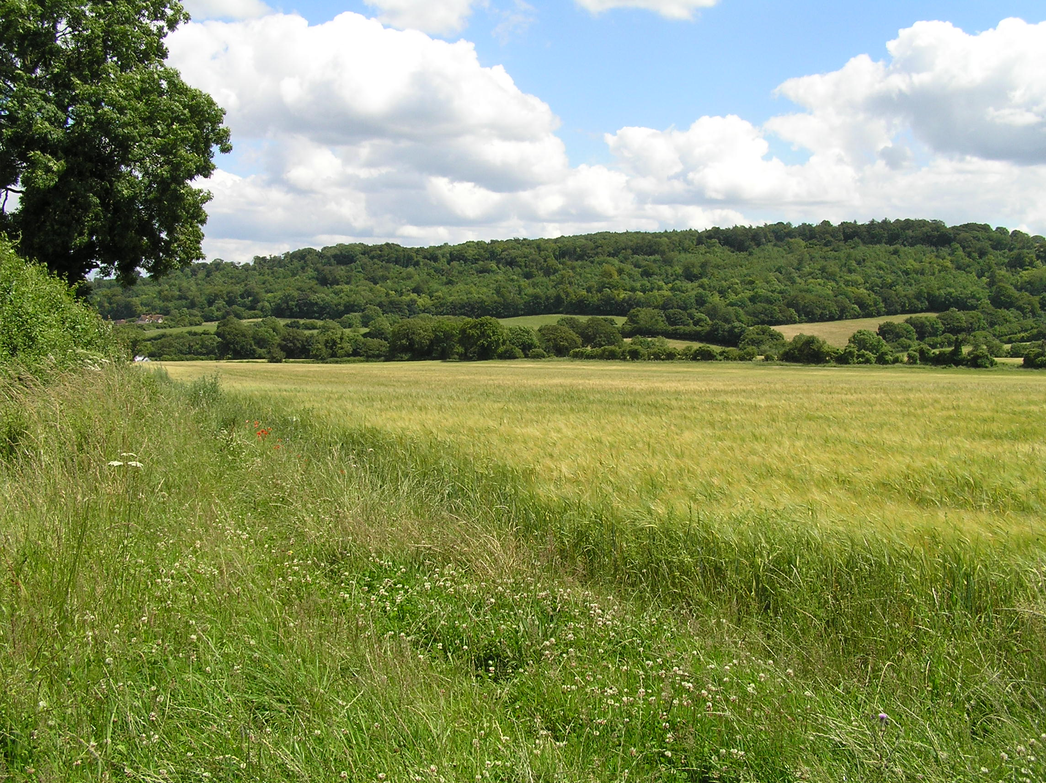

Valley south of Duckmore Lane.

LCA 10.5 Drayton Manor Chalk Slopes (LCT 10)

Summary of Condition/Sensitivity Analysis

Condition |  | Good
Pattern of elements:  Visual detractors:  Visual unity:  Cultural integrity:  Ecological integrity:  Functional integrity: |  | Unified  Few  Strongly unified  Variable  Moderate  Coherent
Sensitivity |  | High
Distinctiveness:  Continuity:  Sense of place:  Landform:  Tree cover:  Visibility:  Guidelines |  | Distinct  Ancient  Moderate  Dominant  Open  Very High  Conserve
Condition

Overall the condition of the landscape is considered to be good. The site lies below the Chiltern Scarp east of Aston Hill. There is a distinctive fall in the landform which drains from the scarp towards the Tring Gap in the east. The general pattern of elements is considered to be unified as the field pattern remains largely intact. Cultural integrity is rated as variable, although the landscape contains significant coaxial enclosures, there are few archaeological sites and historic settlements. The pattern of narrow winding lanes and ancient track ways remains largely intact. Ecological integrity is moderate due to high connectivity, and reasonable areas of designated sites and habitats of District significance compared to other parts of the District. Overall the functional integrity is coherent.

Sensitivity

The area has a distinctive character dominated by its steeply sloping landform. Overall the sense of place is considered to be moderate. The degree of visibility increases with elevation above the valley to the east. The area lacks tree cover and is more open than the heavily wooded scarp slope. Overall the degree of sensitivity is considered to be high.
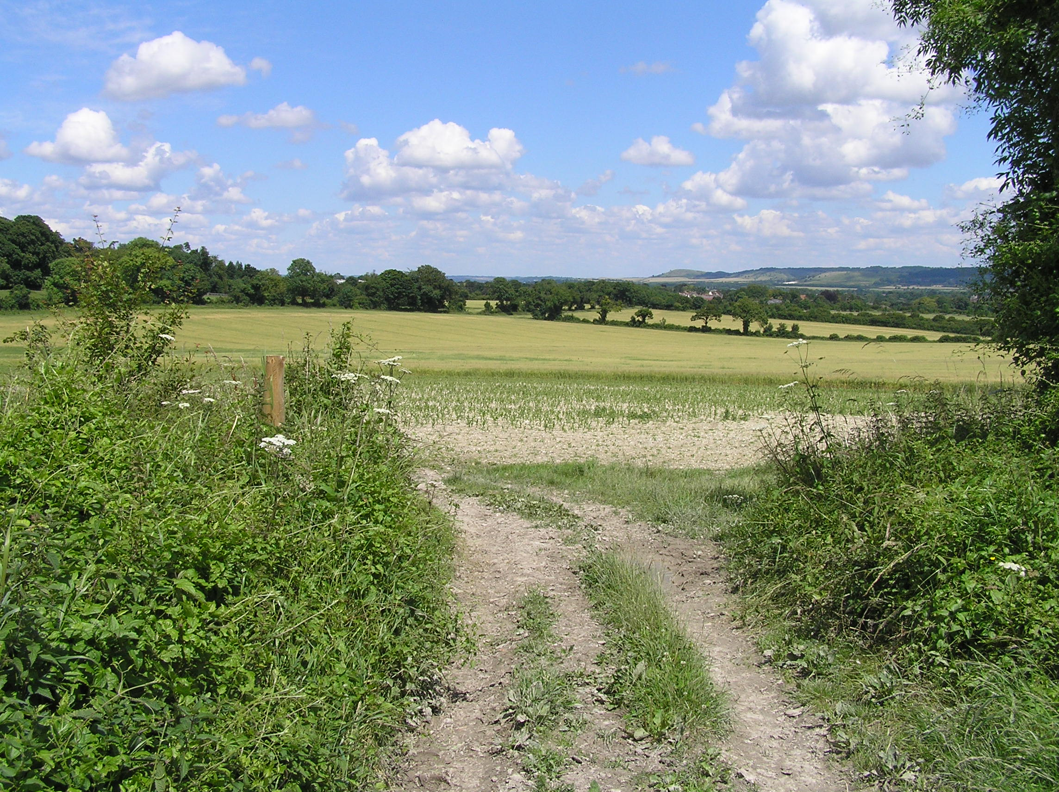

Fields north of Duckmore Lane.

LCA 10.5 Drayton Manor Chalk Slopes (LCT 10)

Landscape Guidelines Conserve

The landscape guidelines for Drayton Manor Chalk Slopes are as follows:

- Conserve the extensive network of hedgerows and tree cover.
- Maintain the condition and extent of calcareous, unimproved and semi-improved grassland wherever possible.
- Maintain connectivity of habitats.
- Conserve the existing field pattern.
- Conserve the character of narrow winding lanes.
- Preserve and manage rights of way to conserve pedestrian access and the extensive footpath network.
- Manage the areas of public access to contain excessive “wear and tear” at popular vantage points.

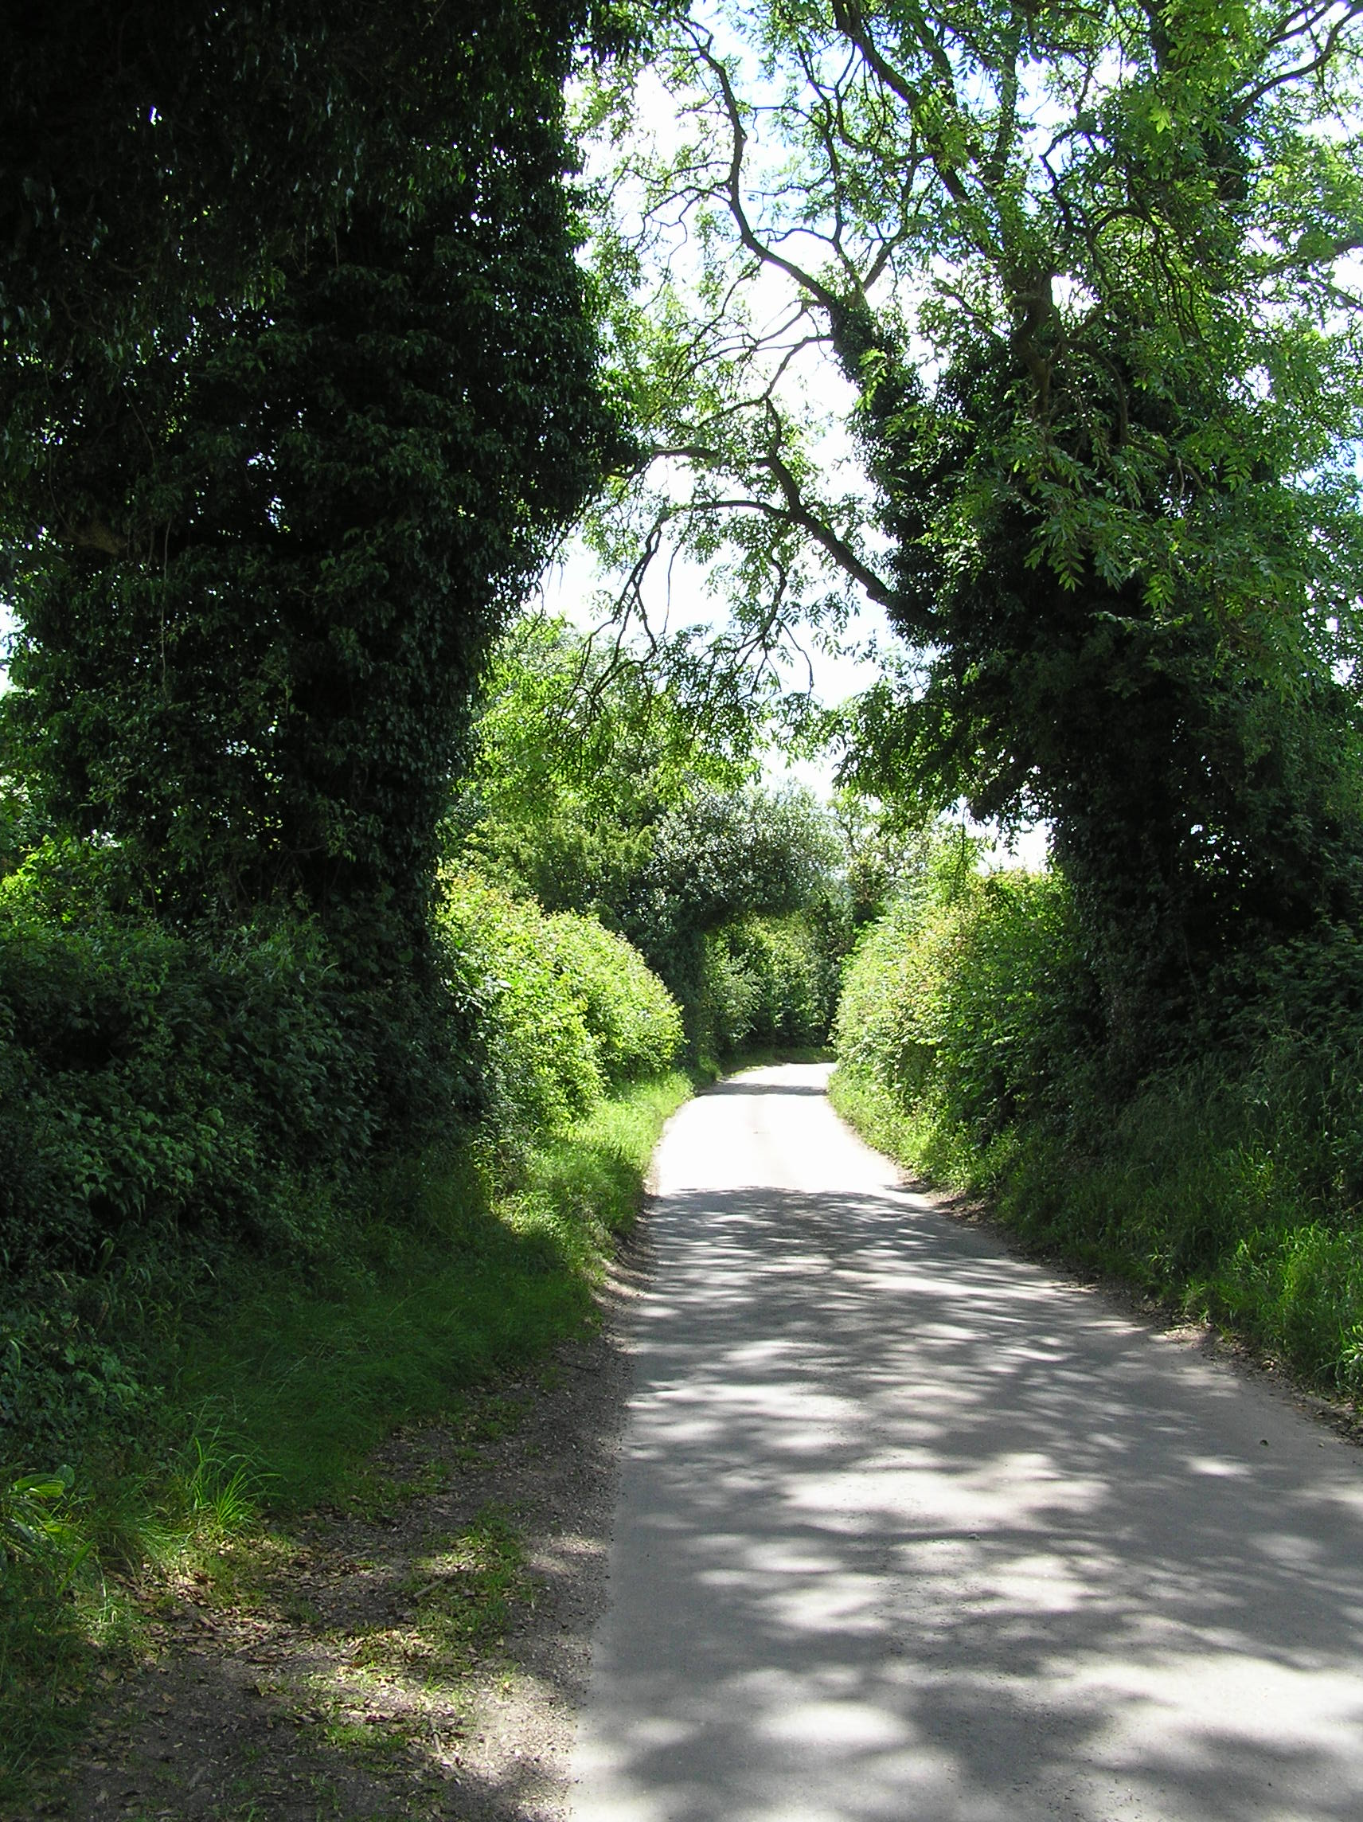

Duckmore Lane climbing up the slopes south of Drayton Manor.

