LCA 10.3 Marsworth and Pitstone Chalk Quarries

Landscape Character Type: LCT 10 Chalk Foothills

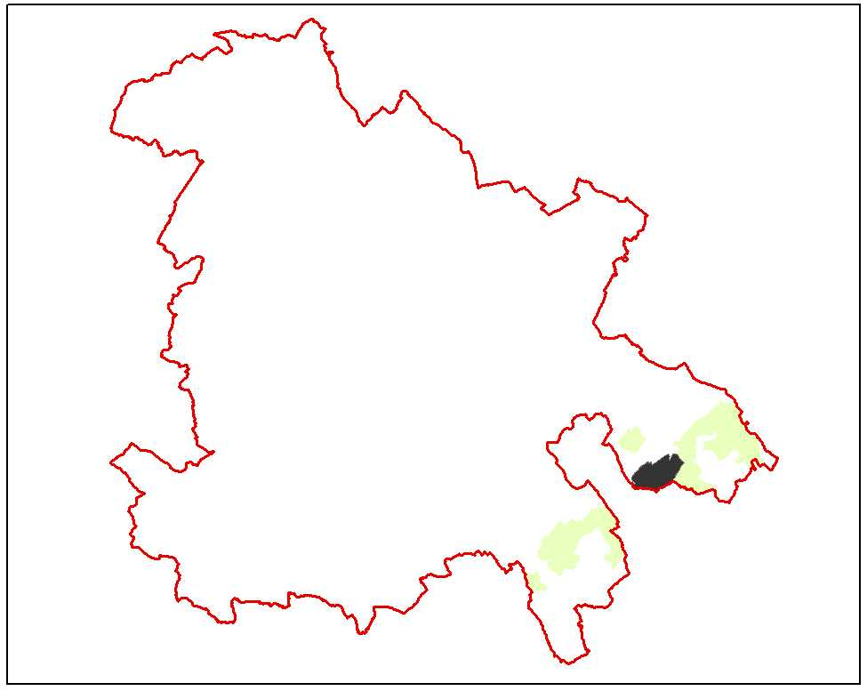

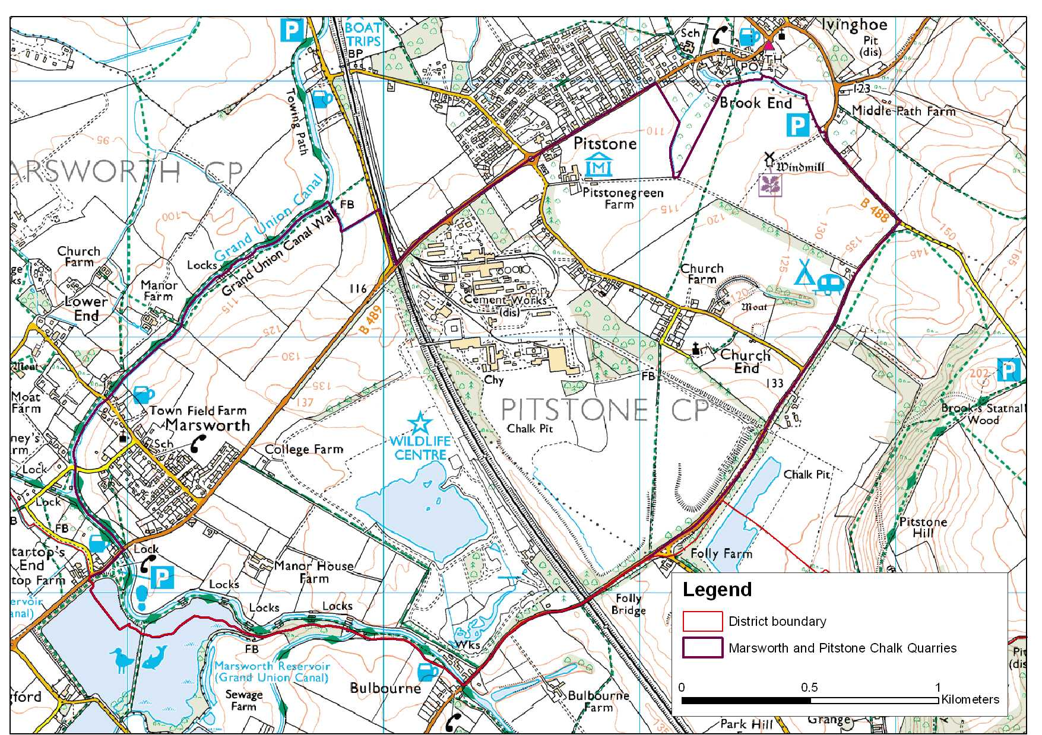

LCA 10.3 Marsworth and Pitstone Chalk Quarries (LCT 10)
Key Characteristics  - Shallow sloping chalk foothills  - Extensive areas of chalk quarrying  - Restored chalk pits under grassland management  - Open arable landscape on periphery of area  - Chalk springs draining off the upper slopes  Distinctive Features  - College Lake Wildlife Centre  - Ivinghoe Windmill  - Grand Union Canal  - Marsworth Reservoir  - Church and Moat at Pitstone Church End  - Fen  Intrusive Elements  - Tring cutting west coast mainline railway  - Extensive redevelopment of the former cement works | Location The area lies within the eastern part of the Tring Gap slightly to the northeast of the town of Tring. It includes the settlement of Marsworth in the west and to the northeast the boundary is formed by the southern edge of Pitstone and Ivinghoe. The eastern boundary follows the B488 which also runs along the edge of the foothills. The western boundary, which is also the county boundary, incorporates the eastern shoreline to the Marsworth Reservoir and the Grand Union Canal.  Landscape character An area of gently rolling chalk hills, that overall, falls from south to north within which a large area of disturbance remains resulting from the previous excavations of chalk pits and the former cement works site since removed. Land has been restored to grassland use and peripheral areas outside the areas of disturbance are in arable. Land restoration and management of College Lake pit has created a wildlife centre. The cement works site has now been developed as housing and an industrial complex. Those fields on the eastern flank of the LCA are large prairie fields often with well trimmed hedges.  The area is crossed by the west coast mainline railway with the western boundary to the area defined by line of the Grand Union Canal noted for its mature tree cover. There is a small settlement at Marsworth. There are a number of spring fed moated sites and dispersed historic features (farm museum and windmill).  Geology The area occurs exclusively over an area of west Melbury marly chalk formation.  Topography There is a general cross fall from the south to north. The levels run at about 135m AOD along the southern boundary falling to 110m AOD just on the outskirts of Pitstone and Ivinghoe. The west coast mainline railway runs across the area in a deep cutting, the construction of which is recorded in illustrations in the British Museum.  Hydrology The area is noted for the springs which rise on the chalk foothills to the south and cross the area, notably at College Lake Wildlife Centre and to the east of the railway the springs feed Pitstone Fen. At Church Farm, south of Pitstone, the local spring feeds the Moat a noted historic feature. There is an extensive lake east of College Farm managed for its ornithological interest. The Grand Union Canal runs along the western boundary to the area. To the west of the canal lies Marsworth Reservoir which was built to supply water for the canal and the two local arms of the canal which connect to Wendover and Aylesbury.  Land use and settlement The area has been much disturbed by quarrying for chalk, initially to supply the cement works at Pitstone, now demolished. The College Lake Pit has been restored for management as a wildlife facility. The pit south of Pitstone village has been restored to agricultural use whilst the fringes of the area to the west, north and east are undisturbed and in arable use. The settlement of Marsworth is nucleated. Some older dwellings occur along the Pitstone to Church End Road. Extensive new development has taken place on the site of the former cement works.  Tree cover Scrub woodland and shelter belts enclose the former cement works and pits. Scrub woodland is well established along railway embankments. Mature tree cover is found along the Grand Union Canal and edge of Marsworth reservoir. Tree species are mainly willow and poplar.

LCA 10.3 Marsworth and Pitstone Chalk Quarries (LCT 10)

Biodiversity There is an interesting mixture of habitats within the area including arable, grassland, quarry, scrub woodland, broadleaved woodland and large areas of open standing water.

College Lake and its immediate environs is now a local Wildlife Trust nature reserve, supporting a variety of habitats including the lakes, woodland and chalk grassland and includes the Pitstone Quarry SSSI. (More information is given in the LCT description.) Nearby is the Pitstone Fen CWS separated from the nature reserve by the railway cutting. In addition to fen there are three other habitats - Scots pine plantation, rough chalk grassland and in the middle a potash rich ridge where flue dust from the cement works was deposited. Each area has its own characteristics and the site is important for a very wide range of flora and fauna.

Around half of the grassland is improved and is distributed mainly around the perimeter of the area. Most of the remainder is unimproved, and tends to be situated more centrally. A small fragment of calcareous grassland is situated in the eastern half of the LCA.

Historic environment
Roman and Saxon settlement is indicated by discoveries during mineral working and finds at Church End. Pitstone church is a fine medieval building with a moat opposite. Marsworth is designated as a conservation area. There are also listed buildings in Marsworth and a 17th century post-mill owned by the National Trust to the east of Church End. In the central parts, quarrying has removed the historic landscape. There is very little evidence of pre 18th century enclosure other than a small area at Church End. Parliamentary enclosures on land adjacent to Marsworth and 19th century enclosure at Pitstone Green Farm. Prairie field on eastern flank of the LCA. The Grand Union Canal was built through the area in 1805 and has several listed locks and works at Bulbourne.

Designations
Chilterns AONB
Conservation Area at Marsworth
Archaeological Notification Areas – 8 No.
SSSI: Pitstone Quarry
CWS – 2 No.
BNS – 2 No.

LCA 10.3 Marsworth and Pitstone Chalk Quarries (LCT 10)

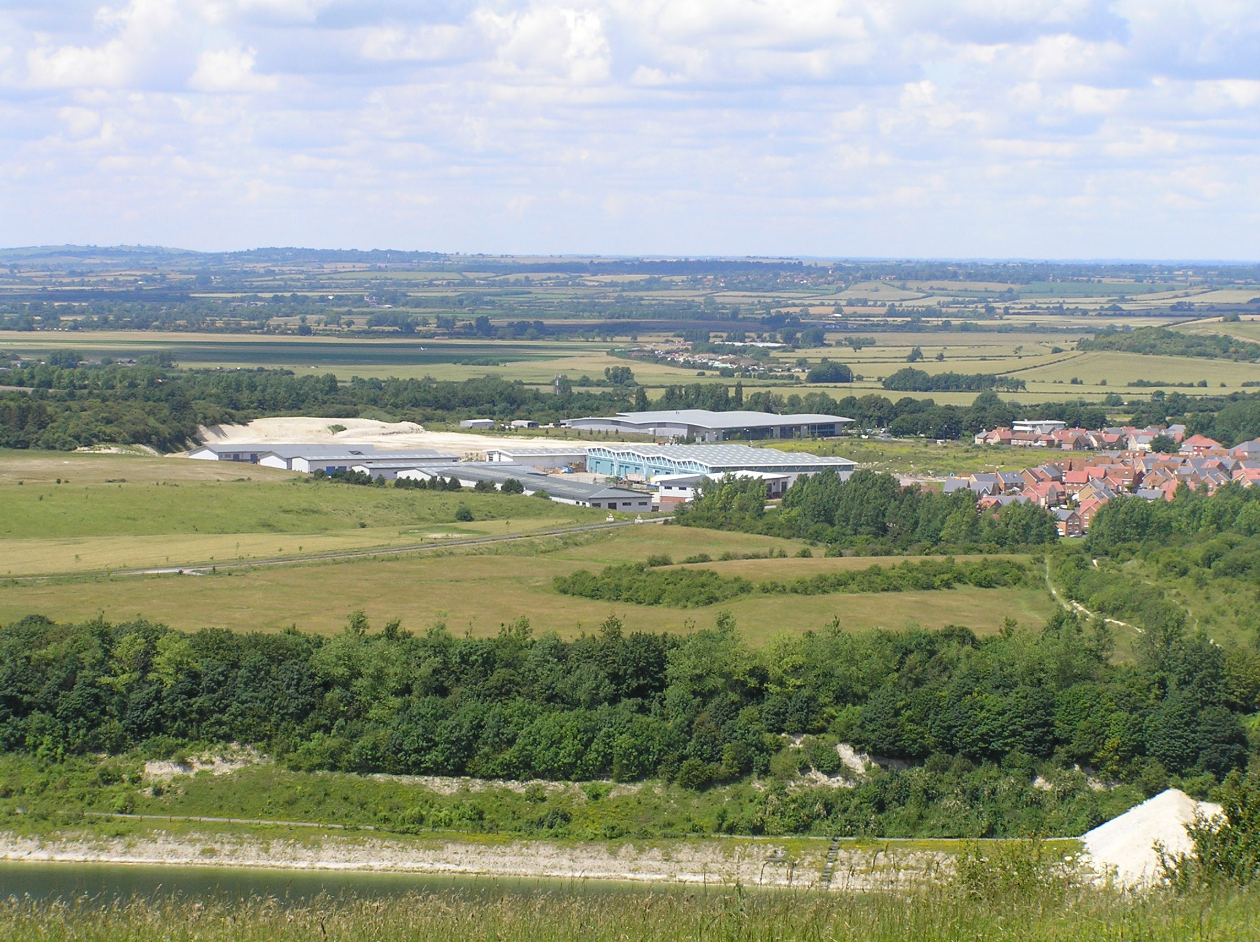

New industrial/commercial development on the site of the former cement works.
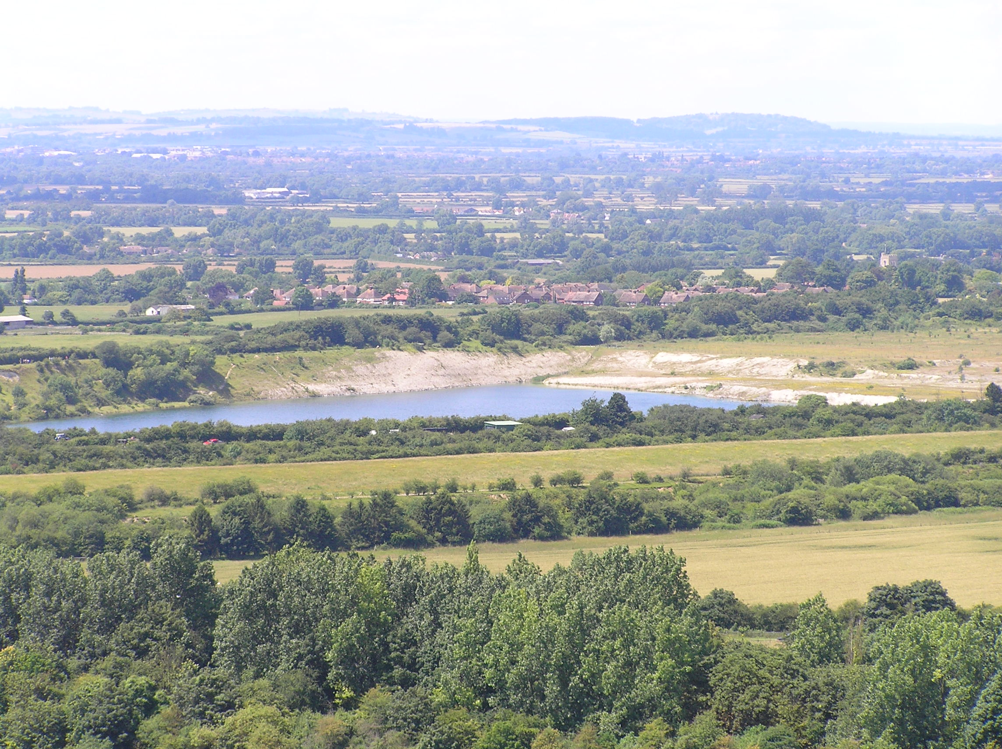

College Lake chalk pit and Wildlife Centre.

LCA 10.3 Marsworth and Pitstone Chalk Quarries (LCT 10)

Summary of Condition/Sensitivity Analysis

Condition |  | Good
Pattern of elements:  Visual detractors:  Visual unity:  Cultural integrity:  Ecological integrity:  Functional integrity: |  | Incoherent  Few  Coherent  Variable  Moderate  Coherent
Sensitivity |  | Moderate
Distinctiveness:  Continuity:  Sense of place:  Landform:  Tree cover:  Visibility:  Guidelines |  | Distinct  Historic  Moderate  Apparent  Intermittent  Moderate  Conserve and Enhance
Condition

Overall the condition of the landscape is considered to be good. The landform has however, been disturbed by mineral extraction followed by restoration and associated new development. The pattern of elements is identified as incoherent due to the disruption of landscape structure by the extraction and restoration process. Cultural integrity is variable. There are small pockets of well preserved and promoted historic character interspersed with areas of arable intensification. Ecological integrity is moderate due to strong connectivity, and a reasonable area of designated sites and habitats of District significance. Overall the functional integrity is coherent.

Sensitivity

The area has a distinctive sloping chalkland landform with an industrial/mineral extraction heritage superimposed on it. This is gradually being replaced by commercial and housing development and associated infrastructure. The degree of visibility increases with elevation above the Vale landscape to the north. Tree cover is intermittent. Overall the degree of sensitivity is considered to be moderate.
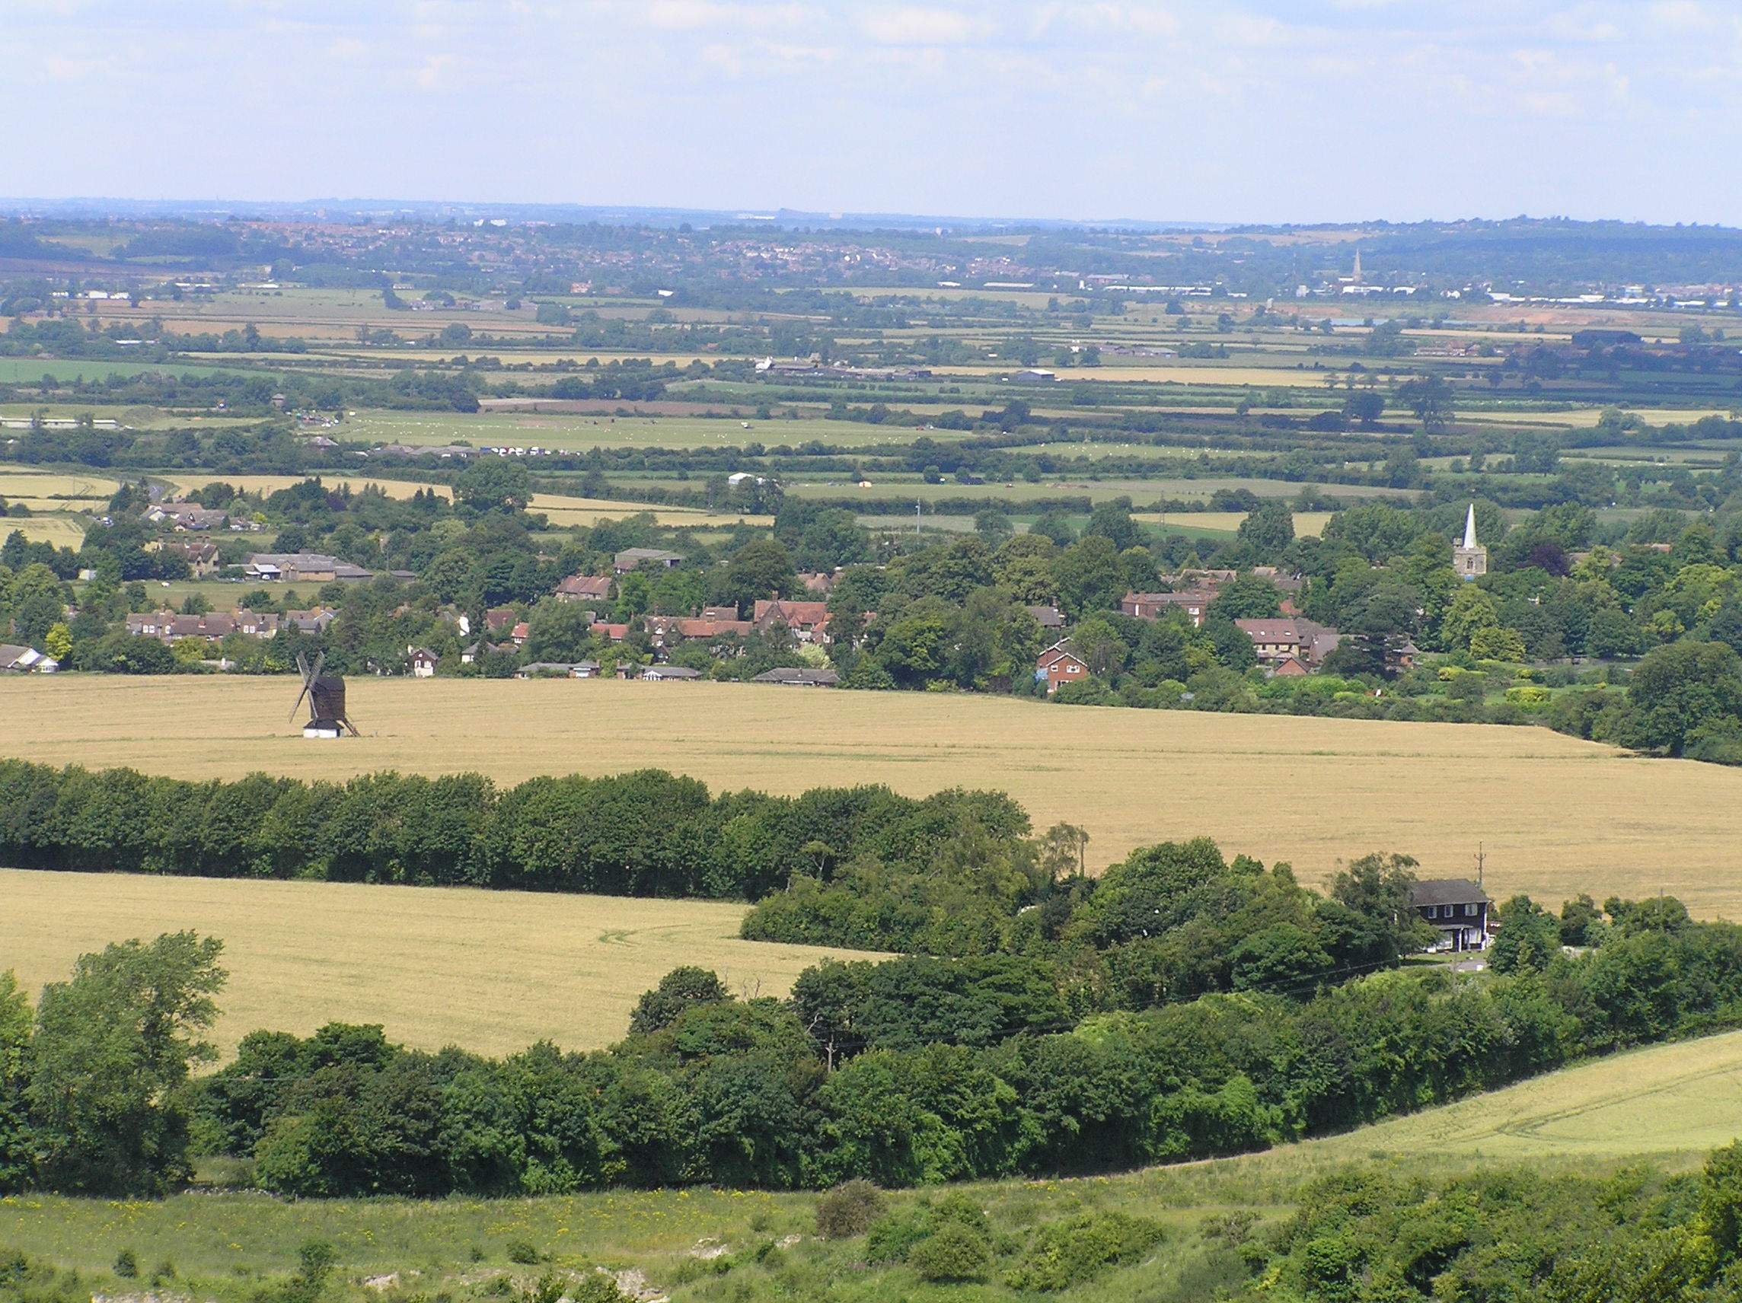

Ivinghoe Windmill and Pitstone Church (LCA 8.4 Pitstone – Edlesborough Slopes) are prominent landmarks in the foreground of vistas from the Chiltern Scarp (LCA 11.1).

LCA 10.3 Marsworth and Pitstone Chalk Quarries (LCT 10)

Landscape Guidelines Conserve and Enhance

The landscape guidelines for Marsworth and Pitstone Chalk Quarries are as follows:

- Conserve and enhance the remaining field pattern and network of hedgerows.
- Conserve and support the landscape aims and objectives of the College Lake Wildlife Centre and Pitstone Green Farm Museum.
- Conserve and enhance the status of all SSSI sites.
- Maintain the condition and extent of calcareous, unimproved and semi-improved grassland. Encourage good management practices.
- Maintain extent and condition of fen habitat.
- Encourage the planting of new woodland to screen the edges of new development at the former cement works site.
- Maintain and enhance access to the towpath on the Grand Union Canal.
- Maintain connectivity of habitats.

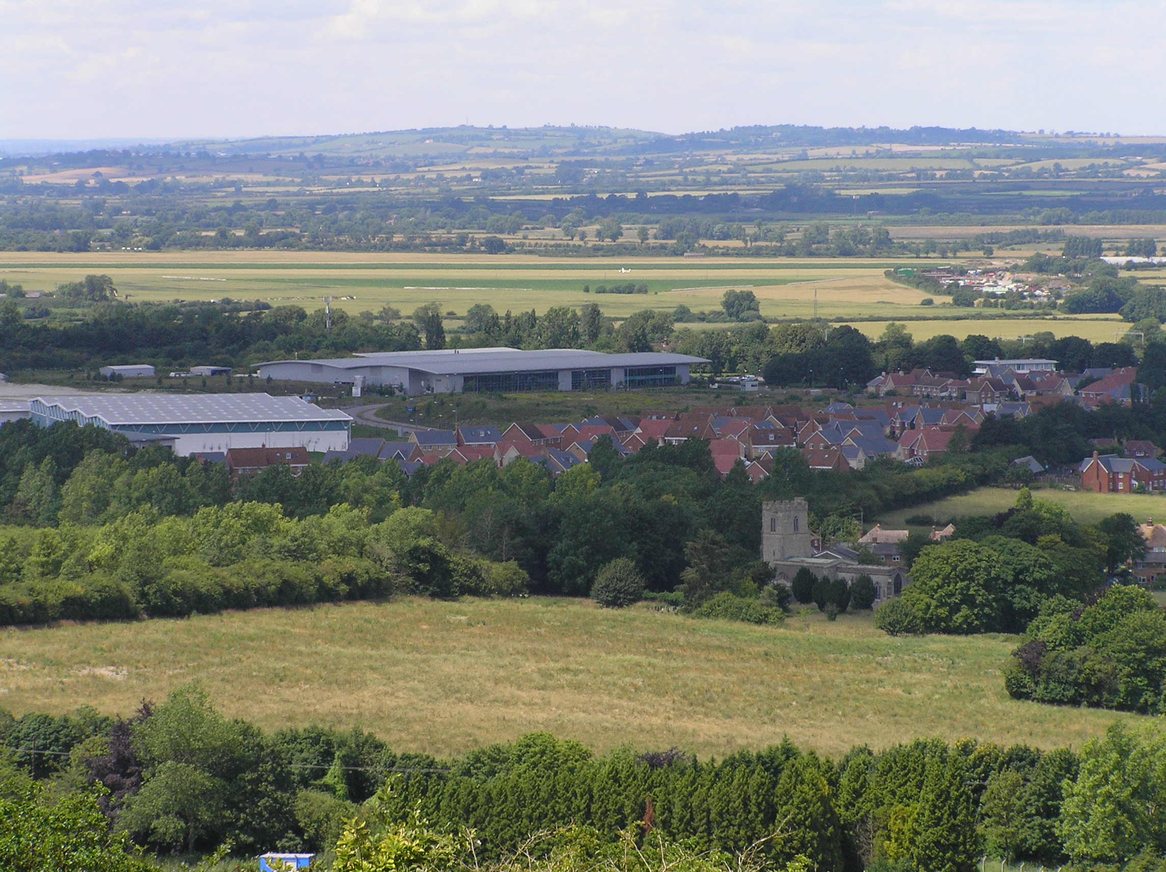

Church End seen from Pitstone Hill against a backdrop of new development on the former
cement works.

