LCA 9.10 Hartwell House and Golf Course

Landscape Character Type: LCT 9 Low Hills and Ridges

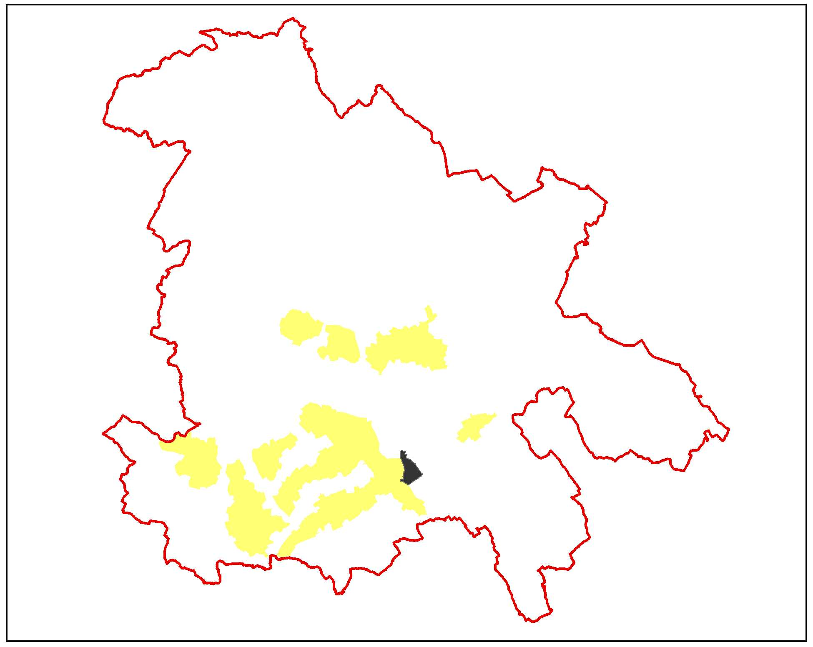

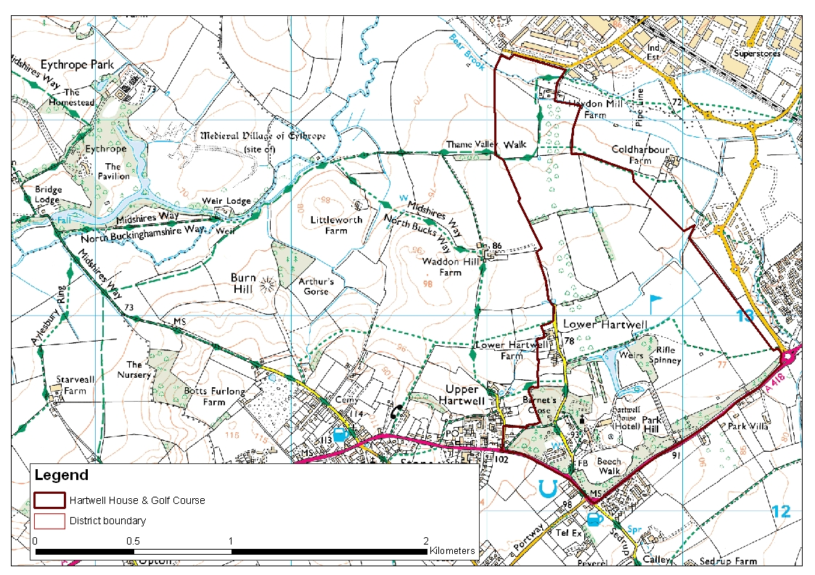

LCA 9.10 Hartwell House and Golf Course (LCT 9)
Key Characteristics  - Mature parkland setting  - Hartwell House and grounds  - Golf course and playing fields  - Gently sloping landform draining towards Bear Brook  Distinctive Features  - Formal gardens and lake around Hartwell House  - Double avenue of trees  - Stone boundary wall containing fossils  - Lodge and wrought iron gates  - Golf course  Intrusive Elements  - Residential and large scale industrial development to the northeast  - Car parking for recreational uses  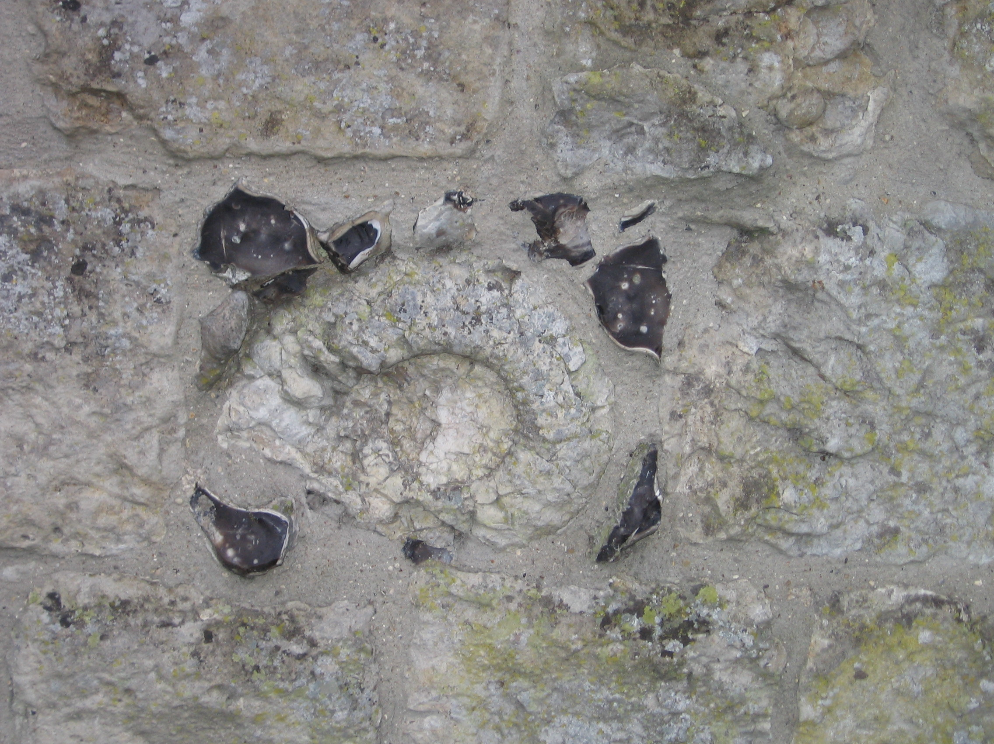  Fossil detail from boundary wall. | Location The area is broadly triangular in shape with well defined boundaries and lies on the west side of Aylesbury. The A418, Oxford Road, forms the southeast and southwest boundaries whilst the urban edge of Aylesbury defines the area to the northeast. The area bounds open countryside on its western side.  Landscape character Strong parkland character throughout but comprises two distinct parts - Hartwell House and grounds within mature well-wooded parkland in the southwest and between it and the urban edge of Aylesbury, more open parkland in use as a golf course and playing fields. The latter occupies previously agricultural parkland within which there are remnants of the field pattern seen as fragments of hedgerow and distinctive stands of mature trees. The character of this area is enhanced by the wooded backdrop of the parkland and woodland o the southwest.  Geology The core of the area overlies Kimmeridge clays with an outcrop of Portland limestone in the southwest corner. Bear Brook crosses alluvial deposits.  Topography Hartwell House and parkland occupy the highest parts at a level of between 95-100m AOD. There is gentle crossfall across the area from southwest to northeast. Levels along the north eastern boundary also fall gently to the north from approximately 75m AOD at the A418 to approximately 70m AOD at the northern extremity.  Hydrology Bear Brook follows part of the north eastern boundary and feeds into the river Thame to the northwest beyond the area boundary. A number of streams and ditches feed into the brook around Coldharbour Farm. The ornamental lake at Hartwell House also feeds into the brook.  Land use and settlement The area is a mixture of parkland, woodland and recreational uses with very limited agricultural use for grazing. Hartwell House and the immediate grounds is a hotel and leisure facility. There is a recent golf clubhouse and associated buildings and car parking close to the north eastern boundary, accessed from within the adjoining urban area. The south east corner of the area is relatively level and used for formal sports pitches.  There are a number of residential properties in close proximity to Hartwell House accessed from the same lane, otherwise there is no settlement and no communications within the area.  Tree cover Hartwell House and grounds lie within a mature woodland setting with a range of specimen trees in particular to the east of the house. A strong but relatively narrow band of woodland reinforces the boundary wall along the A418. The dominant species are beech and oak with a mixture of conifer. A double avenue of trees extends northwards from the house into the golf course. This feature is now fragmented at its northern end but sections of the avenue have been replanted.  Copses, stands of mature trees and shelterbelts are a distinctive feature of the wider landscape and are effective in screening longer distance views to the industrial areas on the fringe of Aylesbury. There has been extensive new tree planting associated with the golf course and along the urban edge.  The historic landscape at Hartwell is a Grade II* English Heritage Registered Historic Park and Garden.  Biodiversity The principal habitat interest in this LCA is associated with the areas of broad habitat types found within the Hartwell House parkland and the golf course, comprising significant areas of the type broadleaved, mixed and yew woodland, in close association with areas of standing open water. The concentration of mature trees here have considerable potential for wildlife.  A small section of watercourse also lies within the LCA, otherwise the remaining habitat is restricted entirely to improved grassland, which is dominant throughout.  Historic environment The historic landscape of this area is dominated by the park and garden of Hartwell House. Hartwell is largely an eighteenth century park with pleasure grounds laid out around an early 17th century country house with remnants of an early 18th century formal layout. The grounds were subsequently changed again in the 19th century when the fashion was for a more ‘naturalised’ appearance. Hartwell is acknowledged as one of Buckinghamshire’s finest estates. This is reflected in the designation by English Heritage as a Registered Park and Garden of grade II* status. The landscape includes a 20th century golf course that impinges upon the former extent of the historic park however, the golf course has managed to retain in it’s plan some of the features and design of the former parkland, this includes part of the northwest avenue.  In terms of the built environment, Hartwell House is a Grade I listed building dating back to the 17th century with various additions from subsequent periods. The gardens and the park contain a number of significant edifices with listed status, these vary from statues to neo classical temples such as the Egyptian Seat, the Gothic Tower and an obelisk, all typical of eighteenth century landscape gardens. The concentration of listed buildings and the significance of the surrounding park has afforded Hartwell conservation area status. Enhancement opportunities exist for the park to restore parts of the north west avenue.  The park incorporates remains of a medieval settlement whilst the historic gardens have archaeological interest in themselves.  The amenity value of this area is particularly high as Hartwell now functions as hotel and heath spa. The golf course and popular Rights of Way that run through the area.  Designations  Conservation Area at Hartwell  EHRHP&G at Hartwell House  Archaeological Notification Areas – 3 No.  BNS – 1 No.

LCA 910 Hartwell House and Golf Course (LCT 9)

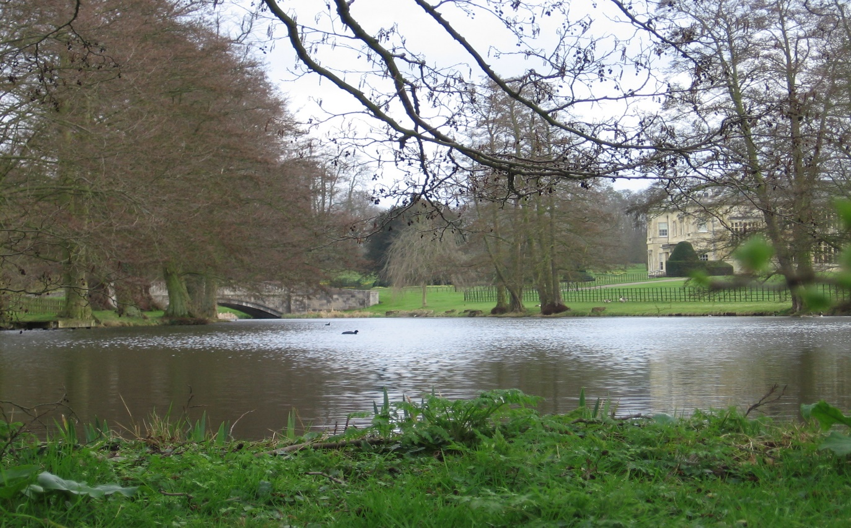

Hartwell House Lake and garden ornaments in a mature parkland setting.

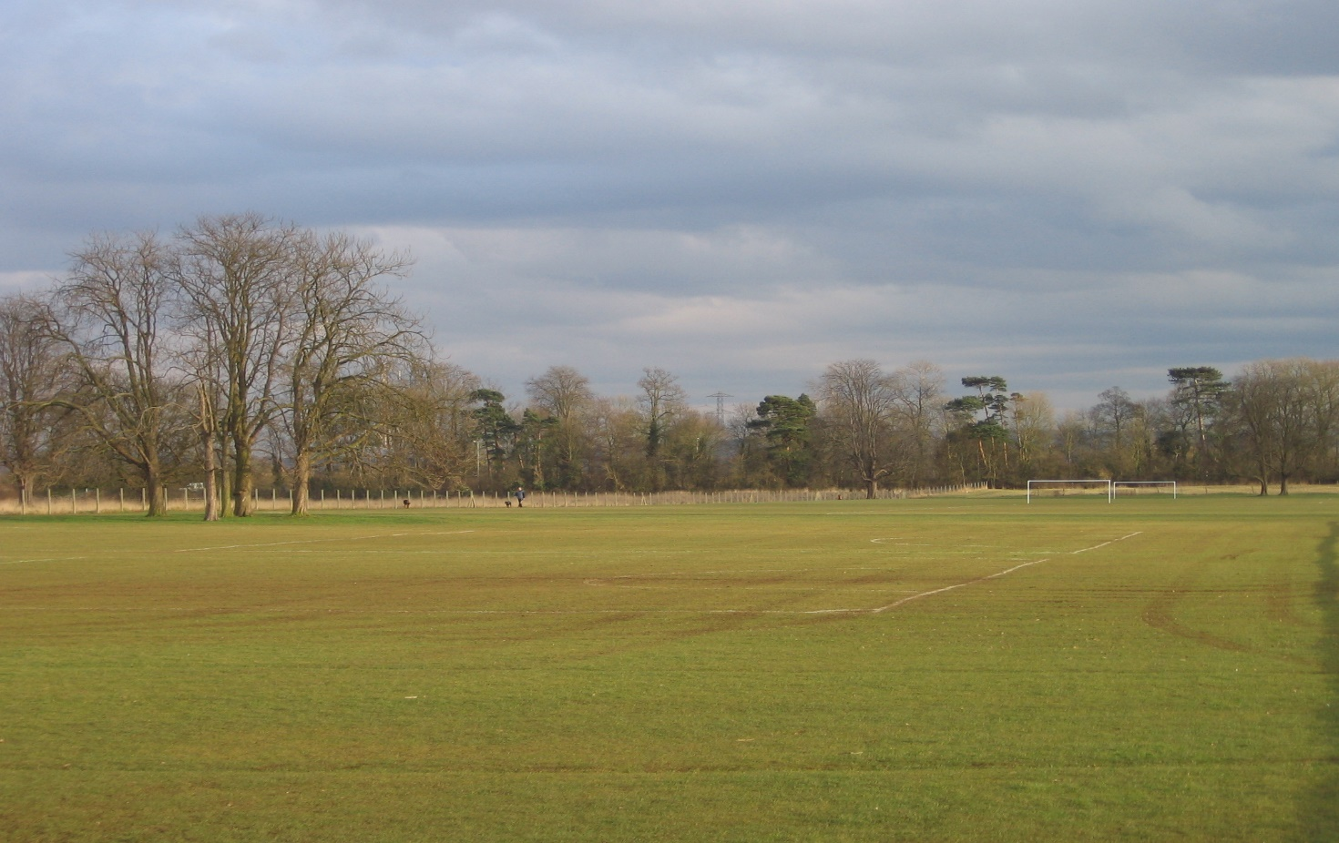

Playing field with group of mature parkland trees and backdrop of mixed woodland along the southeast boundary.

LCA 9.10 Hartwell House and Golf Course (LCT 9)

Summary of Condition/Sensitivity Analysis

Condition |  | Good
Pattern of elements:  Visual Detractors:  Visual unity:  Cultural integrity:  Ecological integrity:  Functional integrity: |  | Unified  Some  Unified  Good  WeakCoherent
Sensitivity |  | Moderate
Distinctiveness:  Continuity:  Sense of place:  Landform:  Tree cover:  Visibility:  Guidelines |  | Unique/rare  Historic  Strong  Insignificant  Enclosed  Low  Conserve and Reinforce
Condition

The landscape is in good condition. The pattern of elements which make up the key characteristics of the area are unified to give a strong visual unity. Cultural integrity is good. Ecological integrity is weak because although connectivity of habitats is strong, the relative contribution of the semi-natural habitat assets to the total interest in the district is low. Functional integrity is coherent. Detracting features within the area are minimal but the recent and more established residential and industrial developments along the northeast boundary and the water treatment infrastructure to the north are all visible from the area but beyond the LCA boundary.

Sensitivity

The landscape has a distinctive sense of historic continuity evident in the well-wooded parkland setting. Overall the sense of place is considered to be strong. Landform is insignificant in its contribution to inter-visibility. A high proportion of mature tree cover creates an enclosed landscape leading to a low definition of visibility. Overall the strong sense of place combined with a low rating of visibility give a landscape of moderate sensitivity.

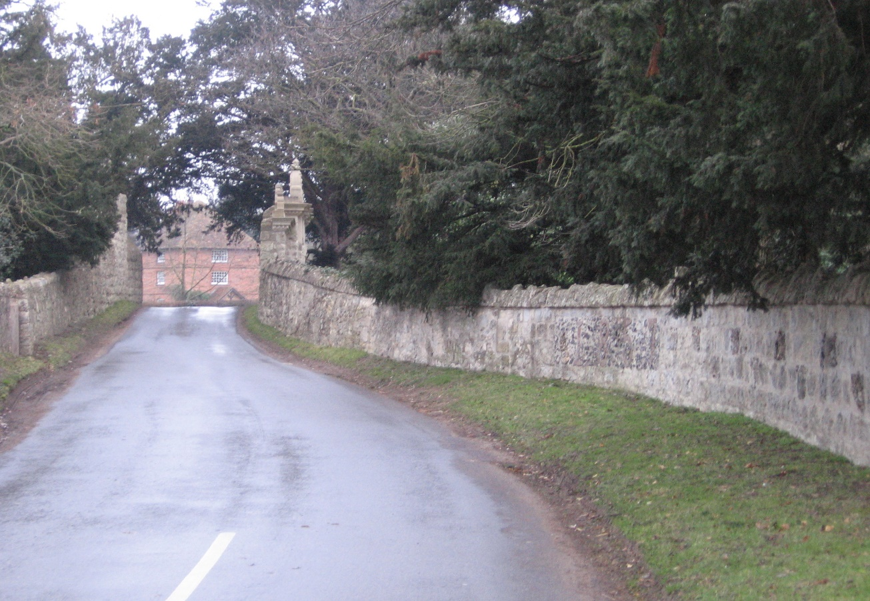

The distinctive stone wall marking the southeast and southwest boundary of the Hartwell Estate and LCA.

LCA 9.10 Hartwell House and Golf Course (LCT 9)

Landscape Guidelines Conserve and Reinforce

Landscape guidelines for Hartwell House and Golf Course are as follows:

- Maintain and manage the parkland setting to the house and grounds at Hartwell.
- Encourage the long-term management of woodland cover for its distinctive contribution to visual amenity and the wider landscape setting.
- Conserve and reinforce the distinctive avenue feature.
- Reinforce existing planting to provide separation and screening to the urban edge.
- Reinforce the screening on the recreational facilities, clubhouse and car parking areas to fully integrate within the landscape.
- Maintain the condition and extent of unimproved and semi-improved grassland.
- Encourage landowners to improve ecological diversity by maintaining varied maintenance regimes.
- Maintain and improve connectivity of habitats.
- Promote ecologically sensitive management of the golf course.

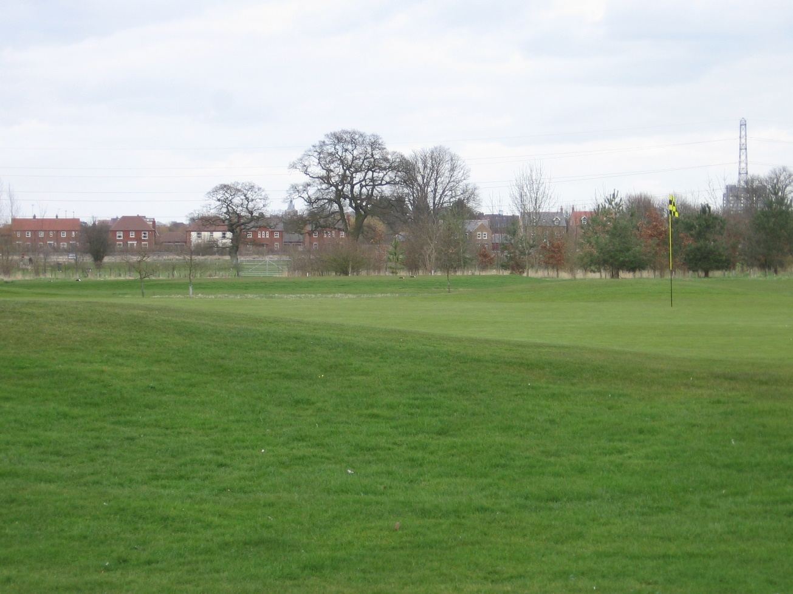

The urban edge of Aylesbury is in close proximity but will eventually be screened by a woodland belt planted along the LCA boundary.

