LCA 9.4 Waddesdon-Eythrope Parkland

Landscape Character Type: LCT 9 Low Hills and Ridges

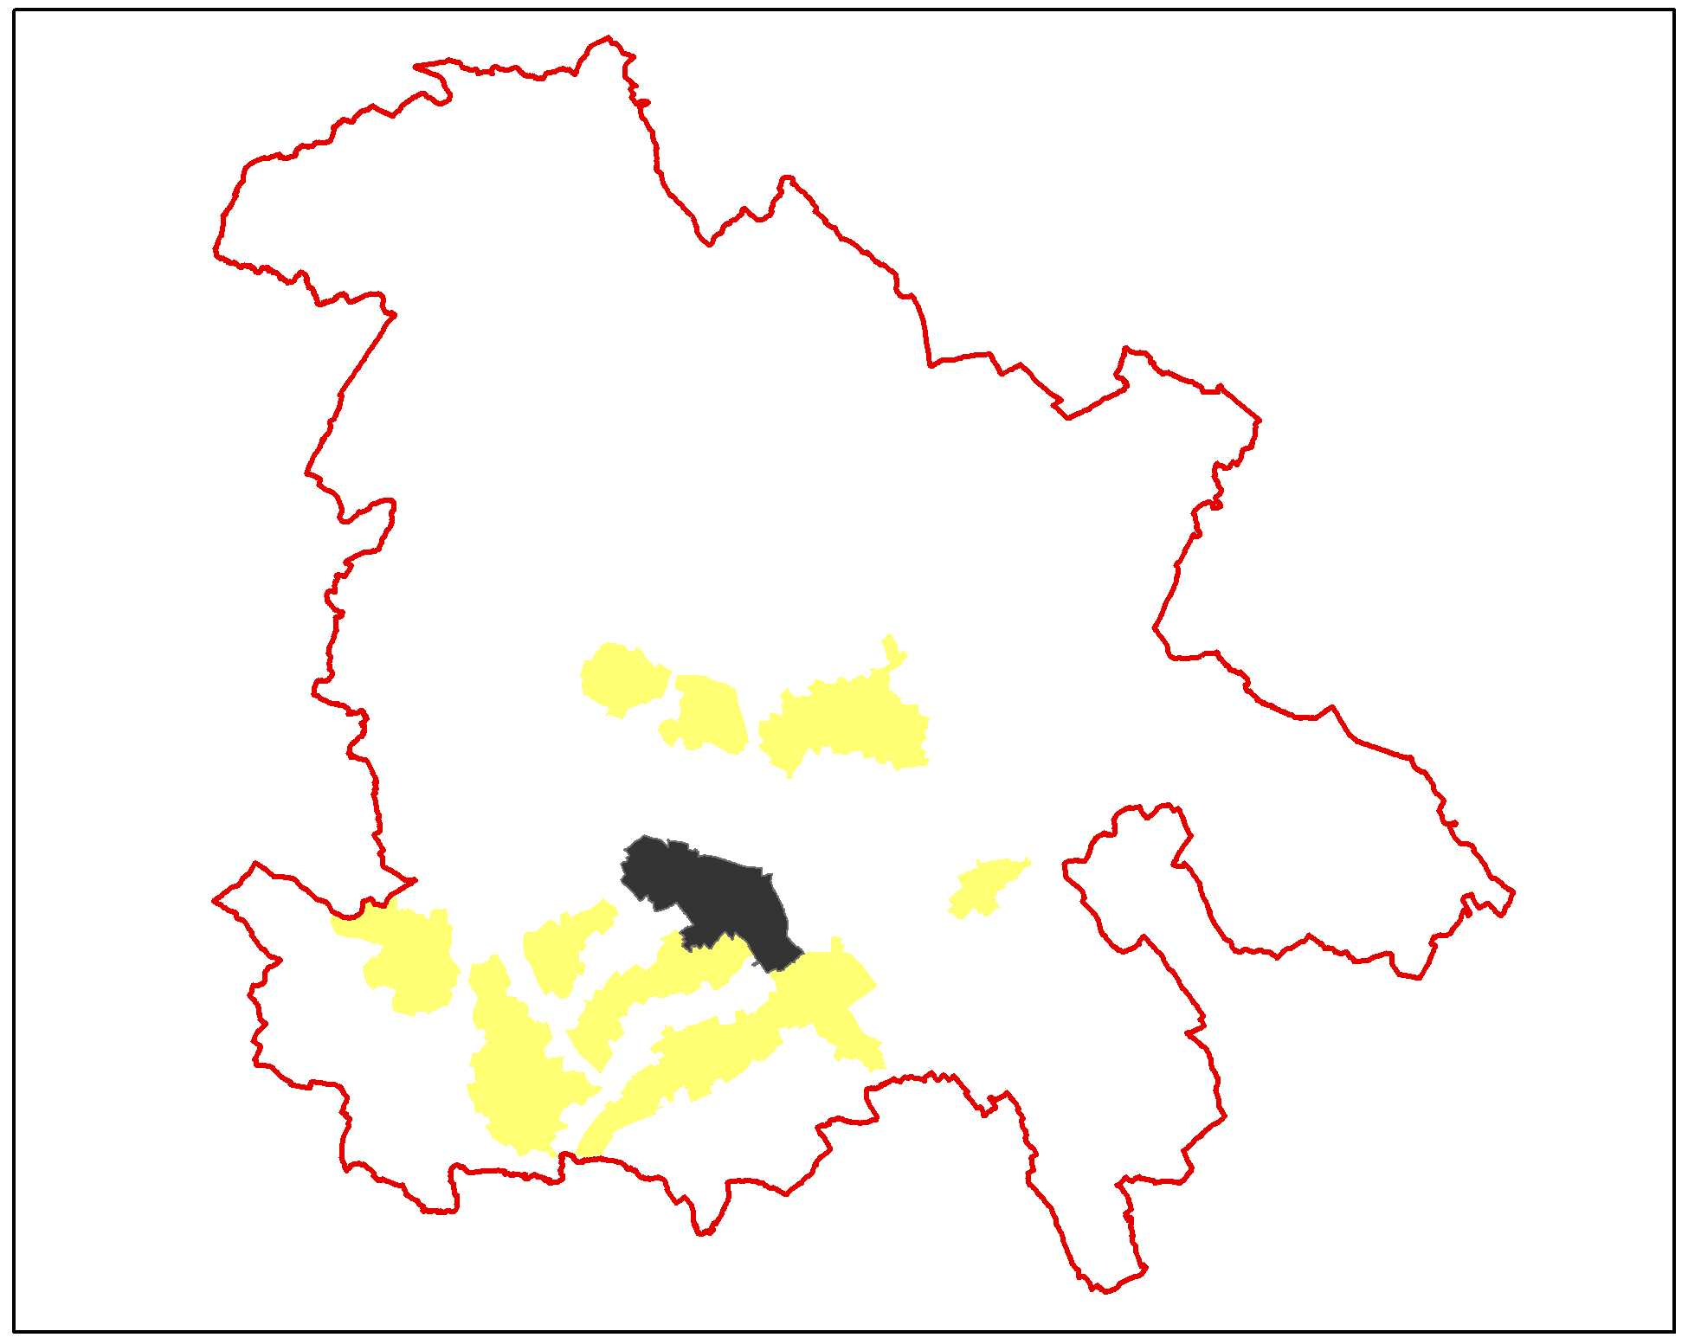

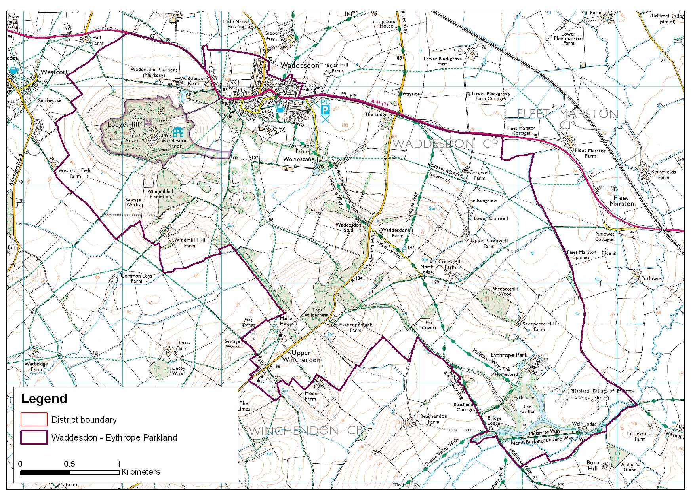

LCA 9.4 Waddesdon-Eythrope Parkland (LCT 9)
Key Characteristics  - Steeply undulating landform  - Long distance views over surrounding countryside from vantage points  - Parkland and gardens at Waddesdon Manor and Eythrope Park  - Extensive woodland cover  - Mixed agricultural use  - Tree lined drives and avenues  - Predominantly large arable fields on the upper slopes and smaller pastoral fields on lower slopes  Distinctive Features  - Lodge and gates at the corner of Waddesdon Hill and the A41  - Rothschild estate architecture  - Roman, Saxon, Medieval and Post-medieval archaeology  - Eythrope Park and Waddesdon Manor.  - Belt of broadleaved woodland  - Ponds  Intrusive Elements  - Traffic on the A41 Bicester Road  - Suburban fringe and school grounds on the south side of Waddesdon village | Location The area lies north west of Aylesbury south of the A41 (but excluding the large village of Waddesdon) and includes the houses and parkland associated with Waddesdon Manor and Eythrope Park. Also within the area are the Manor House and church at Upper Winchendon.  Landscape character An area of undulating landform with distinctive parkland landscapes located at Lodge Hill Waddesdon and at Eythrope Park adjacent to the river Thame. The predominantly arable landscape pattern over the drier hill tops changes on the lower slopes to a pastoral landscape of smaller fields. The area is intrinsically rural with extensive mature woodland interspersed with areas of parkland agriculture that is locally intensive.  Geology Waddesdon Hill and Lodge Hill are outcrops of Portland limestone. The lower slopes of the area are Kimmeridge clays with Ampthill clays at the lowest levels. There are alluvial deposits in the Thame valley with Head deposits under Eythrope Park.  Topography At the southern extent of the area Eythrope Park includes a section of the River Thame. This lies at a level of approximately 70m AOD. The land to the north of Eythrope rises to a peak of 147m AOD at Waddesdon Hill. The hill is a distinctive feature located at the end of a ridge running south west to northeast parallel to the course of the river Thame. Waddesdon Manor sits on a separate hill (Lodge Hill), which lies at a level of 159m AOD. Between Waddesdon Hill and Lodge Hill lies a small valley to the southwest. The bottom of this valley lies at a level of 88m AOD. The A41 forming part of the northern boundary lies at a approximately 80m AOD rising to just above 100m AOD within the settlement of Waddesdon.  Hydrology The general drainage pattern runs from northeast to southwest. The main watercourse is the river Thame running along the southern boundary. The river flows on between two limestone ridges, the Winchendon Ridge to the north and A418 Ridge to the south that both drain into the valley. North of the Winchendon Ridge runs a smaller tributary to the Thame that rises in the valley between Lodge Hill and Waddesdon Hill.  Land use and settlement There are two distinctive land uses - agriculture and parkland. Agricultural use is divided broadly between pastoral use on the northern side of the hill and a predominance of arable cultivation to the south.  The extensive parkland areas focus on the two houses. Waddesdon Manor which occupies the top of Lodge Hill and Eythrope Park which sits on the lower southern slopes of Waddesdon Hill. The parkland extends south to the River Thame and east to the site of the deserted medieval village of Eythrope. Both parklands are associated with the Rothschild family.  The parkland at Waddesdon is owned and managed by the National Trust. The gardens associated with the house include distinguished architectural features. The grounds are set out with numerous walks occasionally providing panoramic views over the surrounding countryside.  A notable feature of the parkland at Eythrope is an extensive lake created when the River Thame was dammed. There are also extensive ornamental gardens and ‘pleasure grounds’.  The area is sparsely settled outside of the two large houses. There is a scattering of farmsteads over the area and lodge houses associated with the two estates. At Upper Winchendon, on the southwest boundary, there is a small settlement stretched out along Main Road, which follows the ridge top before dropping down the hill to connect to the A41.  Tree cover A distinguishing feature of this landscape is the extensive woodland covering the upper slopes. The parkland around both of the large houses contains numerous mature trees both deciduous and coniferous. Between the two areas of parkland the agricultural landscape is laid out with a mixture of plantations of various sizes, sometimes irregular in shape and including numerous ovals. Tracks and drives are also delineated by linear belts and avenues of mature trees - predominantly oak and ash of native species but with a much wider range of deciduous and coniferous tree species especially within the parklands.  The historic landscapes at Waddesdon and Eythrope are English Heritage Registered Historic Parks and Gardens with Grades of I and II respectively. The area of the Eythrope registration is shown on Plan C.  Biodiversity The priority habitat type of parkland is well represented in this LCA by the large area of mature parkland present around Waddesdon Manor in the northwest; this site is noted for its bat interest, and by Eythrope Park in the southwest which is noted for its lichen interest.  Substantial areas of the broad habitat type of broadleaved, mixed and yew woodland is also present associated with the parklands, particularly Waddesdon and connected by the belt of moderate sized stands in the intervening area.  The parkland and woodland is set within a matrix of arable habitat and on the lower slopes the majority of the grassland is improved. The habitat mix is extended further by the water courses, ponds and larger areas of standing water providing further ecological interest, connectivity and potential.  The LCA contains an exceptional large area of BNS and broad habitat types compared with much of the District.  Historic environment The area is predominantly designated as historic parkland covering both Waddesdon and Eythrope, the former is grade 1 . To the northeast of Eythrope, the lower slopes below the parkland are pre 18th century irregular enclosures. Between the two areas of parkland runs a narrow belt of land, parallel with the road running between the Waddesdon Lodge gates and Upper Winchendon, which is predominantly 19th century enclosure land and 19th century woodland. The bulk of Waddesdon Park and some of the adjacent land is designated as a conservation area. Historic buildings are dominated by the country houses within the parks and the Rothschild’s architectural influence on Waddesdon village. Waddesdon manor is a grade I listed building constructed in a French style chateau style for Ferdinand Rothschild in 1874 - 1881. Eythrope Park was created for Alice de Rothschild as the grounds for her house, the Pavilion, which was built in 1883.  The area is rich in archaeological interest. It is traversed by Akeman Street Roman Road and has evidence for Roman and Saxon occupation. There are several deserted and shrunken medieval hamlets, including a fine example with a possible mill and ridge and furrow at Eythrope. Garden archaeology is also significant both at Waddesdon and the demolished Winchendon House, a large 17th century mansion well known for its fine Dutch garden.  This area is of high amenity value and visually sensitive. The historic park of Waddesdon Manor is now owned by the National Trust and open to the public. A number of promoted Rights of Way cross this area, including the North Bucks Way.  Designations  Conservation Area at Waddesdon  EHRHP&G at Waddesdon Manor, Eythorpe  Archaeological Notification Areas – 15 No.  BNS – 4 No.

LCA 9.4 Waddesdon-Eythrope Parkland (LCT 9)

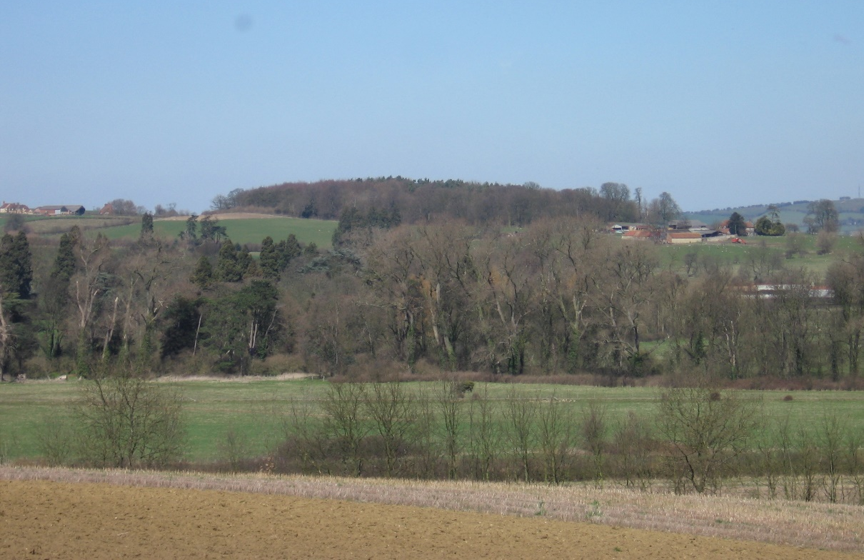

Looking north from Stone across the Thame Valley. The woodland in the foreground is within the Eythrope parkland, the woodland behind is Sheepcothill Wood - typical upper slope woodland
within this LCA.
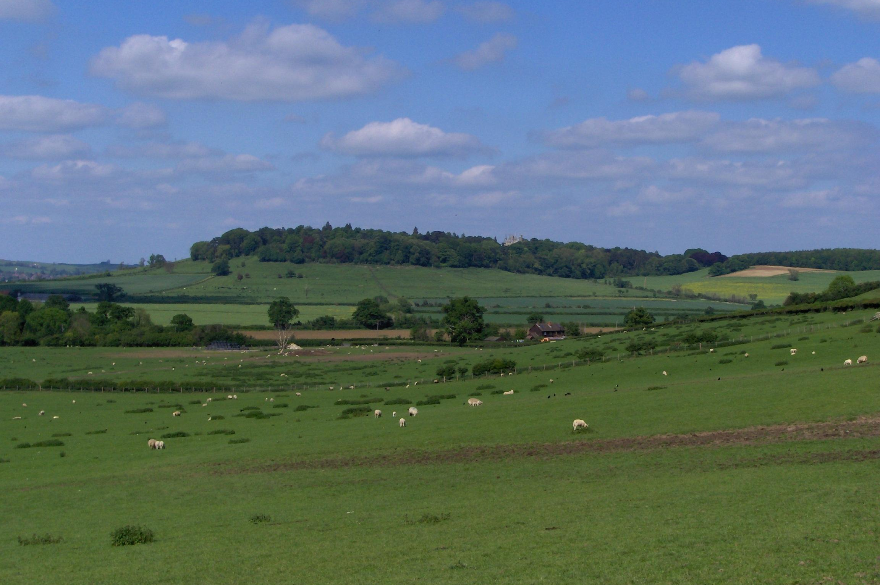

Lodge Hill seen from LCA 9.6 Ashendon Ridge. Waddesdon Manor and the historic gardens
are situated on this hill.

LCA 9.4 Waddesdon-Eythrope Parkland (LCT 9)

Summary of Condition/Sensitivity Analysis

Condition |  | Very Good
Pattern of elements:  Visual Detractors:  Visual unity:  Cultural integrity:  Ecological integrity:  Functional integrity: |  | Unified  Few  Strongly unified  Good  Strong  Very strong
Sensitivity |  | Very High
Distinctiveness:  Continuity:  Sense of place:  Landform:  Tree cover:  Visibility:  Guidelines |  | Unique/rare  Historic  Strong  Dominant  Intermittent  High  Conserve
Condition

The landscape is in a very good condition. The pattern of elements which make up the key characteristics of the area have a strong visual unity. Ecological integrity is strong due to good connectivity and the large areas of designated sites and habitats of District significance. The balance of good cultural features and strong ecological characteristics provides a very strong functional integrity to the area. There are few detracting features other than those associated with the A41 corridor.

Sensitivity

The landscape has a distinctive sense of historic continuity evident in the parkland and well wooded estate lands. Overall the sense of place is considered to be strong. Landform is a particularly distinguishing feature considered to be a dominant physical characteristic. Visibility is considered to be intermittent, screened internally by local woodland cover but providing panoramic views over the surrounding countryside from the fringes of the area. Overall the strong strength of character combined with high visibility give a landscape of very high sensitivity.

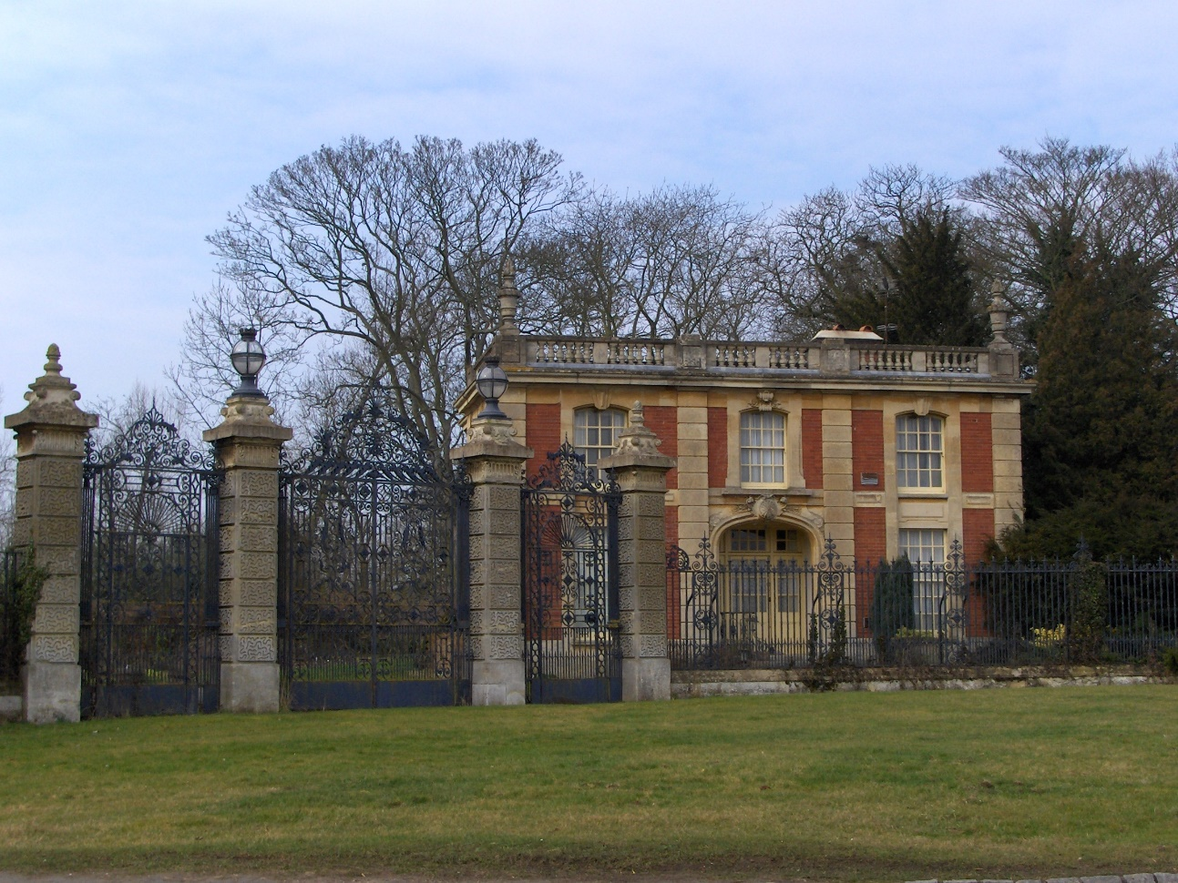

Lodge and entrance gates to Waddesdon Manor – at the junction of Waddesdon Hill and the A41 to the east of Waddesdon village.

LCA 9.4 Waddesdon-Eythrope Parkland (LCT 9)

Landscape Guidelines Conserve

Guidelines for Waddesdon – Eythrope are as follows:

- Encourage the long term management of woodland cover for its visual amenity value.
- Maintain the overall balance between agriculture and woodland ensuring that new woodland is concentrated on the upper slopes of the area.
- Maintain the field pattern on the lower slopes which creates the setting for the wooded estate lands.
- Encourage the management and replanting of the linear tree belts and avenues that link outlying parts of the estates.
- Maintain the condition and extent of unimproved and semi-improved grassland.
- Conserve and enhance the distinctive character of settlements and individual buildings.
- Encourage the establishment of buffer zones consisting of semi-natural vegetation along watercourses in arable areas to enhance biodiversity interconnectivity and landscape quality.
- Encourage the conservation and interpretation of the area’s rich historic environment.
- Ensure the preservation of archaeological earthworks by maintaining grassland.
- Maintain and improve connectivity of fragments of broadleaved woodland.
- Maintain extent of parkland.

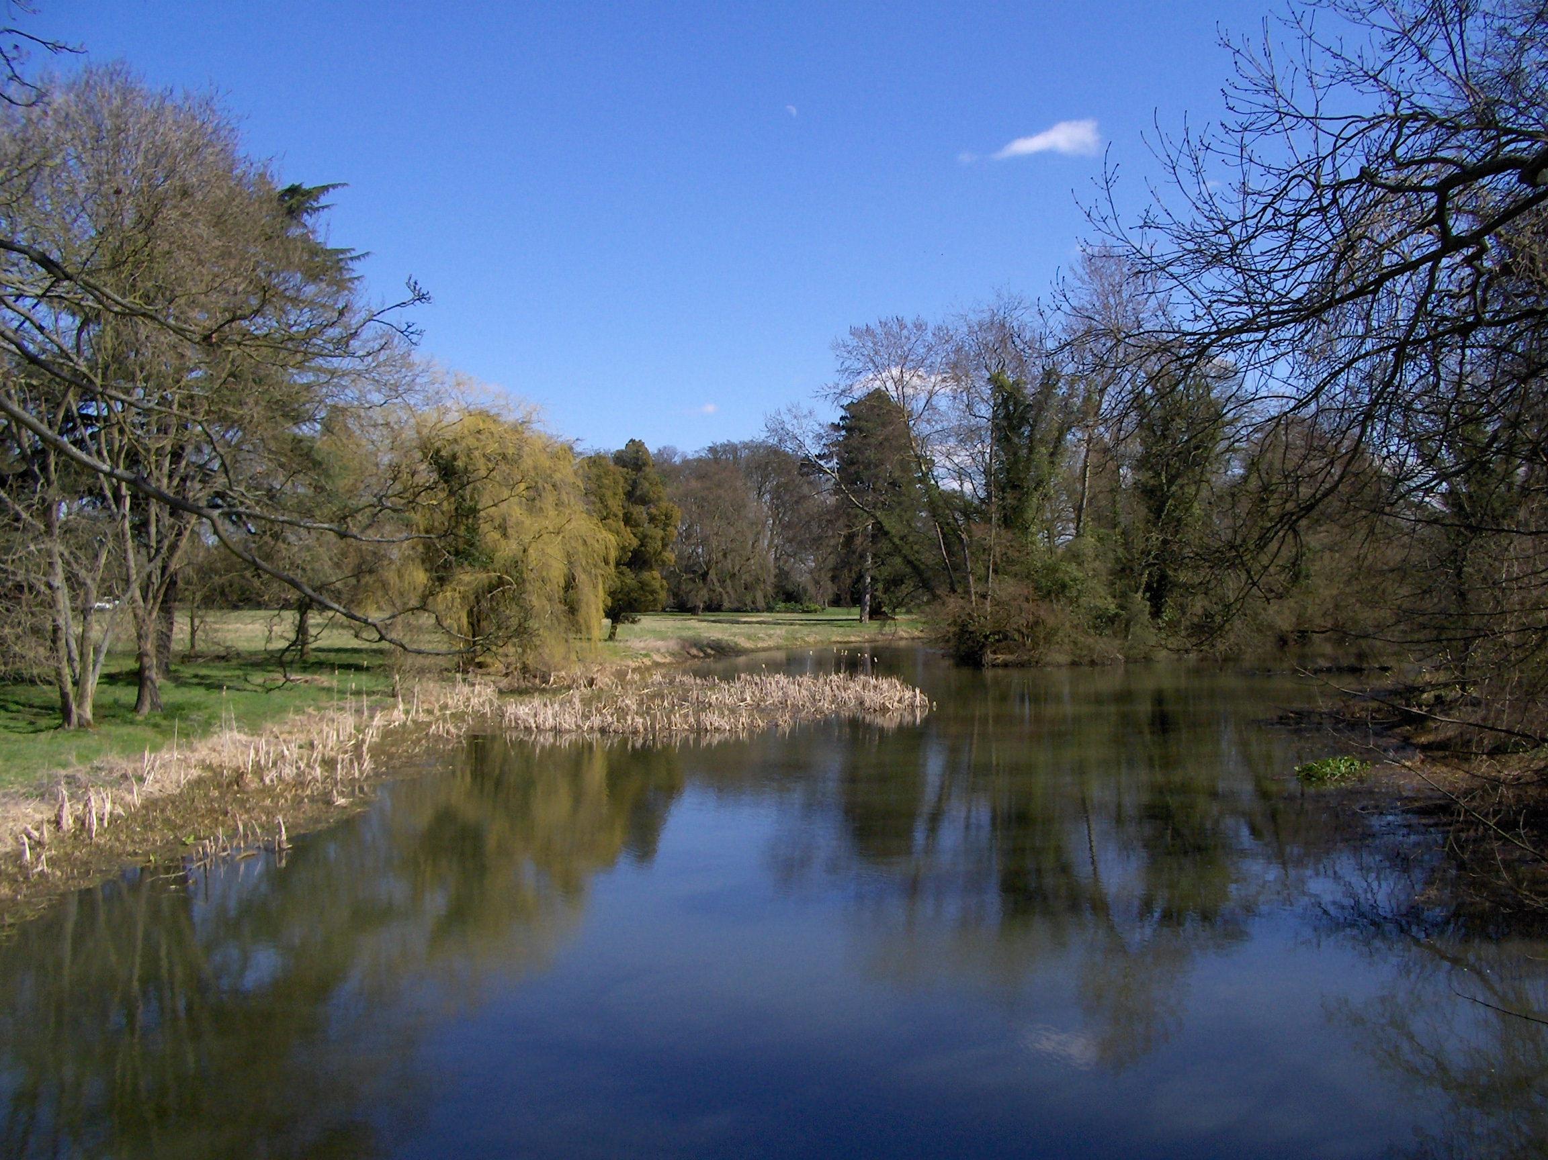

The ornamental lake at Eythrope looking east from the public footpath which forms part of four
promoted routes.

