LCA 7.1 Poundon – Charndon Settled Hills

Landscape Character Type: LCT 7 Wooded Rolling Lowlands

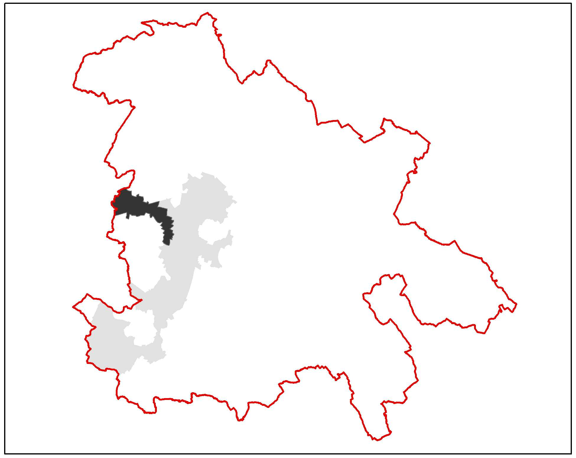

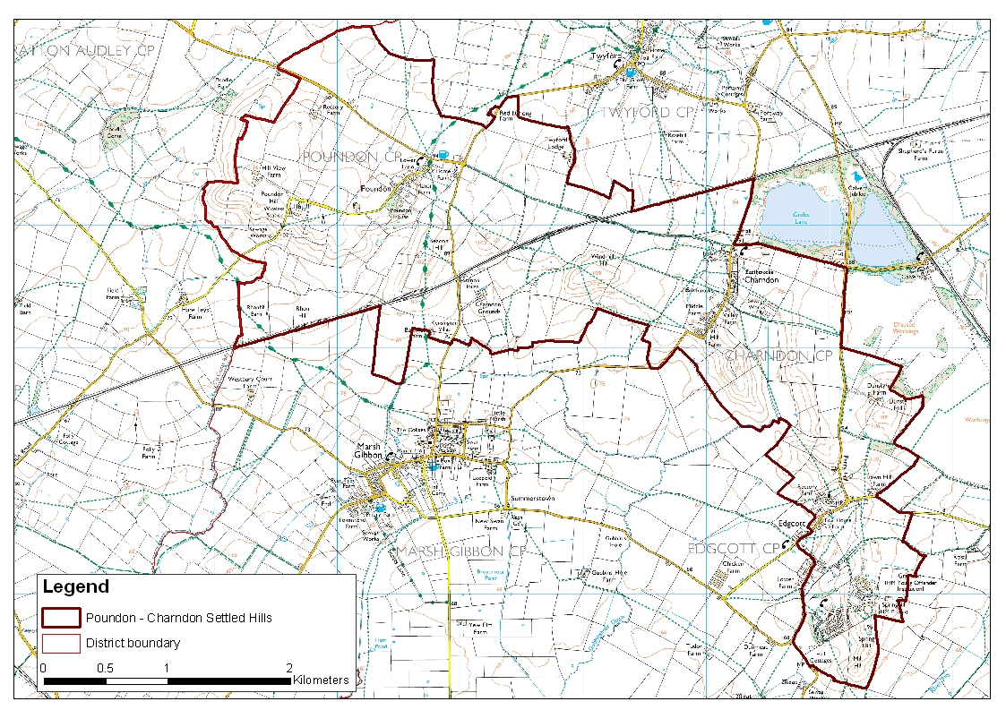

LCA 7.1 Poundon – Charndon Settled Hills (LCT 7)
Key Characteristics  - Line of small hills  - Predominantly pastoral farming  - Predominantly Parliamentary fields in east and pre18th century irregular fields around Poundon  - Low density of woodland cover  - Good views out in all directions  - Settlements straddle hills  Distinctive Features  - Ridge and furrow  - Narrow meandering lanes  - Disused railway  - Trees on top of small hills  - Linear villages of Charndon and Poundon  - Large blocks of neutral lowland meadow  Intrusive Elements  - Grendon and Springhill prisons  - Some hedgerow loss and prairie farming  - Communications mast at Poundon Hill | Location This linear area extends in an arc from the county’s western boundary.  Landscape character A line of linked low domed hills which form a small ridge across the surrounding lower farmland. The majority of the area is in grassland with some arable farming. The fields are generally small or medium sized. There is noticeably more pasture close to streamlines. There are only very small woodland fragments. There are several small settlements straddling the high ground. In comparison to the adjacent lower character areas this area is well settled. There are no roads along the top of the high ground but there are footpaths along most of the highest areas. Grendon and Springhill prisons are visual detractors at the far southern end. There are good views out across the surrounding lower ground, particularly from Poundon Hill where there is a communications mast and complex.  Geology An area of bituminous mudstone (Peterborough Member) overlain by a ridge of Stewartby calcareous mudstone. This in turn is overlain by glacial till at the western end of the ridge - the highest point along this feature.  Topography This is a line of small hills that run from northwest on the county boundary in a gentle curve down to the south. The hills are not high but have distinctly flatter ground to the north and south in the form of Twyford Vale LCA 5.4 and Marsh Gibbon Vale LCA 8.1. The elevation ranges from approximately 115m to 75m AOD. The highest hill being Poundon Hill on the western edge of the area.  Hydrology The area has very little in the way of watercourses with only a few straightened streams or ditches running off the area. Ponds are scattered quite densely across the area particularly on higher ground.  Land use and settlement This is a predominantly pastoral area with less than a third in arable use. The small historic settlements tend to straddle the hills. The Grendon and Springhill prisons are on the southern edge of the area. The hills are not very accessible by road but footpaths run along the top of most of the high ground.  Tree cover There is little woodland within this area. The tree cover within hedgerows is variable with some notably poor areas. Trees on the top of the small rounded hills are a feature.  Biodiversity The majority of the area is composed of grassland habitat, although a fair amount of arable land is also present. A relatively high proportion of the grassland is unimproved and the area contains one large central block of lowland meadow, a priority habitat type which forms the Lawn Farm Tinkers Hole CWS – three unimproved fields of ridge and furrow with subtle variations and a wide array of floristic interest and each with a pond.  Woodland habitat is restricted to small broadleaved copses scattered throughout. Hedgerows within the area are intact and well connected. Those seen during the field assessment were noted for the presence of oak and ash trees, hawthorn and field maple. Small areas of standing water, mostly ponds, are the main aquatic habitats.  Historic environment This landscape was part of Bernwood Forest in the early 13th century. Bernwood had been a hunting ground from the time of Edward the Confessor. It grew to its largest extent under Henry II but the whole area was not covered by woods; in the medieval period a forest was a place where deer roamed for hunting and also included arable open fields, common grazing land and villages.  The landscape is predominantly agricultural containing a mixture of enclosure patterns; around the villages of Poundon they are irregular shaped fields dating before the 18th century, by contrast the fields to the west around the village of Charndon are more regular in shape indicative of parliamentary enclosure  The area contains several small villages, all of them having nucleated row settlement pattern. The most westerly village, Poundon, contains a few listed buildings although the most significant feature is the early 20th century mansion and designed landscape of Poundon House, used by the Special Operations Executive (SOE) during the Second World War for the development and cracking of codes and ciphers. To the south is the village of Edgcott which contains a notable 12th century church and manor farm dating to the 17th century. The village of Charndon is to the east, this settlement was larger in the medieval period and around the present village there are the earthworks of house platforms, hollow-ways and paddocks for keeping animals. There is also a low earthwork on either side of a stream south of Sheephouse Wood and it was suggested it could have been the foundations for a small bridge. Other archaeological remains are good surviving examples of ridge and furrow, found around Charndon and Edgcott. In terms of industrial heritage the area is dissected by the mid19th century Bletchley to Oxford railway line which is currently disused.  The landscape is promoted through Bernwood Jubilee Way guides  Designations  Archaeological Notification Areas – 12 No.  CWS – 2 No.  BNS – 1 No.

LCA 7.1 Poundon – Charndon Settled Hills (LCT 7)

View looking down from the top of the hills. In the background the landform of another hill

can be seen with the settlement of Charndon straddling the rising ground.

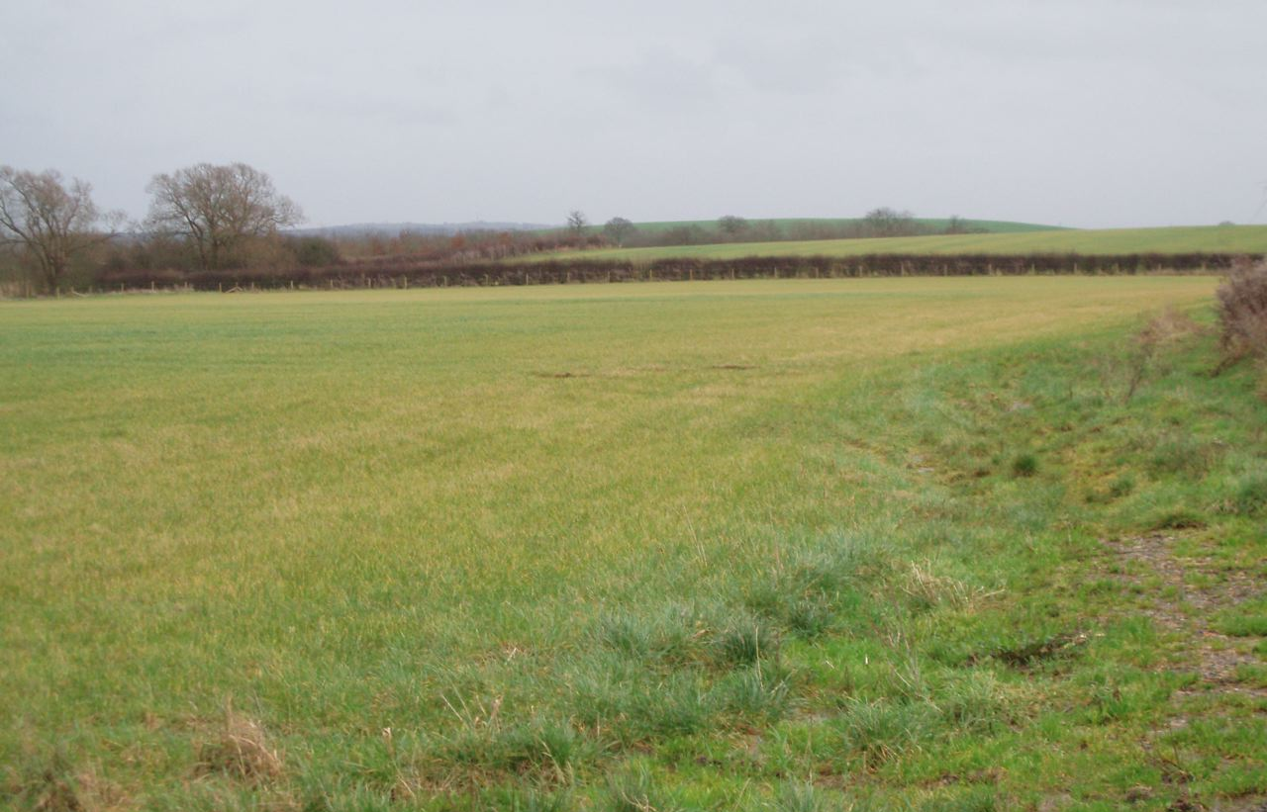

Typical view along the hilltop showing the open landscape and domed character of the hills.

LCA 7.1 Poundon – Charndon Settled Hills (LCT 7)

Summary of Condition/Sensitivity Analysis

Condition |  | Good
Pattern of elements:  Visual detractors:  Visual unity:  Cultural integrity:  Ecological integrity:  Functional integrity: |  | Unified  Few  Strongly unified  Variable  Moderate  Coherent
Sensitivity |  | Moderate
Distinctiveness:  Continuity:  Sense of place:  Landform:  Tree cover:  Visibility:  Guidelines |  | Distinct  Historic  Moderate  Apparent  Intermittent  Moderate  Conserve and Reinforce
Condition

The condition of the landscape is good. This reflects the landscape, which is generally unified by its hedgerow and settlement pattern and has few visual detractors. The area is therefore strongly unified. The cultural integrity is variable being strongest close to the historic settlements with good field pattern and weakest where there are areas of prairie farming. Ecological integrity is moderate despite scoring highly for the presence of priority habitat types, because connectivity could be improved, and the areas of designated sites and broad habitats of district significance are low.
The functional integrity is therefore coherent.

Sensitivity

The landscape has a distinctive character and a good sense of historic continuity. This produces a moderate sense of place. The landform is apparent but not generally dominant, the tree cover is very intermittent combining to give a moderate visibility. Overall the sensitivity of the landscape is considered to be moderate.

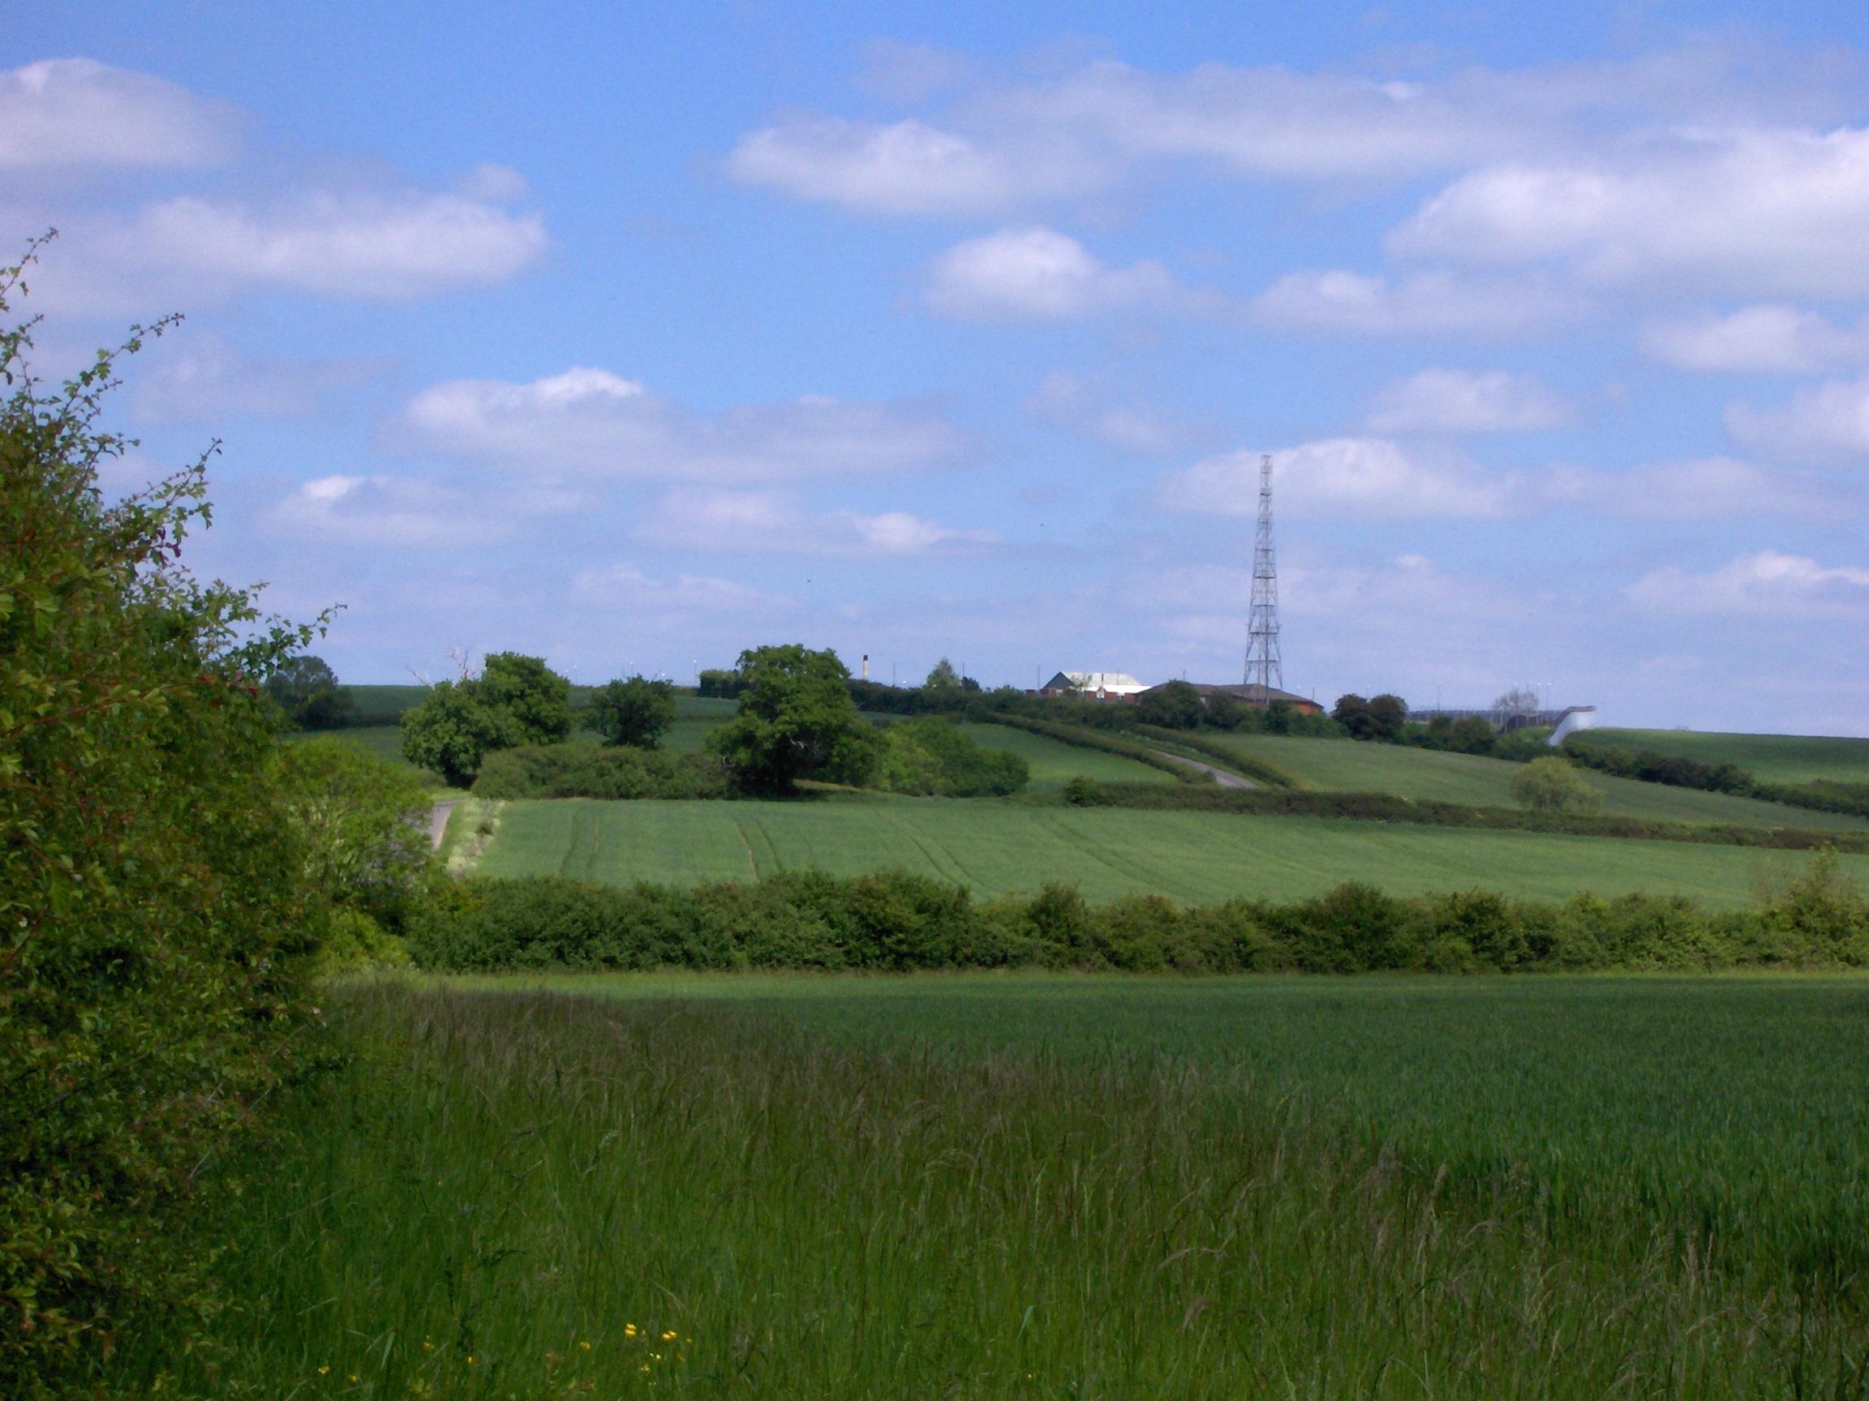

Poundon Hill seen from the south from just beyond the county boundary. The communications mast
is widely visible.

LCA 7.1 Poundon – Charndon Settled Hills (LCT 7)

Landscape Guidelines Conserve and Reinforce

The landscape guidelines for the Poundon-Charndon Settled Hills are as follows:

- Encourage the retention and strengthening of the historic hedgerow pattern by infilling gaps and establishing new hedgerow trees.
- Where the historic field pattern has been lost encourage replanting to restore landscape character, cultural integrity and biodiversity.
- Maintain and improve the condition and extent of hedgerows through traditional cutting regimes.
- Maintain the condition and extent of neutral unimproved and semi-improved grassland wherever possible. Encourage good management practices.
- Promote connectivity of habitats, including woodland copses.
- New housing and alterations to existing housing should be designed to reflect the traditional character of the area and use locally traditional materials.
- Retain and enhance views from publicly accessible land.
- Maintain the strong rural character of minor roads with management of verges and hedgerows.
- Promote and maintain recreational routes along high ground.
- Encourage the preservation of historic earthworks and ridge and furrow by maintaining a continuous grass sward and do not allow bare patches of soil to develop.

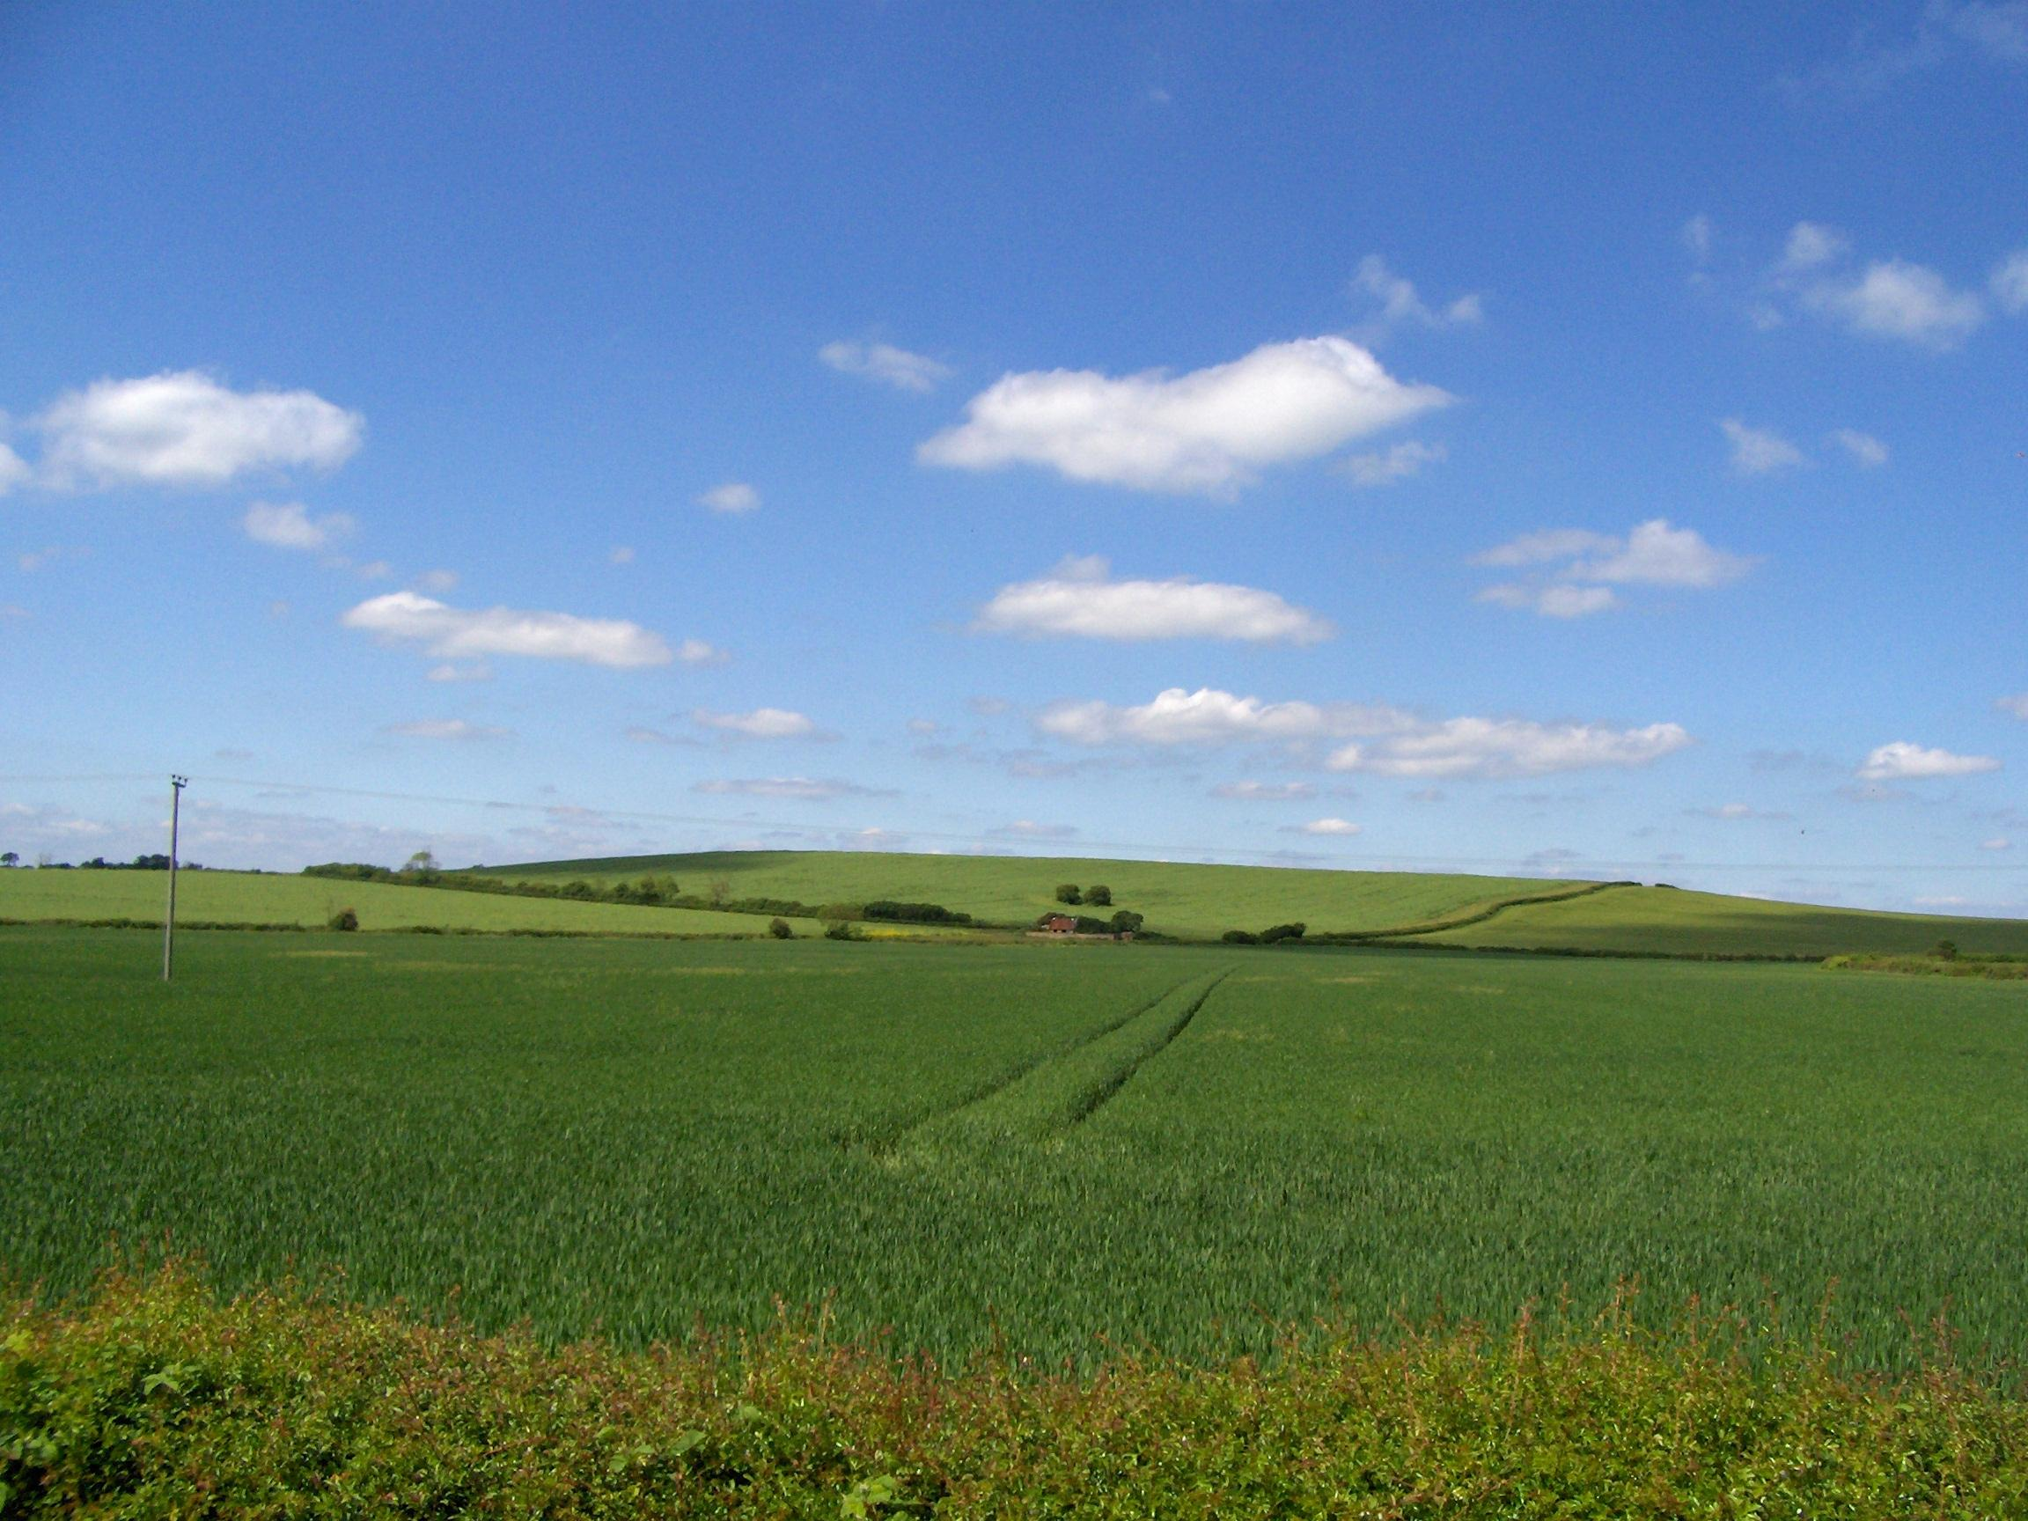

The more open landscape of Windmill Hill is very evident in this view from the south.

