*Insert name / crest*
Community Emergency Plan

Plan Date: | Plan Version:
Plan Owner: | Date for Review:

VERSION CONTROL
Version | Reviewed by | Amended | Date released

Contents
Contents

Document Administration 2
Aim & Objectives 2
Emergency Response Team Contacts 2
Activation triggers 4
Notification of an Incident 4
First Steps in an Emergency 5
Community Emergency Response Team – Roles and Responsibilities 6
Emergency Response Team control room 6
Actions agreed with emergency responders in the event of an evacuation 6
Alternative arrangements for staying in contact if usual communications have been disrupted 6
Telephone Tree 8
Key Locations 9
Useful Numbers 10
Local Skills 10
Local Resources 10
Local Companies Facilities / Contacts 11
Community Organisations / Groups Caring for Vulnerable people 11
Volunteers To Help in An Emergency 11
Local Risk Analysis 12
Draft Agenda for First Meeting of Community Emergency Group 16

Document Administration

Plan Ownership & Maintenance
Name/s of person/s responsible for the plan, routine tests and maintenance, updates to contacts, and sharing of the plan

Plan distribution list:

Name | Role
 | Community Emergency Response Team
 | Thames Valley Police
 | Buckinghamshire Council Resilience Service
 | Local Environment Agency officer
 | Local Flood Warden

Emergency Response Team Contacts

Name | Title | 24 / 7 contact information | Home Address  Email address / telephone number

These can also be added to a WhatsApp group (or similar, for instant messaging)

Aim & Objectives

Aim:
For example: To provide a framework to cope with emergencies or events affecting the community.

Objectives:
For example:
- To establish a Community Emergency Response Team to coordinate and liaise with the emergency services / Local Authority as appropriate
      - To identify actions to minimise harm from identified risks
      - To consider ways of identifying vulnerable people in the community with a view to supporting them in an emergency
      - Identify skills, resources, and equipment your community already has that can be used, if needed, during or after an emergency.
- To establish key contacts for the Community Emergency Response Team, community resources, the emergency services, and Local Authority.

Activation triggers

Use this space to record how your plan will be activated. Include how the plan will be activated because of a call from the emergency services, and how your community will decide to activate the plan yourselves. Examples are in the accompanying Guide.

Notification of an Incident

If you become aware of a serious incident happening or threatening to develop, call the emergency services, if appropriate. Then contact the Emergency Response Team leader with the following information:
- Your name, contact telephone number, address / location
- Full details of the incident as far as you can ascertain without putting yourself at risk:
  - When
  - Where (exact location)
  - What happened and what is happening now
- Emergency Services requested
- Estimated human casualties
- Estimated animal casualties (if any)
- Hazards and road blockages

First Steps in an Emergency

This section is an aide memoire for those listed in the plan as being the first point of contact in activating the plan. Emergencies could happen at any time, and it is useful to have a short one sheet reminder of the first steps to take to begin the activation of the plan.

 | Instructions | Tick
1 | Example: Call 999 (unless already alerted)
2 | Ensure you are in no immediate danger
3 | Start keeping a log and record:  - Any decisions you have made  - Action taken  - Who you spoke to and what you said  - Any information received
4 | Contact other members of the Community Emergency Response Team and members of the community that need to be alerted:  - Those specifically at risk  - Other members of Parish Council via agreed route  - Volunteers and key holders where appropriate
6 | If necessary, contact the Community Emergency Response Group to call a community meeting.  NB: ensure the venue is safe and people can get there safely
7 | Take notes and record actions from the meeting.
8
9
10

Community Emergency Response Team – Roles and Responsibilities

Within the Community Emergency Response Team, specific roles should be delegated to individuals (there may be some with multiple roles). Such roles may include:

- Team Leader
- Deputy Team Leader
- Liaison with voluntary organisations / helpers
- Liaison with emergency services / Local Authority / NHS
- Liaison with community centre / rest centre

Emergency Response Team control room

The location of the Emergency Management Team control room is | Check the locations are suitable – do they have  - Phone lines  - mobile phone coverage  - Email / internet connectivity  - Tables, chairs, wall space (for maps, black boards and / or flip charts for lists etc.)  - Catering equipment (for extended operations)  - Toilets
The alternate location is:
Community Emergency Kit / go box may include
First Aid Kit
Hazard Tape
Gaffer Tape
LED Torches
Extension Lead
Two-way radio’s
Stationery (paper, pens, note pads etc.)
Logbooks

Actions agreed with emergency responders in the event of an evacuation

[Use this space to record details of the actions you can take to help your local authority if an evacuation is necessary in your community.]

1. Help police/local authority with door knocking
2. Tell emergency services who might need extra help to leave their home
3. Contact volunteers to support these activities or support Rest Centres

Alternative arrangements for staying in contact if usual communications have been disrupted

Communication Type | Name of contact | Location
Radio | RAYNET - John Spring | 22 Larch Street, Anytown
WhatsApp Groups | Your Neighbourhood friend or  Community Board Manager | Online

Telephone Tree
The phone tree works with the coordinator (at the top) making the first call to two or more people. In turn, they call the assigned set of people and so on, until the tree is complete.

Community Emergency Coordinator

Contact number
Deputy Community Emergency Coordinator  Contact number |  |  |  | Mrs. A Sample  Contact number
Mr. B Neighbour  Contact number |  | Mrs. B Neighbour  Contact number |  | Mr. C Neighbour  Contact number |  | Mrs. C Neighbour  Contact number
Mr. D Sample  Contact number | Mrs. D Sample  Contact number | Mr. E Sample  Contact number | Mrs. E Sample  Contact number | Mr. F Sample  Contact number | Mrs. F Sample  Contact number | Mr. G Sample  Contact number | Mrs. G Sample  Contact number

Key Locations

Building Name | Address | Facilities available | Key holder Contact details | Other Comments
Example: Church Hall | 1 Church Square | Toilets, very small kitchen | Colin Molesworth – Warden – 07749 8557xx | 1st Choice in an emergency
High School | Whatley Street | Toilets, Showers, Disabled Access | Jane Shulman – Caretaker – 07749 8655xx
 |  |  |  | Rest Centre – some will be pre-arranged with Buckinghamshire Council

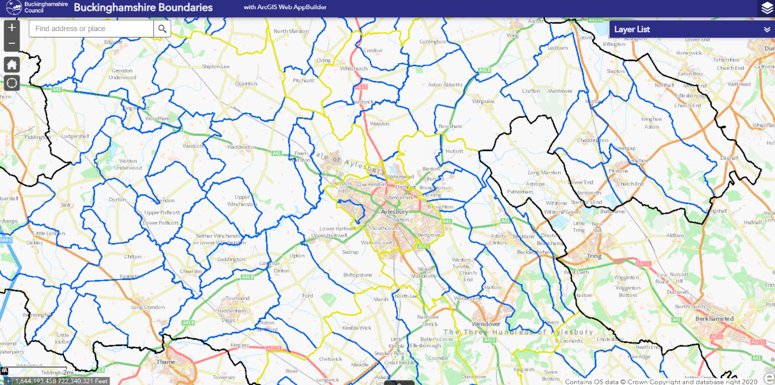
This section could include maps of these centres and floor plans for buildings. – for example.

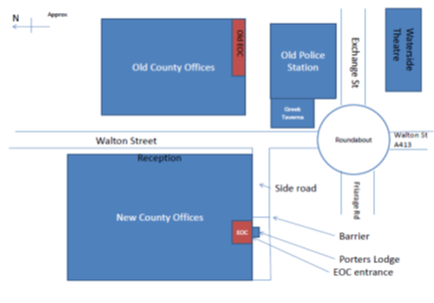

Useful Numbers
Name | Organization | Tel Number
Thames Valley Police |  | 101
Environment Agency | Flood line  Incident line | 0845 988 1188  0800 80 70 60
Thames Water |  | 0845 9200888
Power Cut |  | 105
British Gas |  | 0800 111 999
Buckinghamshire Council Duty Resilience Officer | Buckinghamshire Council | 01183 589332 / 07738 501 318
In addition to important local contacts, the plan should contain contact details of organisations with an emergency response role including local utility companies and the Environment Agency.

Local Skills
Skill/resource | Who? | Contact details | Location
Example:  Trained first aider | Sandy Forman | 01700 5668xx | 17 Brookvale Street
4x4 owner/driver | Bob Southwold | 01700 5648xx | Garages to read of High Street
Chainsaw owner (tree surgeon) | Simon Chalmers | 01700 5605xx | Simon’s Landscaping – 4 Terrace Yard
Doctor
Nurse
Plumber
Electrician
Caterer

Local Resources
Resource | Who? | Contact details | Location
Water/food supplies | Village Shop | 01700 5608xx | 2 High Street
Spare Bedding
Spare clothing
Torches
First Aid Kits

Local Companies Facilities / Contacts
Company | Type of Business | Contact | Availability | First Aider | No of  staff | Other facilities
 | Newsagents
 | PO & general stores
 | Counselling
 | Local Public House

Community Organisations / Groups Caring for Vulnerable people
[Contact details of organisations / groups in your area that are responsible for caring for vulnerable people].
Name | Title | Telephone | Email address | Home Address
Care Home
Hospice

Volunteers To Help in An Emergency
[Use this space to record the contact details of groups or individuals in your local area who have agreed to make themselves available to look after the vulnerable in an emergency].

Group / Individual | Contact details  (24 / 7 preferable) | Capabilities / skills | Comments / Notes

Local Risk Analysis
Risk | Impact on the community | What can you do to prepare or what actions could you take in this scenario to help your community?
National Power Outage: Failure of the national electricity transmission system for up to 7 days. | - Cascading failures to essential services (transport, water, sewage, gas, food, fuel, and finance  - Immediate loss of lighting, heating, and cooking - From 2 hours onwards food quality deteriorates  - Most mains water and sewage systems fail in 12-48 hours. Water treatment and sewage treatment systems will only return to normal once continual power is restored.  - Immediate loss of power to trains, stranded passengers  - Loss of Telecommunications including mobile and internet within about 2 hours  - Significant disruption to public services, business and households resulting (closure of schools, shops, fuel stations, health care services, surgeries, pharmacies)  - Disruption to health care and emergency services - backup generators providing power to most critical services only  - Severe staff absence due to transport disruption and school closures  - Potential public disorder  - Potential loss of life. | - Designated location in your community everyone in your CERT go to once they realise there has been a National Power Outage  - Set-up a physical location where community members can go for more information, to get help and communicate this through whatever means possible  - Check the welfare of the most vulnerable in the community and those that are reliant on power  - Door knocks to let people know of the situation and that they can get help by attending your preprepared location in the community  - Identify radio amateurs in the community who could help pass key messages  - If urgent help is required and no communications are working send a community member to the main office of the local authority
Regional or Local Power cuts: Mains power supply disruption affecting large parts of community | - As above although effects will be less severe as telecommunications, internet and electricity would be available in different areas. | - Door knocking to check the most vulnerable  - Reporting any vulnerable people to the electricity provider for the area
Gas Supply Disruption:  Mains gas supply disruption affecting large parts of the community. | - No piped gas supplies  - All gas heating systems stop working  - People may have no hot water  - Gas appliances left on cause further hazards when restored (explosion, carbon monoxide poisoning)  - Demand for alternative heating may overload the local electricity network causing power failures  - People turning to mobile gas heaters with demand for gas bottles increasing – carbon monoxide poisoning or increase risk as gas explosion / or fires  - Increased risk of hypothermia /cold related disease  - People reliant on gas for cooking unable to cook or turning to electric or other fuel for cooking | - Door knocking to check the most vulnerable  - Report vulnerable people to the electricity provider for the area  To reconnect supply the ‘gas’ company that manages the network in your area will need to  a. visit every house to ensure supply is shut off  b. once fixes are made, revisit every house to turn supply back on and check for any safety issues.  Note: Provision / purchase of a lot of electric heaters could result in overload of the local electricity network leading to power outages.
Water Supply Disruption:  Mains water supply disruption affecting large parts of the community. | - No drinking water in the community via piped supply  - Bottled water becoming unavailable in the community as demand increases  - Sanitation and washing issues  - School and other service closures  - Business closures | - Pre-plan locations the water company could put bottled water distribution stations  - Provide community liaison at water distribution points  - Pass key messages to the community from the water company  - Help identify and check on the welfare of the most vulnerable in the community  - Report vulnerable customers / settings to the water company
Fuel Supply Disruption: Actual or threatened significant disruption to the distribution of fuel (Petrol/Diesel/Red Diesel) for at least 10 days. | - Unable to access fuel  - Traffic congestion around fuel stations  - Public disorder around fuel stations  - National restrictions implemented  - Local restrictions implemented by fuel stations  - Vulnerable may not get normal health and social care  - People unable to travel or get to work | - Pass on key local impacts to responders  - Help identify vulnerable people that may need additional assistance in the community
Flooding  Could be fluvial (river flooding), surface water or flooding from a reservoir/dam failure). Following sustained heavy rainfall, possibly combined with snow melt, surface water, and reservoir/dam failure flooding.  Include any detail here of known flood risks in the community: rivers, brooks, ditches, known areas with surface water flooding issues etc. | - Roads flooded and impassable  - Stranded vehicles  - People stranded in their homes  - Homes and businesses flooded  - Evacuation  - People unable to return to the community | - Communicate risk to the community based on Environment Agency warning levels  - Monitor river levels  - Report surface water flooding on roads to the Local Authority Highways  - Report property flooding  - Deploy /use Community Flood Kit / Defences  - Identify places of safety outside the flood risk areas that people can be evacuated to  - move vehicles to a safe area  - turn off power (unless using a pumped flood system)  - close windows and doors if safe to do so  - retreat to a safe place (such as upper level of building or a friend's house) and lock doors  - move pets, items of value and grab bag upstairs or raise off the floor  - keep phones, chargers, bank cards, insurance details and house keys to hand  - ensure neighbours know a flood is predicated / happening and help if possible
Heatwave:  an average threshold temperature of 30 °C by day and 15 °C overnight for at least two consecutive days. | - Melting roads and footpaths  - Increased dehydration  - People with chronic diseases at greater risk  - Radiation (sun burn)  - Respiratory and cardiovascular risks increase  - Heat exhaustion and heatstroke  - Increase risk of fires  - Increase risk of utility failure | - set-up cool spaces for community to use  - check the welfare of the vulnerable in your community  - pass keeping cool messages to the community  Public advice Heatwave: how to cope in hot weather
Low temperatures and heavy snow:  Mean temperature below 2°C for 48 hours or longer and / or heavy snow and / or widespread ice | - Roads blocked or impassable  - Dangerous roads and footpath due to ice  - Heating systems fail  - People become stranded or cut off from community or services (especially the vulnerable)  - Schools may close  - Increase risk of utility failure  - Increase in car accidents, slips, trips, and falls  - Hypothermia and frostbite  - Carbon monoxide poisoning | - set-up warm spaces for community  - check the welfare of the vulnerable in your community  - pass key safety messages to the community  - form a snow clearance team to help keep key services running  - arrange local gritting of footpaths or know danger areas  Met Office: How cold weather affects your health
Telecommunications Disruption: Up to 7 days of national telecoms disruption, with potential for areas to experience disruption longer. | - Mobile phones not working  - Landline phones not working  - Internet access failure  - Inability to contact anyone, including emergency services | - Designated location for everyone in your CERT go to once they realise there has been a national telecoms outage  - Identify radio amateurs in the community who could help pass key messages
Infectious Animal Disease: | - Restrictions put in place on animals and farms  - Animal Disease Control Zones to all or parts of your community | - Help identify locations for animal disease control zone road and footpath signage  - Help communicate key messages within the community
Other risks could include Severe weather, Severe space weather, Major transport accidents, Industrial accidents, Major fires / explosions, Industrial action, Firearms incident, Unexploded Ordinance (old bombs or explosives), Hazardous materials incident,  Malicious attacks (terrorism), cyber- attacks  See the latest National Risk Register | - Evacuation: An evacuation of parts of your community due to an incident.  - Stranded passengers e.g., from rail, bus of stranded motorists in the area | - Pre-identify places of safety that people could be evacuated to (including key holders and emergency contact details, size, facilities available).  - Consider how you can help communicate quickly with the community should the need for evacuation arise  - Consider what equipment and resources you might need to help those affected  Work with your Local Authority Emergency Planning Team / Resilience Service

Draft Agenda for First Meeting of Community Emergency Group

Date:
Time:
Location:
Attendees:

1. What is the current situation?

You might want to consider the following:
Location of the emergency. Is it near:
- A school?
- A vulnerable area?
- A main access route?
- Type of emergency:
- Is there a threat to life?
- Has electricity, gas or water been affected?
Are there any vulnerable people involved?
- Elderly
- Families with children
- Non-English-speaking people.
- What resources do we need?
- Food?
- Off-road vehicles?
- Blankets?
- Shelter?

2. Establishing contact with the emergency services

3. How can we support the emergency services?

4. What actions can safely be taken?

5. Who is going to take the lead for the agreed actions?

6. Any other issues?

