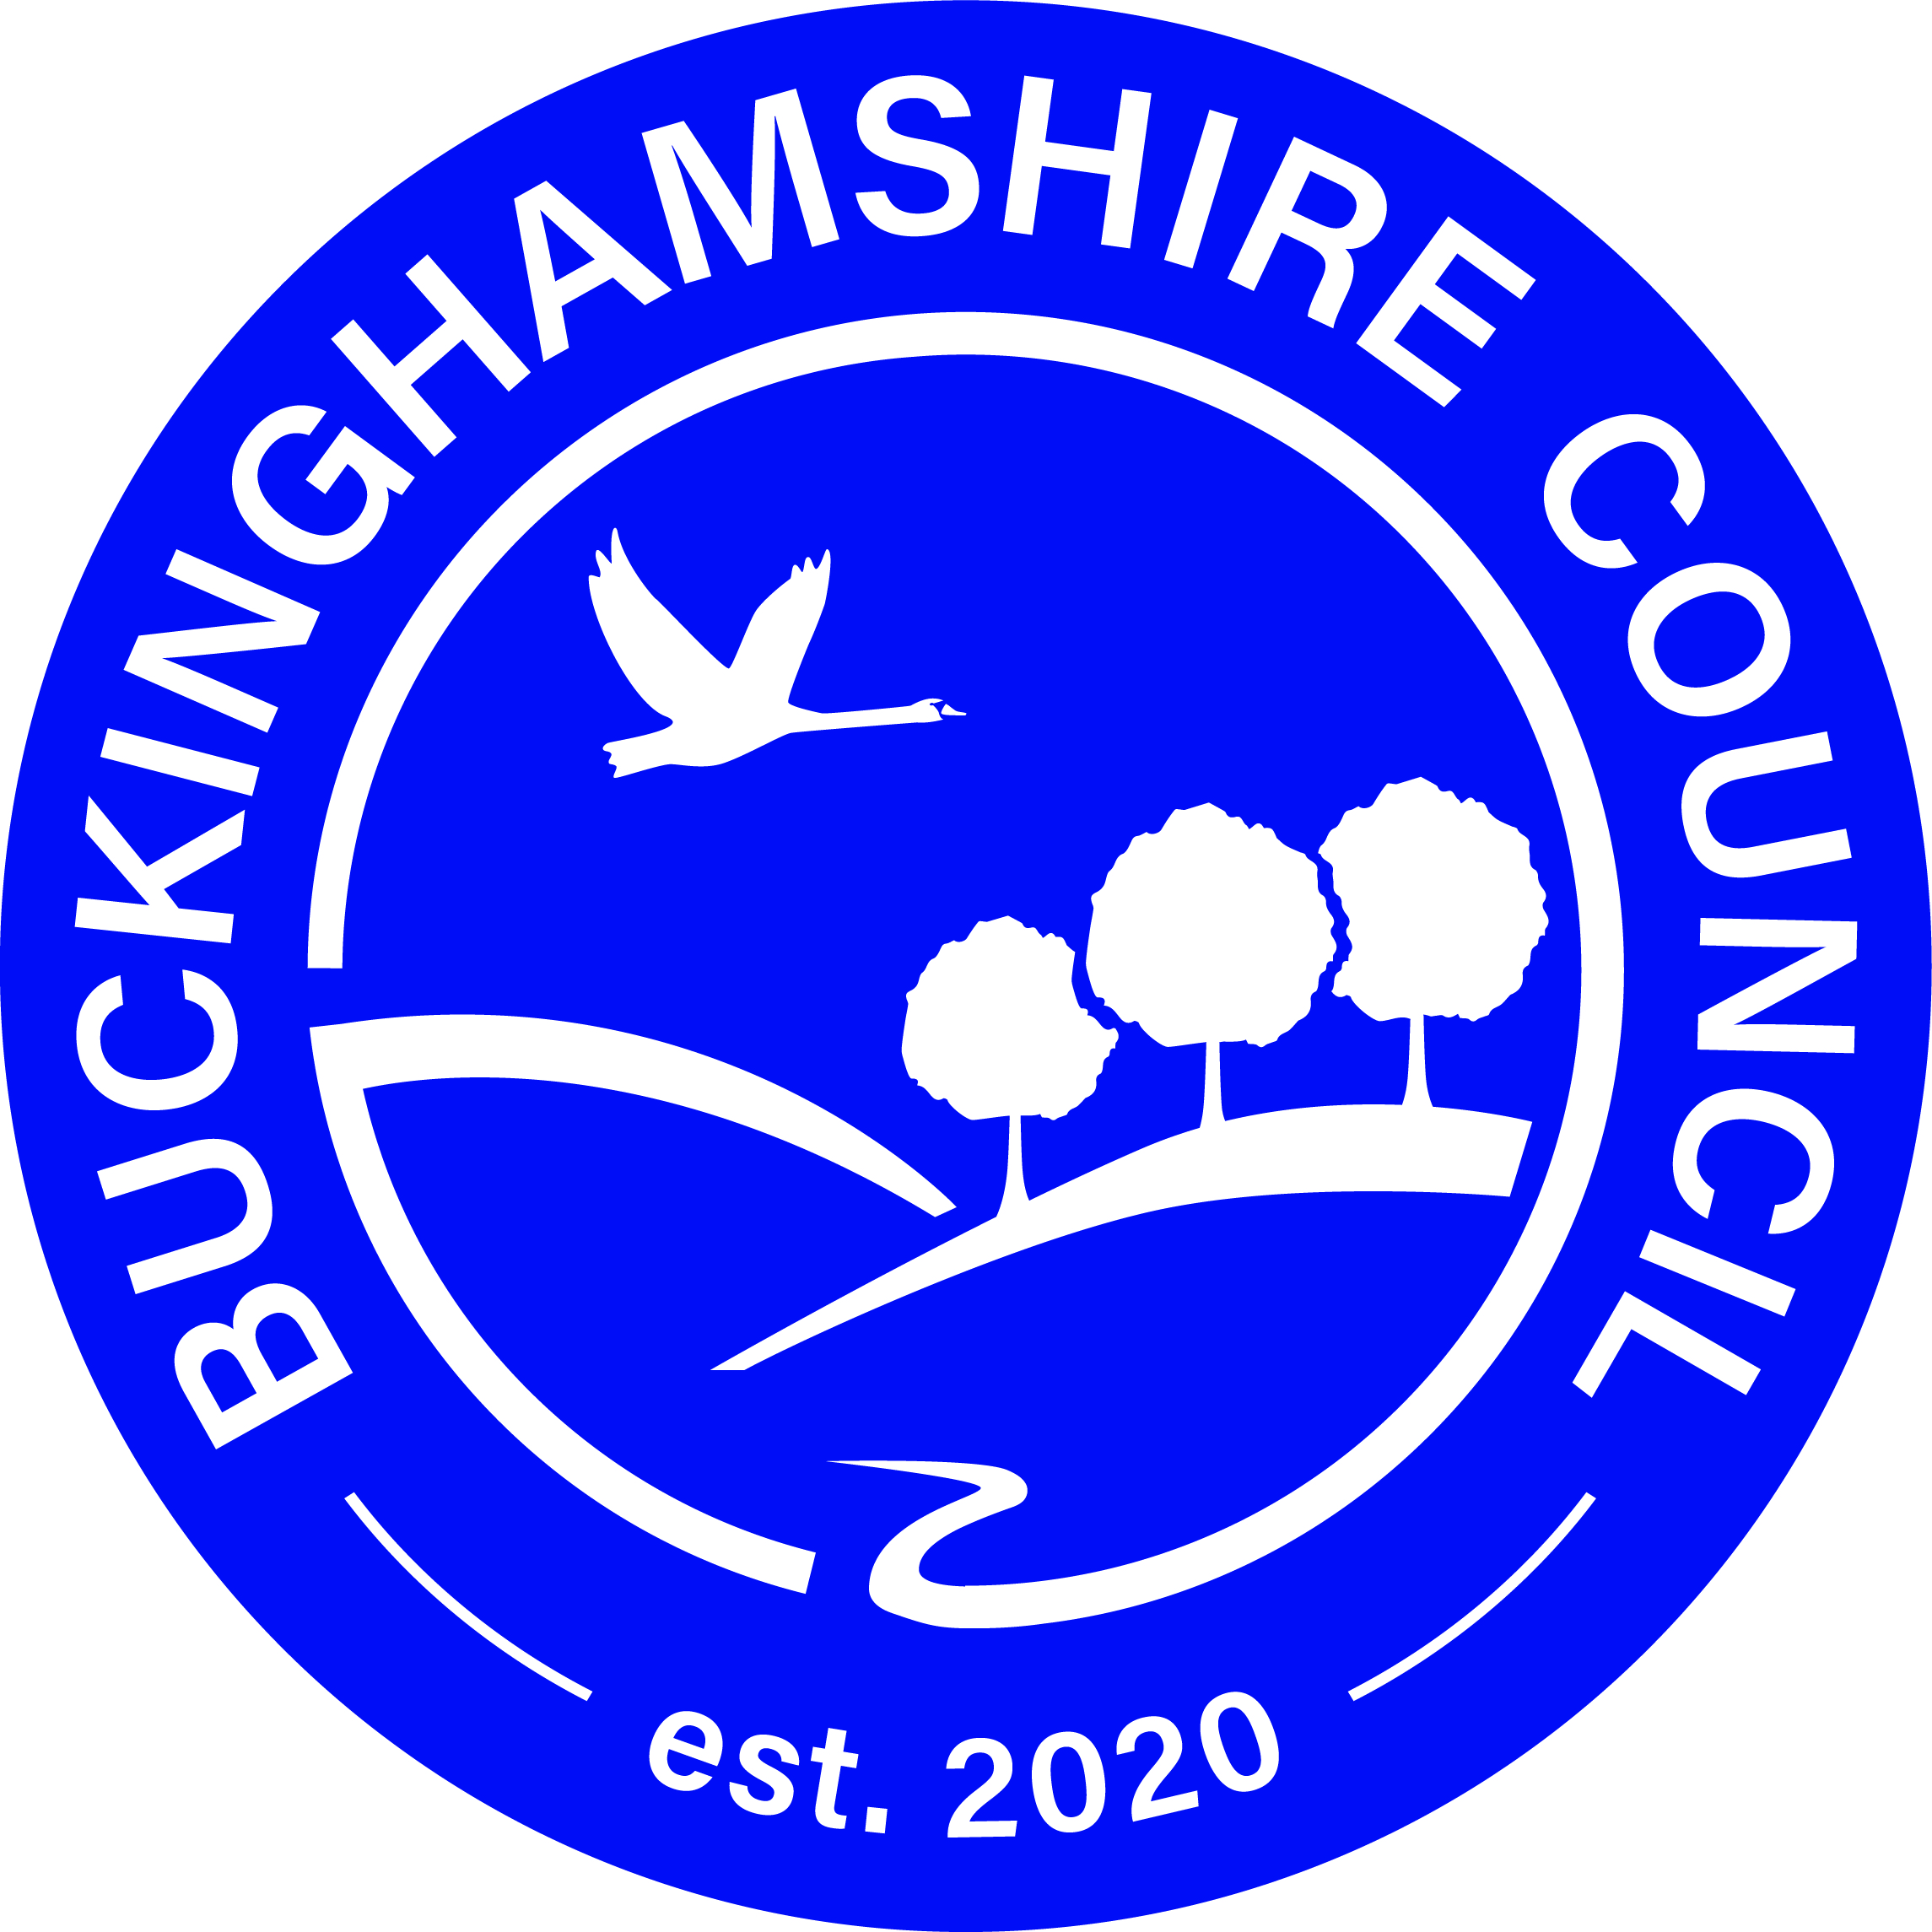

Tourist and Private Sign Application Form

APPLICATION FORM Ref:

Please complete **ALL** questions (IN CAPITALS) in **SECTIONS 1** and **5** and those questions in **SECTION 2** applicable to your particular establishment

**- FAILURE TO DO SO WILL DELAY YOUR APPLICATION ASSESSMENT**

**This tourist signing policy – which is not retrospective - was agreed by Council members on 26 September 1996, and complies with Department of Transport’s guidance note Circular Roads 3/95. It followed extensive consultations with neighbouring Councils, all councils in Buckinghamshire and the Regional Tourist Board and secures a consistent regional tourist signing policy. Council members endorsed the retention of this policy on 25 May 2000.**

**All applications for Tourist Signing in Buckinghamshire have to satisfy four criteria: general eligibility, specific eligibility, site and financial criteria. These have been developed to avoid a proliferation of signs on the highway and to ensure that tourism objectives are balanced against road safety, traffic management and environmental considerations.**

SECTION 1: General Eligibility For Signing A.

Is your business a permanently established (excursion) destination/attraction or facility which attracts, or is used by, visitors to the area, and is open to the public without prior booking, during its normal opening hours? (NB: A tourist destination/attraction is an establishment that offers recreational, cultural, educational or historical interest, eg, stately homes, monuments, museums, zoos, theme parks, parks and gardens. With regard to visitor facilities, signs will be provided for the benefit of tourists/visitors who require accommodation, pubs, restaurants, cafes, shops, etc).

YES NO

If YES, please state the hours of opening:

B. Does your establishment comply with all applicable requirements such as planning permission, registration with the Tourist Board, a fire certificate or registration under the Food Safety Act (where required)?

YES NO

If YES, please supply current details (including copies of registrations or certificates)

C. Is your establishment recognised by the Visit England or Local Authority and does it take part in an appropriate Quality Assurance Scheme e.g. the AA, RAC?

YES NO

D. Has your establishment signed the English Tourist Board’s Visitor Charter?

YES NO

Registration for the Charter is free of charge (English Heritage and National Trust properties are exempt from this requirement). Details are available from the Southern

Tourist Board, 40 Chamberlayne Road, Eastleigh, Hampshire SO50 5JH. Tel. No. 023 8062 5400 Fax No. 023 8062 0010

E. Do you already publicise what your establishment has to offer and the route tourists

should take to find it?

YES NO

If YES, please attach appropriate brochures / adverts / leaflets / guide book entries / press

advertisements etc with your application.

F. Does your establishment have use of a car park?

YES NO

If YES:

1. Is it your own? YES NO

2. Number of spaces?

3. Do you accept coaches? YES NO

4. Is the car park on site? YES NO

If you have answered NO to 4, please give details:

YES NO

G. Does your establishment cater for disabled people?

YES NO

If YES, please give details:

# SECTION 2: Specific Eligibility Criteria

## Hotels and “Bed & Breakfast” establishments:

Can you confirm membership of a quality assurance scheme which requires independent assessment (English Tourist Boards national grading and classification scheme, AA scheme or RAC scheme)?

YES NO

If YES, please state scheme?

## Holiday Centres / Self-catering Accommodation:

These normally require pre-booking enabling proprietors to issue clients with directions. These establishments would not be eligible for tourist signing.

## Camping and Caravan Sites:

Do you have at least 20 pitches available for casual overnight use by touring caravans?

Is your site licensed under the Caravan Sites and Control of Development Act 1960, and / or the Public Health Act 1936, or other relevant legislation? YES NO

Are you a member of the British Graded Holiday Parks Scheme (the ‘Q’ scheme)?

YES NO

## Youth Hostels:

Is your hostel managed by the YHA? YES NO

If NO, please give details of its management:

## Restaurants / Cafeterias / Take Away Food Outlets:

Can you confirm that your establishment is open to casual callers who have not booked in advance? YES NO

## Public Houses:

Do you serve meals (not just bar snacks) both at lunchtime and evenings? YES NO

Do you have indoor facilities to cater for children accompanying their parents, or a children’s

certificate? YES NO

If overnight accommodation is offered, can you confirm membership of a quality assurance scheme that requires independent assessment (English Tourist Boards national grading and classification scheme, AA scheme or RAC scheme)? YES NO

## Recreational Facilities and Sports Venues:

How many significant events (i.e. regional / national) are held at your facility each year?

Can you confirm that your establishment is open to visitors who have not booked in advance?

YES NO

## Tourist Information Centres (TICs) and Points (TIPs):

Only the TICs recognised and networked by the Southern Tourist Board shall be signed with the international “i ” symbol. TICs offer an alternative where the local environment or

the number of eligible businesses makes directional signs impracticable.

## Retail Outlets:

Superstores and out of town retail parks are ineligible for tourist signs. Where eligible,

individual or groups of shops will normally be referenced with generic signing such as “Village Shop”, “Craft Centre”, “Souvenir Shop” or “Garden Centre”.

Can you confirm that your establishment has facilities and features predominantly aimed at tourists? YES NO

## Bypassed Communities:

Communities that have been bypassed may have various tourist facilities that are all eligible for tourist signing. To avoid a proliferation of signs, a single sign, detailing these

facilities with appropriate symbols, may be erected at appropriate junctions from the bypass.

Requests for such signs should come via the local parish / town council, which will be responsible for the associated costs.

Large towns will not be considered for this type of signing, as it would be reasonable to expect them to provide the full range of visitor facilities.

# SECTION 3: Signing Criteria

A Designated Road Network (DRN) has been developed which consists of all motorways and trunk roads; all ‘A’ class roads; all ‘B’ class roads, and all other roads carrying more than 5,000 vehicles per day.

Applications for signing on motorways and trunk roads should be directed to the Highways Agency as they cannot be dealt with by the Council. The Highways Agency can be contacted on 0300 123 5000.

Destinations or facilities not on the DRN will be considered for signing provided the general and specific eligibility criteria are satisfied. Signing will only be permitted from the nearest

junction with the DRN. There may even be exceptional circumstances when this may not be permitted e.g. the presence of competing establishments.

Destinations or facilities with direct access on to the identified DRN will not be considered for signing, if traffic can approach and access/egress the premises in safety.

Please note that:

• Traffic will be directed to the appropriate village/town before signing to the

specific destination/facility commences.

• Comprehensive signing schemes, particularly in urban areas, will be considered, in

consultation with interested parties, which direct traffic to public car parks, where private car

parking facilities are not available. On reaching public car parks, pedestrian signs will be used to direct visitors.

• If permission for signs is granted, private advertisement or temporary direction signs to the establishment or events at the establishments will not be allowed.

• Signing will be kept to the absolute minimum and size, particularly in Areas of

Outstanding Natural Beauty. Signing may be refused where there are siting difficulties, or where the number of destinations at a single junction would be excessive. Continuity signing will usually consist of the symbol alone where appropriate. Only one symbol may be used for each venue – where more than one attraction exists at a venue, the operator will have to decide upon a single symbol that depicts the main attraction.

• Where applications are refused, an explanation as to the reason for refusal will be given.

• In some circumstances, applications not eligible for the characteristic white on brown tourist signing may be eligible for conventional black on white ‘private’ highway signing. However, the Council receives many requests to provide signs to all types of facilities such as schools, public buildings, churches, village halls, farms etc. To agree to provide signs for every facility would inevitably lead to a proliferation of signs particularly at junctions and this can lead to a reduction in road safety. The current policy is, therefore, that there is be a presumption against providing permanent signs on the public highway for all types of private venue unless there were ‘extraordinary circumstances’. Therefore, if your establishment does not meet the tourist sign eligibility, and you would wish to be considered for ‘private’ signing instead, please confirm the ‘extraordinary circumstances’ that prevail in your particular case.

# SECTION 4: Financial Criteria

Applicants are required to complete this application form and submit it with a cheque, for £200.00, to cover the administration charge for assessing the application – this amount is non-refundable.

All signing will be at the applicants expense. Therefore, after confirmation of eligibility – for

either tourist or private signs - , the applicant will be advised of the full cost of providing

signing. This will be a one-off payment covering the design, supply, erection, removal of old signs/posts where necessary, an administration charge and all future maintenance/replacement.

Applicants will be required to meet these costs in advance of the signs being installed.

To ensure sufficient resources are available for future maintenance and / or the removal of signs (eg. if the attraction / facility ceases to operate), all signing will be undertaken by

Buckinghamshire Council.

APPLICATION FORM Ref:

# SECTION 5: Supporting Information:

Does the Parish / Town Council support your application for Tourist / Private Signing?

YES NO

If YES, please provide evidence (eg copies of correspondence etc)

Is there any additional information you wish to provide to support your application?

Please give details of the signing you consider necessary, including preferred legend, most

appropriate recognised symbol (if applicable) and location(s) (please provide a sketch map, in the space overleaf, showing these)

WORDING:

SYMBOL:

SKETCH MAP SHOWING PROPOSED SIGN LOCATION(S)

# COMPANY / ORGANISATION DETAILS:

Your Name:

Your ref:

Your Title/Position:

Tel. No:

Fax No:

Address:

NAME & ADDRESS OF ATTRACTION OR FACILITY (if different from above):

# Declaration

I hereby declare that (please tick each box confirming your declaration);

The information I have provided above is, to the best of my knowledge, an accurate representation of the facts.

I enclose a cheque for £200.00 (non-refundable), made payable to Buckinghamshire Council to enable you to process my application. I have PRINTED my name / attraction address on the back of the cheque.

I enclose copies of registrations / certificates / brochures / advertisements etc to supplement my application.

If the provision of tourist or private signs is approved, I agree to remove all off- site

advertisements / signs etc.

Your signature: Date:

Once completed, please return this application form, any supporting information & the cheque to;

Transport for Buckinghamshire

Corrib Industrial Park,

Griffin Lane

Aylesbury, Bucks HP19 8BP

# Tourist Information Sign ExampleTourist Information Sign ExampleTourist signs

Tourist signs are white on brown signs giving directions to a tourist establishment which offers:

• Recreational, cultural, educational or historical interest

• Facilities for the benefit of tourists/visitors

Only permanently established destination/attraction or facility is signed in this way if it:

• Attracts or is used by visitors to an area and is open to the public without prior booking,

during normal opening hours

• Is recognised by the Southern Tourist Board and/or us and meets general and specific

eligibility, site and financial criteria we set out.

Signs are provided:

For signs on motorways and trunk roads, contact the Highways Agency on 08457 50 40 30

On county roads, destinations or facilities will be signed only from the nearest ‘A’ or ‘B’ class road or other road carrying more than 5,000 vehicles per day

Traffic will be expected to use existing village/town signing before signing to the specific

destination or facility commences

# Applications

Eligible operators/owners or companies must complete an application form (available on request from the contact above) and submit it with a non-refundable cheque for £200 to cover the administration charge for assessing the application.

Our Schemes Delivery team will assess your application, in accordance with the

criteria/terms specified on the form. If the application is not eligible, it will be refused and an

explanation for the refusal will be given. If successful you will be advised of the full cost of

providing the tourist signs, which will be at your expense and must be met in advance of the signs being installed. All works will be undertaken by us and the full cost quoted will include a charge for all future sign maintenance and/or replacement.

Tourist signing will be progressed as resources allow, but progress will depend on the number of applications and scale of requests involved.

For more information call 01296 382416.

Other useful websites: The Highways Agency