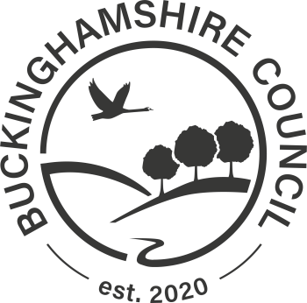
Assisted Collection Cancellation Form

Personal details
Title:
First name:
Surname:
Address:

Declaration:

By completing this form I understand that the assisted collection service for the above address will be cancelled.
I declare that the information on this form is true and accurate.

Signature:
Date:

_________________________________________________________________________

Completed Forms

Thank you for completing the assisted collection cancellation form.
If you have printed this form to complete by hand, please return your completed form to:
Recycling and Waste (Customer Fulfilment)
Buckinghamshire Council,
The Gateway,
Gatehouse Road,
Aylesbury,
Bucks,
HP19 8FF.

